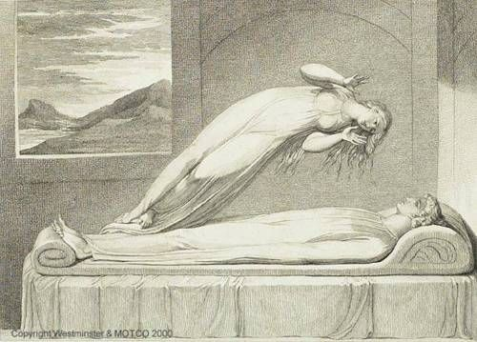

**Life After Death – Immortality of the Soul**

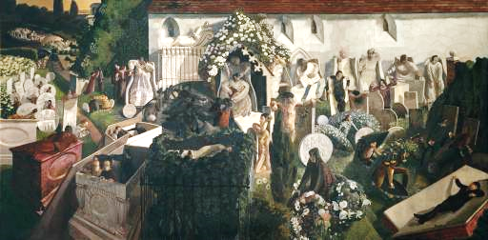

Title:

Artist:

Title:

Artist:

**Life After Death – Immortality of the Soul**





Title:

Artist:

Title:

Artist:





**Life After Death – Immortality of the Soul**

Title:

Artist:

Title:

Artist: