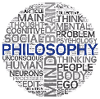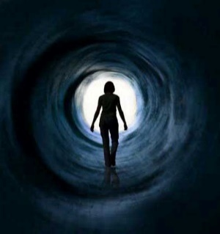

**Life After Death – Immortality of the Soul**

**Key Terms**

What is death?

This might seem like an obvious question and scientists/medical professionals may give a straight forward answer; ‘the complete and permanent cessation of all vital functions in a living creature’, but if we are talking about death being the end of life, then there are differences of opinion.

Some points to consider could be;

* If there is eternal life, is there such a thing as death?
* If death is the end of this life, what is the ‘next’ life like?
* If death leads to another life could this mean when that life ends there is another life? Could this go on into infinity?
* If there is eternal life, where is this going to be?
* Does how we live affect our next life?
* What part of us goes on to the next life?
* Do we get a new body in the next life?
* Is life after death just wishful thinking?
* If immortality is real, at what point after death does this occur?

Materialism or Dualism?

There are two main theories about human nature that have implications for beliefs/ideas about life after death;

* Materialism – the theory that our minds and bodies are inseparable.
* Dualism – the theory that both body and soul exist but are distinct from one another but linked together in some way.

**Soul** – The immaterial ‘I’ that possesses conscious experience, contains passion, desire and action and maintains a perfect identity from birth (or before) to death (or after).

SOul

Materialism.

Materialism does not accept that there is a separate part to the human body called a ‘soul’. An individual is a living, physical body and nothing more. Most materialists believe that at death the body dies and therefore the whole person ceases to exist. Materialists believe an action is the result of a chain of events and eventually science will explain everything. Art and music are not connected to any idea of human spirituality, just vibrations in the air or marks on a canvas. A person is nothing but a brain attached to a body with a nervous system. Emotions are just psychochemical reactions in the brain. Therefore there is no distinction between body and soul.

Dualism.

A dualist approach argues that it is the mind (soul) that determines our personality and the body is an outer shell for the real self. The body is contingent and therefore destined for decay, but the mind, associated with the higher realities such as truth, goodness and justice is immortal. If life is spent in contemplation of these higher realities, then the soul can enter eternity after death of the physical body. This belief that the soul continues after death is known as immortality of the soul.

