|  |  |
| --- | --- |
| **6.1 Ahimsa**  The interpretation and application of ahimsa for a Buddhist in the modern world. (4)  a) The First Precept — to refrain from harming a living thing, the interpretation of ahimsa by Buddhists with specific examples of how this may be lived, such as vegetarianism, right livelihood and involvement in the armed forces.  b) The role of other beliefs and considerations in the living of ahimsa, including differences in application and importance within different traditions, and in the example of the Buddha. Specific reference should be made to excerpts of the Pali Canon and the Lotus Sutra.  With reference to the ideas of the 14th Dalai Lama and T Bartholomeusz. | **ANTHOLOGY (4) www.accesstoinsight.org/tipitaka/index.html (Samyutta Nikaya 42.3 Yodhajiva Sutta: To Yodhajiva (The Warrior))**  14th Dalai Lama, *Ahimsa* - *India’s Contribution to the World* available at <http://meridian-trust.org/video/ahimsa-indias-contribution-to-the-world-h-h-the-dalai-lama/>.  Other useful sources  E Conze *Buddhist Scriptures* Penguin Classics 1969 p 83-90  P Cole & R Gray *Edexcel Religious Studies for AS* (Hodder Education, 2009) Unit 2 Area D |

**..\WINDOWS\Application Data\Microsoft\Media Catalog\Downloaded Clips\cl68\j0260331.wmf..\WINDOWS\Application Data\Microsoft\Media Catalog\Downloaded Clips\cl68\j0260331.wmf**

The basics;

Ahimsa means 'not to injure' and 'compassion' and refers to a key virtue in Indian religions. The word is derived from the Sanskrit root hiṃs – to strike; hiṃsā is injury or harm, a-hiṃsā is the opposite of this, i.e. cause no injury, do no harm. Ahimsa is also referred to as nonviolence, and it applies to all living beings including all animals.

Ahimsa is one of the cardinal virtues and an important principle of Jainism, Hinduism, and Buddhism. Ahimsa is also related to the notion that any violence has karmic consequences. Ahimsa's precept of ‘cause no injury' includes one's deeds, words, and thoughts.

A Level Buddhism – Ahimsa

[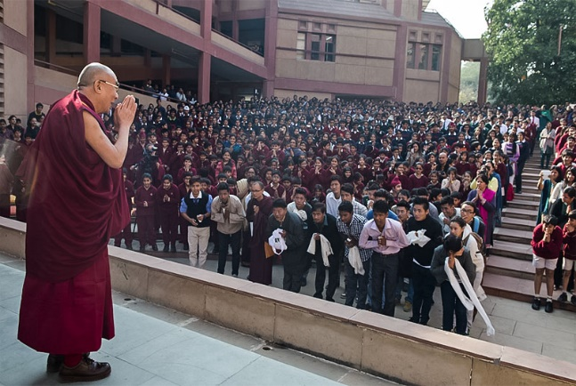](http://www.thetibetpost.com/images/stories/December-2013/Tibet-India-Education-2013.jpg)

*HH the Dalai Lama; New Delhi, India, 6 December 2013: - Vasant Valley School*

"Hello, good morning, elder and younger brothers and sisters. I'm always happy to meet young people, because it makes me feel younger too. We older people have mostly already done our work, but you young people are just at the beginning of your time, making preparations for a happy life."

Ahimsa, or non-violence, His Holiness explained, is an ancient idea that is relevant right now. Every day we hear reports of violence. The gang rape that caught public attention earlier in the year was about men with no values, no sense of caring for other people.

It's clear that if one has inner peace and concern for others' well-being, one cannot do them any harm. Related to this is corruption, which has become like a cancer afflicting the whole world. The opposite of this is self-discipline, taking account of the short and long term consequences of one's actions. In this context, developing a warm heart, a compassionate heart, is the best way to fulfil one's own and others' interests.

On the topic of peace amidst differences, he said, "India has a marvellous, longstanding tradition of inter-religious harmony. You are a living example that it is possible for different religions to live side by side. This is not only a treasure for India, but something you can contribute to the wider world. The sense of ahimsa or non-violence that Gandhi made so well-known is another such treasure...we need you to serve the world by sharing ahimsa and religious harmony."

He concluded, "In the normal run of things to export you have to increase production, so who will produce the ahimsa and religious harmony for export? It'll have to be young people like all of you. This is an example of the opportunity you have to create a better world."

Things to do:

1. Explain what ahimsa is.
2. Explain why the Dalai Lama says ahimsa is ‘an ancient idea that is relevant right now’.
3. Explain how the Dalai Lama suggests ahimsa could be achieved. Give several different reasons from the text.



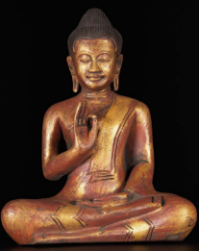

Shakyamuni Buddha…

“Monks, even if bandits were to sever you savagely limb by limb with a

two-handle saw, he who gave rise to a mind of hate towards them

would not be carrying out my teaching”.

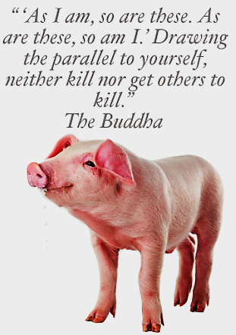In Buddhist thought, Ahimsa is also an important concept, the first precept of Buddhism is to avoid doing harm to other living things.

The website ‘Buddha.net’ defines the first precept as follows:



‘To undertake the training to avoid taking the life of beings. This precept applies to all living beings not just humans. All beings have a right to their

lives and that right should be respected.’

Buddhism teaches us non-violence towards others; violence

towards other living things is contrary to the teachings of the Buddha. He taught us to overcome and avoid suffering. Therefore, we cannot impose suffering on others. Killing not only causes suffering for the person who is killed but also causes suffering for their family and friends who have lost their loved one. It is also the seed of future suffering, with bad karmic consequences for the killer.

Buddha demonstrated non–violence is stronger than violent reaction in the story of Angilimala, a serial killer who killed 999 people and wanted Buddha as his 1000th victim (see the story on the separate pages).

**Dhammapada Vs 5**

Buddha also taught us to show love and compassion to others in place of hate and violence, and not just love for our friends but equally for our enemies, or those who seek to do us harm. One cannot become enlightened without compassion; killing is the fundamental opposite of compassion. The only exception might be, in the opinions of some, a mercy killing such as euthanasia for terminally suffering beings, or defending another innocent being from harm.

**Hatred can never overcome hatred. Only love can bring the end to hating. This is the universal law.**

Non-violent protest exemplified here with protestors who went on strike in 1930 in support of Mahatma Ghandi. Even when faced with violent reactions from authorities, the protestors remained non-violent.

Things to do:

1. Using a teaching from Buddha, explain why he taught ahimsa is an important belief.
2. Explain why practicing himsa would prevent someone from gaining enlightenment. Explain some possible exceptions to this.
3. Explain examples of how ahimsa has been put into practice. What were the outcomes of these actions?

Non-Violence in Buddhist Sutra

[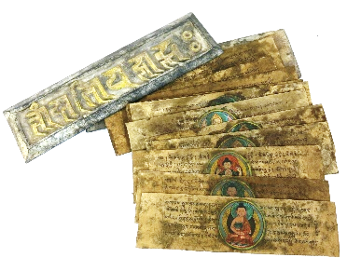](https://www.google.co.uk/url?sa=i&rct=j&q=&esrc=s&source=images&cd=&cad=rja&uact=8&ved=2ahUKEwi_97aimdbaAhUJPFAKHZ_YAXUQjRx6BAgAEAU&url=https://www.pinterest.com/pin/205336064239479685/&psig=AOvVaw19IY6Mc57xjU2epRjz0j8J&ust=1524772199160374)The Buddha spoke about non-violence in many sutras. The Buddha taught through his activities and actions as much as through his words. There are countless passages in Sutras, where the Buddha is very clear - that killing is wrong even where it looks like there is no other choice.

The statement at the top of the previous page seems to be the most extreme form of non-violence possible. The Buddha is clearly saying here that even if someone is killing you, hating him would be contrary to the Dhamma. To many non-Buddhists and maybe even some Buddhists themselves, this seems illogical. How can one not hate — and not only that, have compassion for, someone who is hurting them, or who wants to kill them? But in order to do this, it would obviously require the highest compassion. How should Buddhists react to people such as killers?

It is clear that Buddhists should embrace non-violence towards others and condemn killing and harming others as something terrible that will also result in bad karmic consequences for the killer.

Buddha’s pacifist action heals a serial killer.

[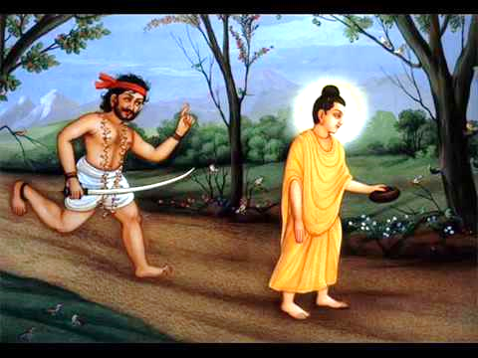](https://www.google.co.uk/url?sa=i&rct=j&q=&esrc=s&source=images&cd=&cad=rja&uact=8&ved=2ahUKEwj55OS5mtbaAhXJIlAKHWTdBeIQjRx6BAgAEAU&url=https://www.youtube.com/watch?v%3D7QeugvIcWmg&psig=AOvVaw2fv98tpBfYcovYxPEDL-DM&ust=1524772420613446)The story of Angulimala is one of the most famous in the Buddhist canon and one of the stories that we can learn most from to apply to today’s world. Angulimala became a serial murderer, killing innocent people and terrorising many others. He chopped off their fingers and made them into a necklace and thus became known as “Angulimala” (translates as Finger Necklace). He had killed 999 people and wanted Buddha as his 1000th victim. However Shakyamuni saves Angulimala from himself. When the mass murderer fails to take Buddha as his 1000th victim he falls to Buddha’ feet and asks to be taken as a monk.

Later, King Pasenadi looks for Angulimala, sees the Buddha and warns him about the serial killer. The Buddha then asks the king, what he would do if he saw that Angulimala had changed, abandoned violence and become a monk to which the king replies that he would be very pleased and even support Angulimala. The Buddha then shows him the newly named Ahimsaka to which the King, in shock, congratulates him and the Buddha saying:

[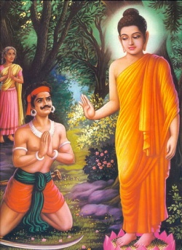](https://www.google.co.uk/url?sa=i&rct=j&q=&esrc=s&source=images&cd=&cad=rja&uact=8&ved=2ahUKEwiqnZbEmtbaAhWMZlAKHY3cDBsQjRx6BAgAEAU&url=http://www.chinabuddhismencyclopedia.com/en/index.php?title%3DBuddhist_Story:_Angulimala:_A_Story_of_the_Power_of_Compassion&psig=AOvVaw2fv98tpBfYcovYxPEDL-DM&ust=1524772420613446)“Venerable sir, we ourselves could not tame him with force and weapons, yet the Blessed One has tamed him without force and weapons”.

Ahimsaka’s life as a monk is far from easy. Often, when he went for alms he was attacked by people who remembered him and what he did in his former life. However, he takes all this as it comes and does not retaliate towards his attackers. The Buddha tells him that this is the result of his actions and that him being attacked is his karmic debt being paid off. Ahimsaka later became enlightened and became an arhat, after years of purifying the negative karma of his violent past.

The main point of the story of Aguilimala is that no one is inherently evil and that no one is beyond redemption. The Buddha challenges someone who practices extreme violence with non-violence and wins. As the King admits, his armies had not been able to beat Angulimala with violence but the Buddha had done it with compassion.

[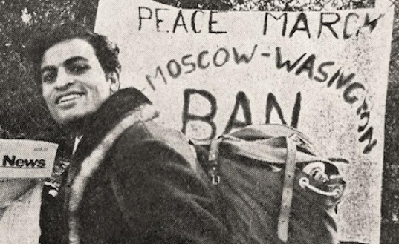](https://www.google.co.uk/url?sa=i&rct=j&q=&esrc=s&source=images&cd=&cad=rja&uact=8&ved=2ahUKEwjLgcqIoNbaAhUNY1AKHQ0QBVcQjRx6BAgAEAU&url=https://theecologist.org/2015/apr/30/satish-kumar-films-inspire-change-makers-future&psig=AOvVaw34EjdtrPCrIp5RArbYz4XM&ust=1524773961526627)*As Indian Peace Activist Satish Kumar writes:*

“The real challenge is to talk to those who are violent, those who disagree, those who oppose and who intend to harm. External violence is only a symptom, a manifestation of some deeper cause. Only in dialogue can the perpetrators of violence and the victims of violence discover its root cause. And find ways to heal the discord.”

From the story of Angulimala, and many other similar stories, it is clear that Buddhists must avoid killing and creating suffering. Equally, we should not hate someone who creates our suffering. We might object and disagree with the negative action, but we should view all sentient beings as redeemable.

Because of these teachings, it follows that Buddhists should also be against the death penalty because it goes against the principle of Ahimsa. Criminals and wrong-doers should be imprisoned to pay for their crimes, in the same way that Angulimala had to pay for his. Some criminals end up being forgiven by the families of their victims and end up making up for their actions. They must have at least the chance to do this and from a Buddhist perspective, repay their karmic debt.

What to do about war and soldiers?

[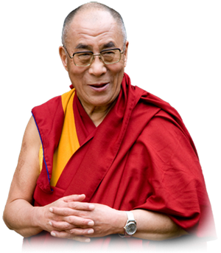](https://www.google.co.uk/url?sa=i&rct=j&q=&esrc=s&source=images&cd=&cad=rja&uact=8&ved=2ahUKEwiqpLbtnNbaAhWDfFAKHcrIAFIQjRx6BAgAEAU&url=http://tibet.net/about-tibet/his-holiness/&psig=AOvVaw1NAlvlH506QajjK1-gwmll&ust=1524773156152949)

“Of course, war and the large military establishments are the greatest sources of violence in the world. Whether their purpose is defensive or offensive, these vast powerful organizations exist solely to kill human beings. We should think carefully about the reality of war. Most of us have been conditioned to regard military combat as exciting and glamorous - an opportunity for men to prove their competence and courage. Since armies are legal, we feel that war is acceptable; in general, nobody feels that war is criminal or that accepting it is criminal attitude. In fact, we have been brainwashed. War is neither glamorous nor attractive. It is monstrous. Its very nature is one of tragedy and suffering.” HH Dalai Lama.

Buddhists are generally opposed to war; it goes against the fundamental teachings of Buddhism and the first precept. However, Buddhists are against the practice of war — not against the soldiers fighting in it.

As the Dalai Lama also says later on, the vast majority of soldiers join to defend the country, or establish themselves in a good career - not to kill. In short, soldiers join with good intentions. Therefore, it is unacceptable to claim that soldiers are somehow responsible for murder. Buddhists are against killing and war - not the people fighting the wars.

Things to do:

1. Using a teaching the extent in which the practice of ahimsa should be taken.
2. Explain reasons why there may be some exceptions to not killing other sentient beings.
3. Explain, referring to Satish Kumar’s ideas how violence can be overcome.
4. Explain the Dalai Lama’s view on war and soldiers and the general Buddhist views on war.

Non-violent action.

Non violence is still an *action*, with positive karmic results. Non-violence isn’t simply not participating in violence, for Buddhists it is actively engaging in trying to end violence and hate. Engaged Buddhism (Thich Nhat Hanh) is an example of this. Why is this concept so important? Because, refraining from killing isn’t enough. Reducing suffering of others also requires “action” - karma in Sanskrit. If we are to decrease suffering, we cannot let injustice continue unopposed. Therefore, non-violent resistance against oppressors, aligns best with Buddhist teachings. In the sixties, this might result in a “sit in protest” against war, or the civil rights movement.

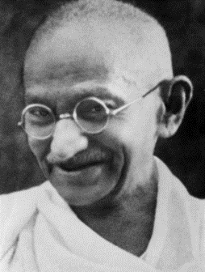A recent study by Chenoweth and Stephan actually indicates that non-violent resistance is more effective than violent revolution. Non-violent revolution was effective in 60% of cases in comparison with violent revolution which was only effective 23% of the time in the cases studied.

**“Non-violence is a weapon of the strong.”**

Ahimsa has been a part of Buddhist tradition since ancient times. In modern times, Ghandi made the concept famous. Buddha would have agreed with Gandhi when he said:

Things to do:

1. Using an example explain why non-violence should be an *action* for Buddhists
2. Explain reasons for this belief, referring to Buddhist teachings.
3. Explain, referring to an example, how it has been shown that non-violence is more effective than violence. Why do you think this might be?

Things to do - Research:

Find out more about ‘Engaged Buddhism’ and the work of Thich Nhat Hanh. Particularly focus on where he has peacefully campaigned against war and violence and helped people who are suffering due to the violence of others.

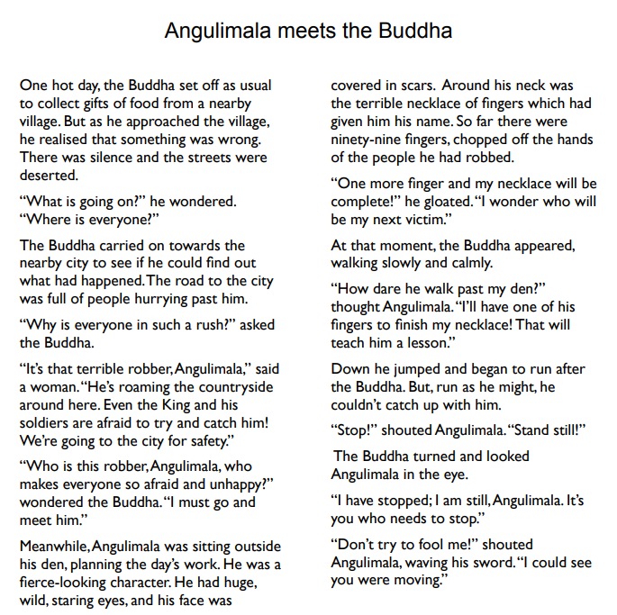

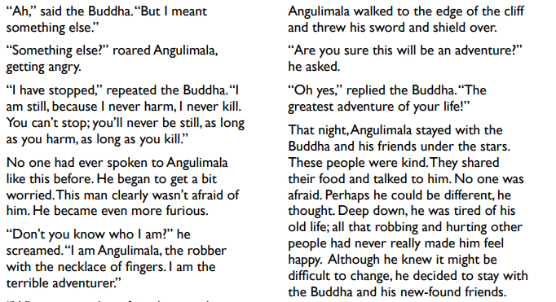





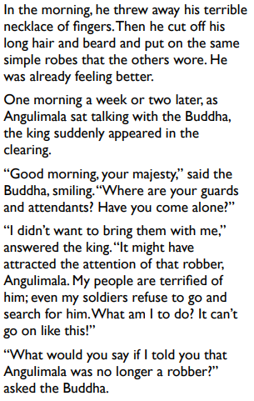

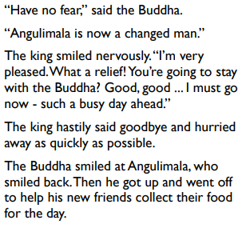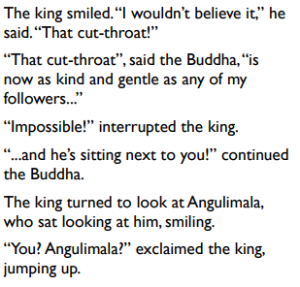

The story of Anguilimala was the inspiration for the foundation of the Buddhist prison Chapliancy of the same name. Helping convicted criminals, particularly supporting them after leaving prison can help reduce the chance of them re-offending.

ANGULIMALA’S Objectives:

To make available facilities for the teaching and practice of Buddhism in Her Majesty’s Prisons and other places of lawful detention or custody.

Specifically:

* To recruit and advise a team of Buddhist visiting chaplains to be available as soon as there is a call for their services;
* To act in an advisory capacity, and to liaise with the Ministry of Justice chaplaincy officials, with individual chaplains within Her Majesty’s Prisons, and with any other relevant bodies or officials;
* To provide an aftercare and advisory service for prisoners after release.