Joy in all Things - The Bodhisattva Virtues

Anthology pages 132 – 135

- What are the cardinal virtues of Buddhism?

- How is it suggested in this extract that sorrow can be overcome?

- Write down a quotation that suggests Bodhisattvas remain compassionate in the face of adversity.

- Who is Mara and why is it important that a Bodhisattva is not ‘shaken by all the deeds of Mara’?

- In addition to the Ten Perfections of a Bodhisattva, there are Ten Good Deeds, note these down.

- Note down the three Bodies of the Buddha.

- What is the key difference between the Body of Bliss and the Body of Essence.

- Explain the nature and purpose of the Transformation Body.

- Describe and explain the collective nature of the three Bodies of Buddha.

- What is the purpose of the constant repetition of mantras?

10a. Briefly explain what Tantric Buddhism is.

10b. Briefly explain the origins of Tantric Buddhism (ThoughtCo. is a good website
for 10a & 10b).

Walpola Rahula - The Bodhisattva Ideal

Anthology pages 136 – 140

- What does Rahula claim is an incorrect assumption about the Bodhisattva idea in Mahayana and Theravada Buddhism, and what does he claim is the correct belief?

1a. Why is it ‘convenient’ for some western Buddhists to refer to Theravada
Buddhism as, Hinaya?

- What is the evidence for Rahula’s claim that there is an incorrect assumption about the Bodhisattva ideal in Mahayana and Theravada beliefs about the Bodhisattva ideal?

- What is the evidence for Rahula’s claim of the correct about the Bodhisattva ideal in Mahayana and Theravada beliefs about the Bodhisattva ideal?

- What does Asanga suggest about the Three Yanas found in Mahayana Scripture?

- How is this in keeping with Theravada Buddhism?

- Briefly explain the persons of Sravaka, Pratyekabuddha and Bodhisattva.

- How does Asanga’s definition of the Three Yanikas help to clarify understanding of the importance of Bodhisattvas? It may be helpful to refer to similarities and differences here.

- Explain Asanga’s position on Bodhisattvas and Arahants.

- What does Mahayana suggest about a Buddha, a Pratyekabuddha and a Sravaka in regard to their liberation from impurities?

- What is the difference between the above and the capabilities of a Buddha?

- How are Mahayana and Theravada views on this similar?

- How does the Theravada Tripitaka suggest one may attain the states of the Sravaka, Pratyekebuddha and Buddha-domain?

- What are these states referred to as in Theravada Buddhism? What is the evidence of this?

- Give an example of a Bodhisattva from the Jataka.

- What conclusion can be gained from this example?

- Give further evidence that Theravada do accept the Bodhisattva ideal.

- What is the significant difference between Mahayana and Theravada with regard to the Bodhisattva ideal?

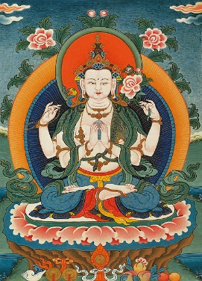
Conclusions

- Explore the overall view of the nature of a Bodhisattva outlined in the anthology.

- Explore differences in understanding of the Bodhisattva ideal in Mahayana and Theravada Buddhism.

