**..\WINDOWS\Application Data\Microsoft\Media Catalog\Downloaded Clips\cl68\j0260331.wmf..\WINDOWS\Application Data\Microsoft\Media Catalog\Downloaded Clips\cl68\j0260331.wmf**

An outline.

Ch’an (Chinese) or Zen (Japanese) Buddhism claims to be a special line of transmission of the Buddhist teachings that began with Buddha Shakyamuni. According to the traditional account of its origins, the Buddha was once surrounded by several disciples and at one point he silently held up a flower and turned it in his hand. One disciple, Kasyapa, understood the message in this gesture and smiled in recognition. As a result, the ‘special transmission’ of which Zen speaks is a silent one, in which the truth of the Dharma is conveyed in gestures and actions. It claims to bring a direct, intuitive grasp of reality which is personally transmitted ‘from mind to mind’ by a master to his disciple. The Zen tradition asserts that this transmission was passed on from generation to generation in ancient India as an alternative, and in parallel, to scriptural tradition. However there is no evidence that Zen was recognised as a distinct tradition in India so it is unclear whether Zen began in India or China.

**A Level Buddhism – Zen Buddhism**

Bodhidharma.

In 520 CE, the Indian master Bodhidharma travelled to China and reportedly founded the line of Ch’an masters there. Bodhidharma

was a colourful character, there are many legends about his life. It is

said that as part of his training his meditated for nine years facing a

wall until his legs fell off and he cut off his eyelids to keep himself from

dozing in meditation. He is said to have insulted the Chinese Emperor

by telling him that good deeds such as sponsoring monasteries and

copying scriptures, would earn him no merit at all; the Ch’an tradition does not place as much value on study as it does meditation practice. Bodhidharma is recognised as founder of the Shao-lin temple in southern China, the home of Kung Fu. It is said that Bodhidharma developed the martial arts during a long period of retreat as a way of maintaining physical health and strength.

Modern Scholars accept Bodhidharma as an historical figure, but date his arrival in China earlier, around 480 CE. Although he discouraged intensive study of the scripture, Bodhidharma had a special connection with the Lankavatara Sutra, which is the main scripture of this tradition. This Mahayana Sutra teaches the emptiness (shunyata) teachings of the Second Turning of the Dharma Wheel, as well as the Third Turning on Buddha nature (tathagatagarbha).

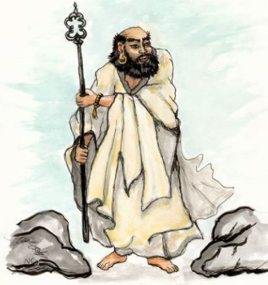

The Patriachs.

After Bodhidharma there were six generations of ‘patriarchs’, the most prominent Ch’an master in each period. In the 7th century Hung Jen, the 5th Patriarch ran a poetry competition to find his successor. The most learned chief monk wrote the following;

An illiterate servant, Hui neng, who worked in the monastery kitchen wrote the following;

**‘The body is the Bodhi tree, the mind is like a clear mirror, at all times we must strive to polish it, and must not let the dust collect.’**

**‘The body is the Bodhi tree is originally not a tree, the mirror has no stand, Buddha nature is always clean and pure, where is there room for dust?’**

**The mind is the Bodhi tree, the body is the mirror stand, the mirror is originally clean and pure, where can it be stained by dust ?’**

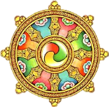

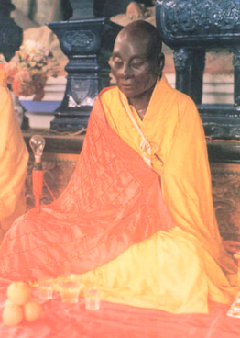

The Patriarchs (continued).

The first verse was a conventional Buddhist expression of the need to purify the mind of the ignorance that prevents us from seeing clearly. The second poem shows a deeper level of understanding, because from the enlightened point of view the Buddha nature is unchanging, always pure and never stained. The ‘dust’ of karma and ignorance is an illusion, and when we become enlightened we realise that it was never really there. Hui neng was therefore chosen as the 6th Patriarch, which was an important step in the history of Ch’an because he was illiterate. His success demonstrated that scriptural study, in itself does not bring true depth of spiritual understanding.

Explain...

1. …the origins of Ch’an/Zen Buddhism. Make sure you refer to ‘special transmission’ in your answer.
2. … how Ch’an began in China and how the character of Bodhidharma affected its development.
3. … how the 6th Patriarch was chosen (include a quotation) and what this shows about the nature of Ch’an Buddhism.



Soto and Rinzai.

Ch’an survived the persecution of Buddhism in China in 845CE because it did not depend on large monasteries or vast libraries of scriptures, nor did it require elaborate institutions that needed wealth to support them.

During the 9th and 10th centuries, Ch’an split into several different school, the two main ones being Lin Chi and Ts’ao tung, which later became the Soto and Rinzai schools of Japanese Zen. Ch’an continued as a Buddhist tradition in China until the Communist revolution in 1949. It continues to flourish in Taiwan and South Korea.

Ch’an meditation was introduced in Japan as early as the 7th century, but it wasn’t until the 12th century that Zen became popular in Japan. The master who established Zen was Eisai (1141-1215) a Japanese monk who travelled to China to further his studies. He later brought back the Rinzai tradition to Japan. Rinzai attracted Japan’s warrior and political classes because of the way it cultivates toughness, the martial arts and intellectual riddles called *koans*. The monk Dogen (1200-1253), however was not satisfied with the Rinzai teachings and went to China himself in search of something more meaningful. He brought back to Japan the Soto tradition which emphasises quiet meditation and a simple life of poverty and peace, uninvolved in worldly intrigue. It is often said that the character of Soto Zen attracted the farmer and peasant classes.

Dogen is widely regarded as a remarkable Buddhist saint. He studied Buddhist scriptures but came to feel that study becomes a distraction is it is not done to support meditation. He chose to follow the example of the Buddha and led a simple life of poverty, entirely dedicated to benefitting others. It was Dogen who

taught the importance of zazen or sitting meditation which now

characterised the Soto school.

Both Soto and Rinzai schools of Zen continue in Japan today. Several

Japanese masters introduced Zen to North America in the 20th century,

where it is becoming well established.

