**..\WINDOWS\Application Data\Microsoft\Media Catalog\Downloaded Clips\cl68\j0260331.wmf..\WINDOWS\Application Data\Microsoft\Media Catalog\Downloaded Clips\cl68\j0260331.wmf**

Buddhism spreads to the West.

Buddhism didn’t become established in the West until relatively

recently. However, contacts and cultural exchanges took place

between Europe and India from the earliest times. The first

documented exchange with Buddhism is that of Menander (King

Milinda) of Greece who engages in discussions with the monk

Nagasena (found in the Theravada scripture, The Questions of King Milinda).

After the time of Christ commerce between Asia and the Roman Empire was strong and Buddhist ideas were known in Europe. A small number of Indians including Buddhist monks settled in Athens and Alexandria. There was a lot of cross-cultural exchange, for example many of the Jataka Tales were retold as Aesop’s Fables. However, with the fall of the Roman Empire contacts with Asia were lost and with it knowledge of Indian religions.

During the Middle Ages the popes sent several missionaries to Asia, who

came back with information about Buddhism and Hinduism. Accounts of

people like Marco Polo were sympathetic, but Christians at the time were

largely intolerant of all non-Christian religions.

With the European expansion in the 16th and 19th centuries, Europeans came to know about Indian religions again, for example the Portuguese occupying parts of Sri Lanka. In the 18th century (post Reformation) Europe became more receptive to new ideas and in the 19th century this led to a new academic discipline – comparative religion. There were several reasons for this more receptive period; The Enlightenment saw developments in science and reason, weakening the authority of Christianity; some people began to believe in a ‘natural religion’, a cross-cultural, fundamental truth common to all human kind. In the 19th century scientific evolution theories, weakened Biblical creation accounts, bringing into question, for some, the existence of a creator god.

By the end of the 19th century, Buddhism was becoming

fashionable in Europe. People were attracted by its ideas of

self-help instead of dependence on God or priests, its

similarities with science that is based on experience and its

belief that the universe is subject to laws. Buddhism,

however was more than science, it also had mysticism

and, paradoxically, appeared to bring faith and reason

together.

**A Level Buddhism – Buddhism in the West**



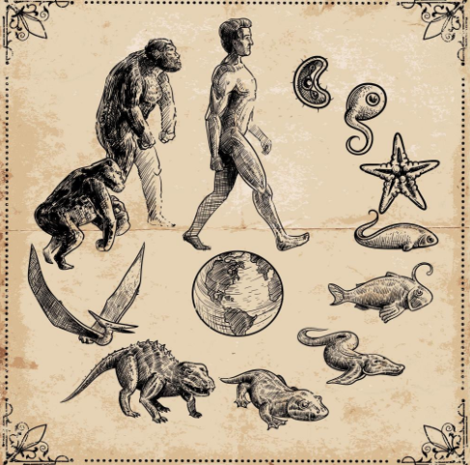

Explain...

1. … how Buddhism first became known to early Europeans (include reference to King Milinda, the Roman Empire and cross-cultural links).
2. … why knowledge of Buddhism was lost to Europeans for quite some time.
3. … how knowledge and interest in Buddhism re-emerged from the 16th

century onwards.



Buddhism in the West in the 19th and 20th Centuries.

At this time interest in Buddhism in the West was primarily intellectual and mainly only for the cultural elite. Scholars began to translate Buddhist scriptures. The Sir Edwin Arnold wrote a life story of Buddha in verse called The Light of Asia, published in 1879 and Herman Hesse wrote Siddhartha in 1922.

Spiritualism was in fashion at this time, based on the belief that the spirits of the dead could communicate with the living especially through mediums. The Theosophical Society was set up in New York in 1875, offering a mix of obscure religions, with a particular influence from Hinduism. This movement spread to London and succeeded in introducing key concepts such as karma and rebirth to the British public.