**..\WINDOWS\Application Data\Microsoft\Media Catalog\Downloaded Clips\cl68\j0260331.wmf..\WINDOWS\Application Data\Microsoft\Media Catalog\Downloaded Clips\cl68\j0260331.wmf**

A brief outline.

Pure Land Buddhism is part of the Mahayana tradition of Buddhism. A Mahayana sutra tells the story of a monk named Dharmakara, who vowed, in the presence of a buddha who live aeons ago that when he attained enlightenment he would create a perfect paradise out of compassion for the suffering of all beings. One of his vows was that beings would only have to think of him and he would lead them to this paradise after death. Dharmakara gained enlightenment and became known as Buddha Amitabha (Amida Buddha in Japanese). Pure Land began in China in the second century CE then developed and spread throughout China and into Japan. Pure Land is the main type of Buddhism practised in Japan today.

Pure Land is based on faith in Amitabha Buddha, in the hope of being reborn in the paradise where Amitabha lives. The Pure Land he created was called

Sukhavati, which is a land which can be found far to the west, beyond the boundaries of our own world. Amitabha created this paradise out of his compassion and love for all beings. Pure Land Buddhists believe that if they are reborn into this land, they will be taught by Amitabha himself and will therefore have a much better chance of attaining Buddhahood. In the Pure Land there is no suffering, and none of the problems that stop people in our own world attaining enlightenment.

**A Level Buddhism – Pure Land Buddhism**

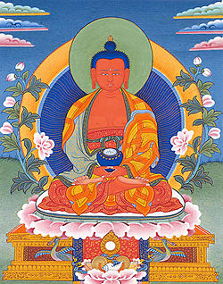

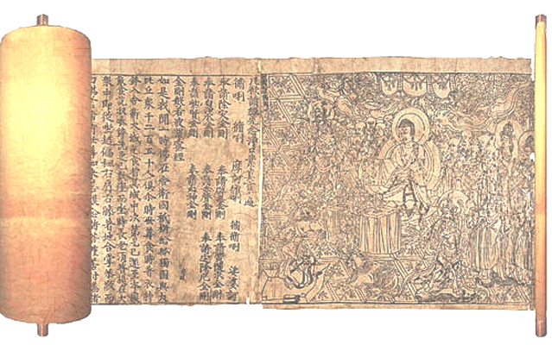

**“Sukhavati is rich in a great variety of flowers and fruits, adorned with jewel trees**

**which are frequented by flocks of birds with sweet voices… And all the beings who are born … in this Buddha-field, are all fixed on the right method of salvation, until they have won nibbana. For this reason that world system is called the ‘Happy Land’.**

**(*The larger Sukhavativyuha Sutra, sections 16-24*)**

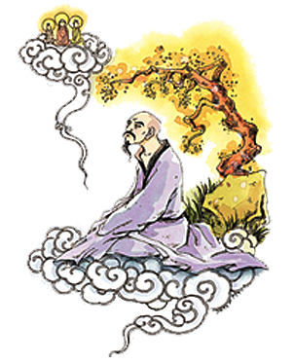

How to reach the Pure Land.

T’an-luan is considered to be the person who founded Pure Land Buddhism in China who is said to have had a vision of Amitabha. He encouraged believers to follow five types of religious practice: reciting scriptures, meditating on Amitabha and his paradise, worshipping Amitabha, chanting his name and making praises and offerings to him. Of these five, he taught that the most important is to recite Amitabha’s name. If a person follows these practices, they will be reborn in the paradise of Sukhavati.

Pure Land Buddhism focusses on having faith in Amitabha and believing he will help Buddhists be reborn in Sukhavati. Faith in Amitabha is more important than a person’s own actions and behaviour (all except the very worst sinners can go to Sukhavati). This is quite different from other schools of Buddhism. For example Theravada Buddhism teaches that enlightenment can only be achieved through a person’s own thoughts and actions, and they cannot rely on any outside help to achieve enlightenment. The fact that it is seen to be easier to reach enlightenment in Pure Land Buddhism, with Amitabha’s help, has allowed this school of Buddhism to gain popular appeal. It became popular in China, especially with the masses who could not pursue philosophical studies. It also attracted people of questionable morals who were not following sila in the Eightfold Path. Pure land remained the most popular form of Buddhism in China until the 20th Century.

Things to do.

1. What do the cockerel the snake and the pig symbolise in Buddhism? You may draw and label pictures of each if you wish.
2. Give examples of actions that may result from being (a) greedy (b) full of hate, and (c) ignorant. You may do this in cartoon strip form if you wish.

Things to do.

1. What do the cockerel the snake and the pig symbolise in Buddhism? You may draw and label pictures of each if you wish.
2. Give examples of actions that may result from being (a) greedy (b) full of hate, and (c) ignorant. You may do this in cartoon strip form if you wish.

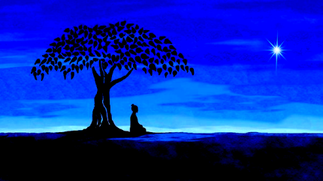

**“Even a bad man will be received in Buddha’s land, how much more**

**a good man?’ Honen (12th century Japanese Pure Land teacher)**

Pure Land in Japan .

The recitation of Amida Buddha’s name was included in Buddhist meditation in Japan in the ninth century. However, Pure Land only became a distinct school in the 13th century. The founder of Pure Land in Buddhism in Japan (Jodoshu) is thought to be Honen, a monk-scholar who taught that Buddhist institutions had become corrupt and the only way to salvation was through devotion to Amida Buddha. He believed scriptural study was too difficult for most and so taught the ‘easy path’ of devotion. Honen was forced to disrobe and made to leave Kyoto by orthodox Buddhist leaders, however, he continued to teach in the countryside. Most of his followers remained celibate monks and led a simple life.

A disciple of Honen – Shinran, founded the True Pure Land school or Jodo-Shinshu (also referred to as Shin Buddhism). He believed that his was the only correct understanding of Honen’s teaching. He criticised the principle of merit-gaining through virtuous action as he claimed it only led to self-importance and pride.

He said we are all hopeless sinners with no hope of enlightenment. The only way was through whole-hearted belief in and devotion to Amida Buddha.

Shinran had a dream in which he had a vision of the bodhisattva of compassion, Kwannon, who advised him to get married. As a result,

teachers in the True Pure Land school get married, have jobs and

families so there is no monastic tradition in this school.

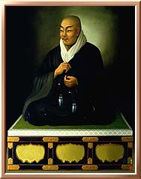

**“When beings hear my name and think on me, I will come and welcome them.**

**Not discriminating at all between the poor and the rich and well born,**

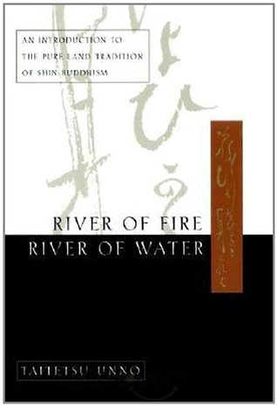**Not discriminating between the inferior and highly gifted,**

**Not choosing the learned and those who uphold pure precepts,**

**Not rejecting those who break precepts and whose evil karma is profound,**

**Solely making beings turn about and abundantly say the Name**

**I can make bits of rubble change into gold.”**

**Tz’u (cited in Unno, River of Fire, River of Water, 1998)**



Analyse...

To what extent could it be argued that Pure Land does not follow the main principles of the Buddha’s teaching?

In your answer make sure you refer to the main Buddhist teachings, particularly the Eightfold Path, including Sila and Samadhi. Include quotations and reference to Pure Land in China and Japan.