**..\WINDOWS\Application Data\Microsoft\Media Catalog\Downloaded Clips\cl68\j0260331.wmf..\WINDOWS\Application Data\Microsoft\Media Catalog\Downloaded Clips\cl68\j0260331.wmf**

**A Level Buddhism – Pure Land Buddhism**

A brief outline.

Pure Land Buddhism is part of the Mahayana tradition of Buddhism. It began in China in the second century CE then developed and spread throughout China and into Japan. Pure Land is the main type of Buddhism practised in Japan today.

Pure Land is based on faith in Amitabha Buddha, in the hope of being reborn in the paradise where Amitabha lives. Amitabha was a king who renounced his throne to become a monk. Mahayana scriptures tell how, when he achieved enlightenment and became a Buddha, he created a pure land called Sukhavati, which is a land which can be found far to the west, beyond the boundaries of our own world. Amitabha created this paradise out of his compassion and love for all beings. Pure Land Buddhists believe that if they are reborn into this land, they will be taught by Amitabha himself and will therefore have a much better chance of attaining Buddhahood. In the Pure Land there is no suffering, and none of the problems that stop people in our own world attaining enlightenment.

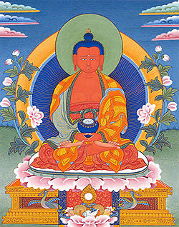

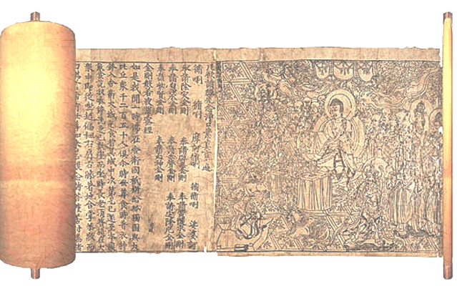

“Sukhavati is rich in a great variety of flowers and fruits, adorned with jewel trees

which are frequented by flocks of birds with sweet voices… And all the beings who are born … in this Buddha-field, are all fixed on the right method of salvation, until they have won nibbana. For this reason that world system is called the ‘Happy Land’.

(*The larger Sukhavativyuha Sutra, sections 16-24*)

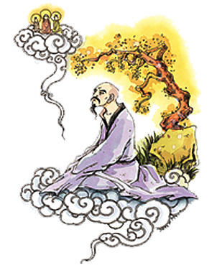

How to reach the Pure Land.

T’an-luan is considered to be the person who founded Pure Land Buddhism in China. He encouraged believers to follow five types of religious practice: reciting scriptures, meditating on Amitabha and his paradise, worshipping Amitabha, chanting his name and making praises and offerings to him. Of these five, he taught that the most important is to recite Amitabha’s name. If a person follows these practices, they will be reborn in the paradise of Sukhavati.

Pure Land Buddhism focusses on having faith in Amitabha and believing he will help Buddhists be reborn in Sukhavati. Faith in Amitabha is more important than a person’s own actions and behaviour. This is quite different from other schools of Buddhism. For example Theravada Buddhism teaches that enlightenment can only be achieved through a person’s own thoughts and actions, and they cannot rely on any outside help to achieve enlightenment. The fact that it is seen to be easier to reach enlightenment in Pure Land Buddhism, with Amitabha’s help, has allowed this school of Buddhism to gain popular appeal.

Things to do.

1. What do the cockerel the snake and the pig symbolise in Buddhism? You may draw and label pictures of each if you wish.
2. Give examples of actions that may result from being (a) greedy (b) full of hate, and (c) ignorant. You may do this in cartoon strip form if you wish.

Things to do.

1. What do the cockerel the snake and the pig symbolise in Buddhism? You may draw and label pictures of each if you wish.
2. Give examples of actions that may result from being (a) greedy (b) full of hate, and (c) ignorant. You may do this in cartoon strip form if you wish.



“Even a bad man will be received in Buddha’s land, how much more a good man?’ Honen (12th century Japanese Pure Land teacher)