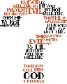
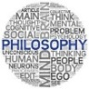
The Iranaean Theodicy

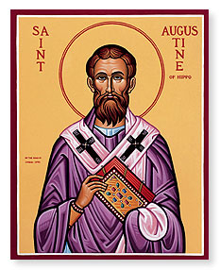
- Where did Iranaeus draw his inspiration from for his theodicy?

- What does this verse say?

- How does Iranaeus interpret this verse?

- Why does Iranaeus suggest humans are not ready made perfect?

- Explain the key differences between Augustine’s and Iranaeus’ theodicies.

- How does Swinburne develop Iranaeus’ theodicy?

- How does Hick develop Iranaeus’ theodicy?

- Why might suffering lead some people to behave in an immoral way?

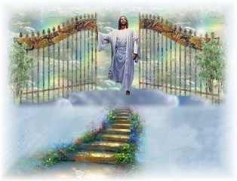
- What does this mean for Iranaeus’ theodicy?

The Iranaean Theodicy

- Where did Iranaeus draw his inspiration from for his theodicy?

Genesis 1:26

- What does this verse say?

²⁶ Then God said, “Let us make mankind in our image, in our likeness…’

- How does Iranaeus interpret this verse?

That there are two stages to the creation of humans. ‘Image’ not a physical likeness but we share certain characteristics with God such as intelligence, consciousness and morality. ‘Likeness’ – we were not created perfectly, but from birth, but we have the potential to become perfect.

- Why does Iranaeus suggest humans are not ready made perfect?

Morality developed through hard work rather than pre-programmed is infinitely more valuable.

- Explain the key differences between Augustine’s and Iranaeus’ theodicies.

A says God created the world perfectly. I says the world was not created perfect, that genuine moral development is only possible where pain and suffering are real. If there is no pain, then there is no moral consequence. Growth comes through our response to challenges we face.

- How does Swinburne develop Iranaeus’ theodicy?

S says moral virtues such as generosity and compassion are only possible in an imperfect world. Pain -> Compassion; Poverty -> Generosity; Corruption -> selflessness.

- How does Hick develop Iranaeus’ theodicy?

Idea of ‘soul-making’ – the process of moral growth. If God intervened there would be no human freedom. God created us with an epistemic distance – a distance in knowledge of God’s existence making us uncertain of God’s existence. If there was no distance we would act out of fear of punishment and judgement rather than out of virtue.

- Why might suffering lead some people to behave in an immoral way?

Anger, greed, revenge etc…

- What does this mean for Iranaeus’ theodicy?

For evil & suffering to be justified everyone must attain perfection – but they don’t so the process of soul-making goes on after death making ‘universal salvation’ possible. Everyone eventually makes it to heaven.

