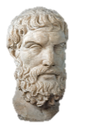
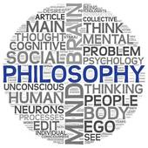
AS RS – The Problem of Suffering & Evil

To begin...

- Note down different examples of evil.

- From your examples highlight moral evils in one colour and natural evils in another colour.

- Which of these two types of evil do you think it would be harder for religious believers to accept? Give reasons for your answer.

The concept of Evil.

Evil is divided into natural and moral evil, although sometimes human actions can exacerbate natural evil, for example building homes on a flood plain.

The consequence of evil is suffering. Suffering involves mental anguish, physical pain and depression and the effects can be long lasting. Suffering often seems unjust, for example when the innocent suffer.

The Problem of Evil.

The effects of evil are obviously unpleasant for those affected by it. For religious people this poses a challenge to their faith, this challenge is known as the ‘problem of evil’. This is the problem of how an omnipotent; omniscient; omnibenevolent God could allow evil and suffering to happen to his creation without doing something about it.

Epicurus.

The classic formulation of problem of evil was devised by Greek philosopher Epicurus. His formulation is often referred to as the ‘Inconsistent Triad’.
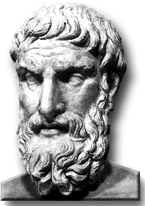
If an omnipotent, omniscient, and omnibenevolent god exists, then evil does not.
There is evil in the world.
Therefore, an omnipotent, omniscient, and omnibenevolent God does not exist.

The problem of evil is a particular problem for believers in the God of classical theism (the traditional Christian idea of God). The logical problem of evil argues that evil makes the existence of God impossible. The evidential problem of evil argues that evil makes the existence of God improbable.

The Logical Problem of Evil.

This argument suggests that the existence of evil is incompatible with the existence of God. As a result it is logically inconsistent to accept that both exist;

- As God created the universe out of nothing, He has total responsibility for everything in it. If He is omnipotent, He can do anything logically possible. This means he could have created a world free of evil and suffering and that, should he have allowed them to come about, He could end all evil and suffering.
- As God is omniscient, he has knowledge of everything, including suffering and evil, therefore he knows how to stop it.
- If God is omnibenevolent, He would wish to end all evil and suffering. J.L. Mackie claimed, ‘A wholly good being eliminates evil as far as it can’. No all-loving God would allow His creation to suffer for no reason. As God is omnipotent he could carry out his desire to end suffering.

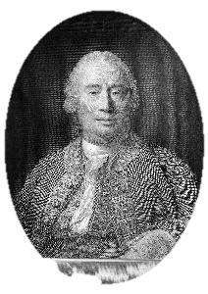
- David Hume argued that only two of the three qualities of God can exist alongside each other. Therefore either God is not omnipotent, or God is not omnibenevolent, or evil does not exist. Whilst the existence of evil has been questioned by some, Hume considered its effects are felt too widely to be dismissed. Therefore, accepting that evil exists he concluded that God must either be impotent or malicious. Either way, the means that God of classical theism cannot exist.

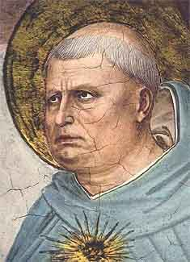
- For Aquinas, the concept of infinite goodness is an essential part of God’s nature, proof against this infinite goodness, is proof that God does not exist. Aquinas, however, differs from Hume in that Hume, an atheist, accepted this conclusion, whereas went on to reject it. Aquinas’ logical argument only works if, in talking about God’s goodness, we are referring to the same thing as human goodness, and assuming that what we call evil is incompatible with the goodness of God.

Epicurus…

Explain what Epicurus says about the existence of the God of classical theism.

Mackie…
Use a quotation to explain what Mackie says about the existence of the God of classical theism.

Hume…
Explain what Hume says about the nature and existence of the God of classical theism.

Use evidence…

Explain the philosopher’s views about the nature of God using examples of evil and/or suffering. Refer to both natural and moral evil.

Evaluate…
Do evil and suffering disprove God’s existence? Explain two reasons why it does and two reasons why it doesn’t.

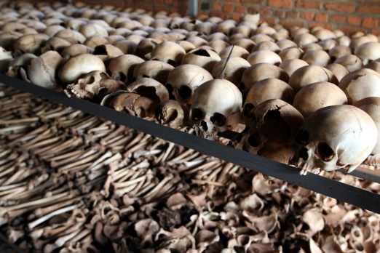

The Evidential Problem of Evil.

The logical problem of evil argues that the existence of the God of classical theism is incompatible with what is known about evil and the suffering it causes. The evidential problem of evil argues that what is known about evil and suffering is evidence (rather than proof) against the existence of God, therefore God’s existence is improbable.

William Rowe

Rowe bases his case for atheism around the form of evil he refers to as, ‘intense human and animal suffering that occurs on a daily basis’. He accepts that if this evil and suffering resulted in some ‘greater good’ that could only be achieved by the presence of evil, then the resulting suffering might be considered justifiable. However, Rowe argues that this type of suffering is not all required for a greater good (much suffering seems pointless), therefore it is evidence against God’s existence.
- Instances of intense suffering exist that an omnipotent, omniscient being could have prevented.

- An omniscient, wholly good being would prevent the occurrence of intense suffering, unless it could not do so.

- Therefore there does not exist an omnipotent, omniscient, wholly good being.

Rowe uses examples to illustrate his points;

Rowe explains that the five-year-old did not need to be raped and beaten before she was murdered even if her death was necessary for the greater good. All that was needed was for her to be killed quickly. This is also open to doubt because what good did her death bring as a result of this evil?
A young girl lives with her mother, her mother’s boyfriend and an unemployed man. The adults were drinking in a nearby pub. The boyfriend had been taking drugs and drinking heavily. He was asked to leave the pub early but the mother and lodger stayed in the pub. At 2am the mother went home and the lodger went to a party. The boyfriend was jealous and attacked the mother when she came in. He then passed out and the mother went to bed. Later the five year old little girl went downstairs to go to the bathroom. The lodger returns home from the party at 4am and found the little girl dead. She had been raped and beaten by the boyfriend.

Explain…

Explain the evidential problem of evil, referring to William Rowe.

Explain your own examples of unnecessary suffering explaining why this suggests the God of classical theism does not exist.

Is there ever a point to suffering? Explain with examples, suggesting how theists might respond to Hume and Rowes’ arguments that suffering and evil suggest God does not exist.

Similarly Rowe explains that the fawn could have died quickly rather than dying in agony. Rowe is arguing, therefore, that such evidence of unnecessary evil points to the non-existence of the God of classical theism.
In a forest lightning strikes a dead tree, which starts a forest fire. In the fire a fawn is trapped and is horribly burned. It lies in agony for several days before death relieves its suffering.

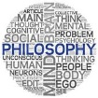
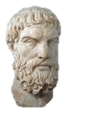
Religious Responses to the Problem of Evil

To begin...

Note down any reasons you can think of that theists might put forward to suggest suffering and evil do not prove God does not exist.

What is a theodicy?

A typical defence of against the problem of evil is that God’s goodness is a different concept from our own, and that as a temporary part of his plan his goodness might allow him to tolerate the existence of what we consider to be evil. In this case there is no contradiction in supposing that God is omniscient, omnipotent and omnibenevolent, and has a reason for evil to exist. A number of philosophers have come up with theodicies to explain what reason this might be.

‘Theodicy’ literally means the ‘justice of God’. When applied to the problem of evil it is more helpful to think of it as ‘justification of God’. A theodicy seeks to explain the existence of evil and at the same time retain the three attributes of the God of classical theism. These have included considering evil and suffering as an illusion.

Augustinian Theodicies.

St Augustine (354-430) based his arguments on the Bible, in particular the Creation and Fall accounts in Genesis, and on philosophical tradition. His theodicy is based on two major assumptions;

- Evil did not come from God since God’s creation was faultless and perfect.

- Evil, having come from somewhere else, God is justified in allowing it to stay.

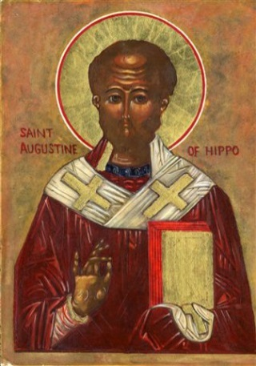
Augustin converted from Manichaeism to Christianity, this would influence his theodicy. Manichaeism taught that two opposing natures existed - light (good) and dark (bad), both of equal power. A human is the battle ground for the power of light and darkness; the good is the soul, and the dark is the body. The soul is incorruptible and is under domination from the body. Humans are said to be saved if they come to know and identify themselves with their soul. Matter is evil and traps the human spirit, but there is said to be a divine ‘spark’ which must escape the material world to join the Ultimate Good.
Augustine rejected the dualism of Manichaeism in favour of the God of classical theism. However he took the Manichaeism concept of Good as that which brings tranquil pleasure associated with God’s creation, and the dark becomes the evil which disrupts the harmony of creation. However, God preserves the order in his creation. Wickedness and mortality in Manichaeism, become ‘sin’ and the punishment for Augustine. Humans inherit sin as a punishment for the original sin of Adam and Eve therefore personal evil is inevitable.
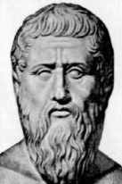

To begin...

- What is a theodicy? Write down a definition on your key terms sheet.
- Note down the basis of Augustine’s theodicy.
- Explain why Augustin claimed that personal evil is inevitable.
k

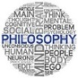
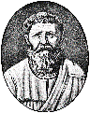
Explanations for the Existence of Evil & Suffering
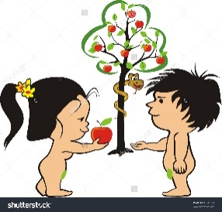
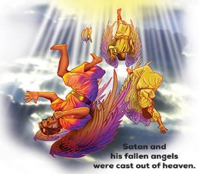

To begin...

Explain two religious ideas about the origins of evil.
Genesis 3:6-23 (include the punishments given to men and women for disobedience) + Revelation 12:7-12.

Augustine – on evil.

Augustine traced the origins of evil to those areas in the world that have free will; namely angels and human beings. As evil isn’t a substance, these beings could not have chosen to do an evil thing. According to Augustine, what was chosen was to turn their attention away from God, to things of lesser goodness.
The fallen angels led by Lucifer chose to rebel against God and were cast out of Heaven. Adam and Eve disobeyed God by eating fruit from the tree of knowledge of Good and evil and were cast out of the Garden of Eden. This misuse of free will unbalanced the harmony of God’s creation and led to the privation of goodness in the world that we call evil.
For when the will abandons what is above itself, and turns to what is lower, it becomes evil – not because that is evil to which it turns but because the turning itself is wicked.
Augustine, City of God, c.426.

Augustine – on suffering.

Augustine said that suffering is fully deserved as a consequence of human sin. The first sin caused the world to become distanced from God. In this remoteness from God moral evil flourished. Moral evil occurs because of the wrong choices that humans make when they disobey God’s commands. For example if people ignore God’s commands, ‘You shall not kill’, or ‘You shall not commit adultery’ suffering occurs as a result.

What about natural evil?
Natural evil is the consequence of moral evil as the rebellion of the fallen angels and the first humans disrupted the perfect and natural order of God’s creation. This disruption has prevented God’s creation from achieving its true nature. Since the original sin occurred there has been enmity between humans and other creatures. Humans would constantly have to battle to grow enough food. Pain, such as that during childbirth, entered the world, along with death.

Both types of evil are interpreted as a punishment: ‘All evil is either sin or the punishment for sin’. Augustine made the point that all humans, including supposedly innocent babies, deserve to suffer because all humans were present ‘in the loins of Adam’, reflecting the belief that every generation was seminally present in Adam. Every generation is therefore guilty because they inherit Adam’s guilt for disobeying God.

Explain...

- What did Augustine say were the origins of evil?
- How do the punishments given to man and woman, because of their disobedience of God, cause suffering?
- Why did Augustine say human suffering is deserved? Give an example.
- How does Augustine explain natural evil?

Augustine’s theodicy is often referred to as Soul-deciding which is the idea that humans have the choice to turn back to God, through the salvation of Jesus.

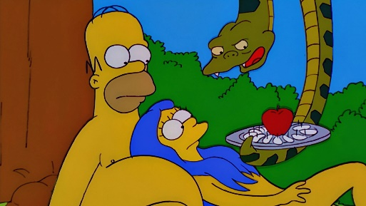
In summary; Humans were created perfect, humans have free will, humans used their free will to turn away from God (the Fall) and so God gave us the chance of reconciliation with God, though repentance and salvation through Jesus. If we choose to turn to God, we will be going to Heaven, but if we choose not to then we will go to Hell.

God has the right not to intervene and put a stop to evil and suffering since he is a just God and we are worthy of punishment. It is by his grace and infinite love however, that we are able to accept his offer of salvation and eternal life in heaven.

Augustine’s aesthetics argument.
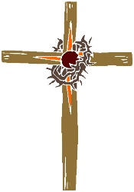
Augustine concluded with a reminder of God’s grace (love); if God were simply just, everyone would go to their rightful punishment in hell. Through God’s grace, Jesus was sent to die on the cross so some might be saved and sent to heaven. Augustine’s aesthetic argument states that the world only appears to be evil when parts of it are seen in isolation of the whole. In the context of the final judgement, when evil will be punished, wrongs will be righted and God’s grace will prevail, the totality of creation is perfect. Augustine writes, ‘the universe, even with its sinister aspects is perfect’.

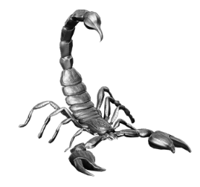
The problem of evil can therefore be seen as a problem of perspective. Humans by their nature have a limited perspective, judging things by their practical usefulness to themselves and other self-centred criteria. From this point of view evil is a reality. From the perspective of God’s omniscience, however, evil has no reality, for what we consider evil in fact magnifies the goodness of the whole. Augustine uses the example of a scorpion’s poison which is evil from its victims point of view but not from the scorpion’s point of view.

Explain...

- Summarise Augustine’s soul-deciding theodicy.
- Why does Augustine say God has a right not to intervene to end suffering and evil?
- Briefly explain Augustine’s aesthetics argument.

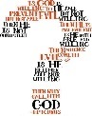
Explanations for the Existence of Evil & Suffering

Irenaeus’ Theodicy

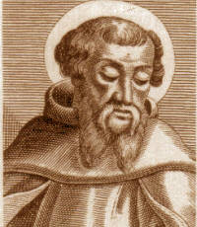
Irenaeus (c.130-200) was the Bishop of Lyons. Irenaean theodicy is ‘soul making’. His theodicy is concerned with the development of humanity.

Irenaeus based his theodicy on Genesis 1:26. He claimed there were two stages of human development. He distinguished between the ‘image’ and the ‘likeness’ of God. Humans are created in the image of God, not physically but sharing certain characteristics with God such as intelligence, consciousness and morality. From birth, humans begin a process of development to become like God. Humans were not created perfect, but with the potential to become perfect. Adam and Eve were expelled from the Garden of Eden because they were immature and needed to develop, they were to grow into the likeness (content) of God. They were the raw material for a further stage of God’s creative work.

The fall of humanity is seen as a failure within this second phase of becoming more like God in content.

Suffering is a necessary part of God’s created universe – it is through suffering that human souls are made developed. The world is a ‘vale of soul making’. Morality is developed through hard work, in this way morality is much more valuable than if it were pre-programmed, that would simply make us robots.

One of the ways in which this ‘test’ is carried out is through faith. God’s purpose cannot easily be discerned, but believers continue to believe despite the evidence. This faith becomes a virtue. John Hick calls this lack of understanding an ‘epistemic distance’.

To summarise Irenaeus' Theodicy:

- Humans were created in the image and likeness of God.
- We are in an immature moral state, though we have the potential for moral perfection.
- Throughout our lives we change from being human animals to ‘children of God’.
- This is a choice made after struggle and experience, as we choose God rather than our baser instinct.
- There are no angels or external forces at work here.
- God brings in suffering for the benefit of humanity.
- From it we learn positive values, and about the world around us.

Swinburne’s development.

‘We would never learn the art of goodness in a world designed as a complete paradise’ Swinburne claims that the virtues of compassion, generosity and selflessness are only possible in an imperfect world;

- Pain makes us feel compassion
- Poverty encourages us to be generous
- Corruption encourages selflessness.
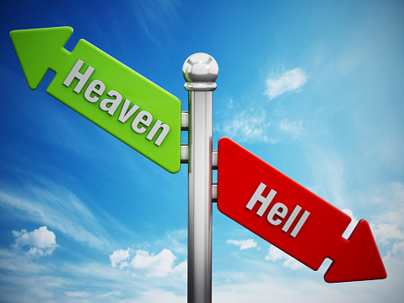
The world runs to a series of natural laws. These laws are independent of our needs, and operate regardless of anything. Natural evil is when these laws come into conflict with our own perceived needs.

Heaven and hell are important within Irenaeus’s Theodicy as part of the process of deification, the lifting up of humanity to the divine. This process enables humans to achieve perfection.

John Hick.

Hick developed Irenaeus’ theodicy with the idea of ‘soul-making’ – the process of moral growth. If God intervened, that would mean that there would be no human freedom. God created us with an epistemic distance – a distance in knowledge, making knowledge of God’s existence uncertain. If there was no distance we would act out of fear of judgement and punishment, rather than out of virtue.

Explain...

- Why do Ireanaeus and HIck describe this world as a ‘vale of soul-making’?
- What does Hick’s ‘epistemic distance’ mean?
- What is an epistemic distance important to Iranaeus’ theodicy?
- Summarise Ireanaeus’ theodicy.
- Explain Swinburne’s development of Iranaeus’ theodicy.

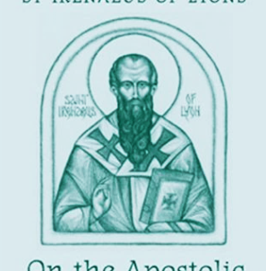

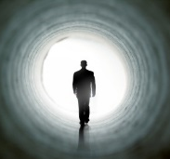
Problems with Irenaeus’ Theodicy

Irenaeus argued that everyone goes to heaven. This would appear unjust, in that evil goes unpunished. Morality becomes pointless. This is not orthodox Christianity. It denies the fall, and Jesus’ role is reduced to that of moral example.

Why should ‘soul making’ involve suffering? The ‘suffering is good for you’ argument seems unjust, especially in the suffering of innocents. Hume was critical: ‘Could not our world be a little more hospitable and still teach us what we need to know? Could we not learn through pleasure as well as pain?’ Swinburne argues that our suffering is limited, by our own capacity to feel pain, and by our lifespan.

Can suffering ever be justified on the grounds of motive? Suffering does not sit easily with the concept of a loving God. It seems difficult to justify something like the Holocaust with the concept of ‘soul making’.

Group Work...Criticisms of Iranaeus’ Theodicy.

Consider these questions…

- Is suffering the only way to create moral growth?
- Do the ends justify the means?
- Does suffering always result in moral growth?
- Is universal salvation fair?

Group Work...Criticisms of Augustine’s Theodicy.

Consider these questions…

- Could a perfect world go wrong?
- Was the world really made perfect?
- How could perfect beings choose to do wrong?
- Is it reasonable to say suffering isn’t a real thing?

