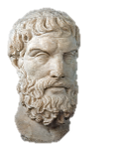
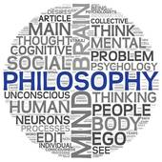
AS RS – The Problem of Suffering & Evil

To begin...

- Note down different examples of evil.

- From your examples highlight moral evils in one colour and natural evils in another colour.

- Which of these two types of evil do you think it would be harder for religious believers to accept? Give reasons for your answer.

The concept of Evil.

Evil is divided into natural and moral evil, although sometimes human actions can exacerbate natural evil, for example building homes on a flood plain.

The consequence of evil is suffering. Suffering involves mental anguish, physical pain and depression and the effects can be long lasting. Suffering often seems unjust, for example when the innocent suffer.

The Problem of Evil.

The effects of evil are obviously unpleasant for those affected by it. For religious people this poses a challenge to their faith, this challenge is known as the ‘problem of evil’. This is the problem of how an omnipotent; omniscient; omnibenevolent God could allow evil and suffering to happen to his creation without doing something about it.

Epicurus.

The classic formulation of problem of evil was devised by Greek philosopher Epicurus. His formulation is often referred to as the ‘Inconsistent Triad’.
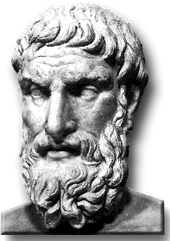
If an omnipotent, omniscient, and omnibenevolent god exists, then evil does not.
There is evil in the world.
Therefore, an omnipotent, omniscient, and omnibenevolent God does not exist.

The problem of evil is a particular problem for believers in the God of classical theism (the traditional Christian idea of God). The logical problem of evil argues that evil makes the existence of God impossible. The evidential problem of evil argues that evil makes the existence of God improbable.

The Logical Problem of Evil.

This argument suggests that the existence of evil is incompatible with the existence of God. As a result it is logically inconsistent to accept that both exist;

- As God created the universe out of nothing, He has total responsibility for everything in it. If He is omnipotent, He can do anything logically possible. This means he could have created a world free of evil and suffering and that, should he have allowed them to come about, He could end all evil and suffering.

- As God is omniscient, he has knowledge of everything, including suffering and evil, therefore he knows how to stop it.
- If God is omnibenevolent, He would wish to end all evil and suffering. J.L. Mackie claimed, ‘A wholly good being eliminates evil as far as it can’. No all-loving God would allow His creation to suffer for no reason. As God is omnipotent he could carry out his desire to end suffering.

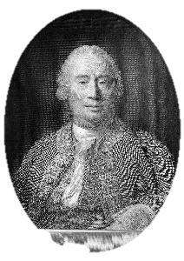
- David Hume argued that only two of the three qualities of God can exist alongside each other. Therefore either God is not omnipotent, or God is not omnibenevolent, or evil does not exist. Whilst the existence of evil has been questioned by some, Hume considered its effects are felt too widely to be dismissed. Therefore, accepting that evil exists he concluded that God must either be impotent or malicious. Either way, the means that God of classical theism cannot exist.

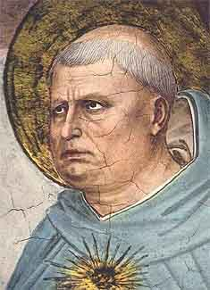
- For Aquinas, the concept of infinite goodness is an essential part of God’s nature, proof against this infinite goodness, is proof that God does not exist. Aquinas, however, differs from Hume in that Hume, an atheist, accepted this conclusion, whereas went on to reject it. Aquinas’ logical argument only works if, in talking about God’s goodness, we are referring to the same thing as human goodness, and assuming that what we call evil is incompatible with the goodness of God.

Epicurus…

Explain what Epicurus says about the existence of the God of classical theism.

Mackie…
Use a quotation to explain what Mackie says about the existence of the God of classical theism.

Hume…
Explain what Hume says about the nature and existence of the God of classical theism.

Use evidence…

Explain the philosopher’s views about the nature of God using examples of evil and/or suffering. Refer to both natural and moral evil.

Evaluate…
Do evil and suffering disprove God’s existence? Explain two reasons why it does and two reasons why it doesn’t.

The Evidential Problem of Evil.

The logical problem of evil argues that the existence of the God of classical theism is incompatible with what is known about evil and the suffering it causes. The evidential problem of evil argues that what is known about evil and suffering is evidence (rather than proof) against the existence of God, therefore God’s existence is improbable.

William Rowe

Rowe bases his case for atheism around the form of evil he refers to as, ‘intense human and animal suffering that occurs on a daily basis’. He accepts that if this evil and suffering resulted in some ‘greater good’, that could only be achieved by the presence of evil, then the resulting suffering might be considered justifiable. However, Rowe argues that this type of suffering is not all required for a greater good (much suffering seems pointless), therefore it is evidence against God’s existence.

