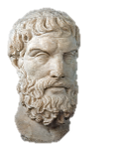
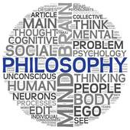
AS RS – The Problem of Suffering & Evil

To begin...

- Note down different examples of evil.

- From your examples highlight moral evils in one colour and natural evils in another colour.

- Which of these two types of evil do you think it would be harder for religious believers to accept? Give reasons for your answer.

The concept of Evil.

Evil is divided into natural and moral evil, although sometimes human actions can exacerbate natural evil, for example building homes on a flood plain.

The consequence of evil is suffering. Suffering involves mental anguish, physical pain and depression and the effects can be long lasting. Suffering often seems unjust, for example when the innocent suffer.

The Problem of Evil.

The effects of evil are obviously unpleasant for those affected by it. For religious people this poses a challenge to their faith, this challenge is known as the ‘problem of evil’. This is the problem of how an omnipotent; omniscient; omnibenevolent God could allow evil and suffering to happen to his creation without doing something about it.

Epicurus.

The classic formulation of problem of evil was devised by Greek philosopher Epicurus. His formulation is often referred to as the ‘Inconsistent Triad’.
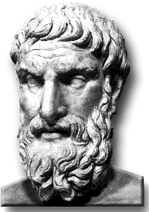
If an omnipotent, omniscient, and omnibenevolent god exists, then evil does not.
There is evil in the world.
Therefore, an omnipotent, omniscient, and omnibenevolent God does not exist.

The problem of evil is a particular problem for believers in the God of classical theism (the traditional Christian idea of God). The logical problem of evil argues that evil makes the existence of God impossible. The evidential problem of evil argues that evil makes the existence of God improbable.

The Logical Problem of Evil.

This argument suggests that the existence of evil is incompatible with the existence of God. As a result it is logically inconsistent to accept that both exist;

- As God created the universe out of nothing, He has total responsibility for everything in it. If He is omnipotent, He can do anything logically possible. This means he could have created a world free of evil and suffering and that, should he have allowed them to come about, He could end all evil and suffering.
- As God is omniscient, he has knowledge of everything, including suffering and evil, therefore he knows how to stop it.
- If God is omnibenevolent, He would wish to end all evil and suffering. J.L. Mackie claimed, ‘A wholly good being eliminates evil as far as it can’. No all-loving God would allow His creation to suffer for no reason. As God is omnipotent he could carry out his desire to end suffering.

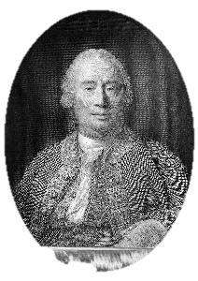
- David Hume argued that only two of the three qualities of God can exist alongside each other. Therefore either God is not omnipotent, or God is not omnibenevolent, or evil does not exist. Whilst the existence of evil has been questioned by some, Hume considered its effects are felt too widely to be dismissed. Therefore, accepting that evil exists he concluded that God must either be impotent or malicious. Either way, the means that God of classical theism cannot exist.

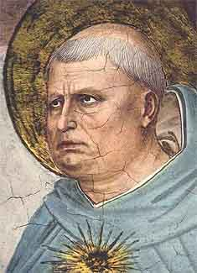
- For Aquinas, the concept of infinite goodness is an essential part of God’s nature, proof against this infinite goodness, is proof that God does not exist. Aquinas, however, differs from Hume in that Hume, an atheist, accepted this conclusion, whereas went on to reject it. Aquinas’ logical argument only works if, in talking about God’s goodness, we are referring to the same thing as human goodness, and assuming that what we call evil is incompatible with the goodness of God.

Epicurus…

Explain what Epicurus says about the existence of the God of classical theism.

Mackie…
Use a quotation to explain what Mackie says about the existence of the God of classical theism.

Hume…
Explain what Hume says about the nature and existence of the God of classical theism.

Use evidence…

Explain the philosopher’s views about the nature of God using examples of evil and/or suffering. Refer to both natural and moral evil.

Evaluate…
Do evil and suffering disprove God’s existence? Explain two reasons why it does and two reasons why it doesn’t.

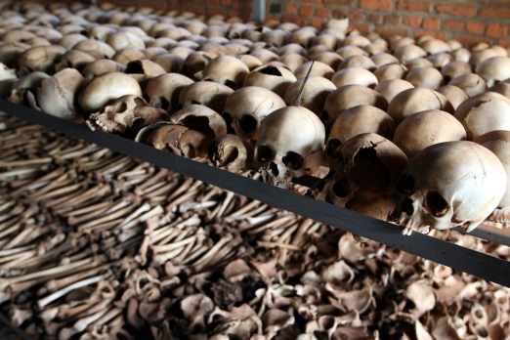

The Evidential Problem of Evil.

The logical problem of evil argues that the existence of the God of classical theism is incompatible with what is known about evil and the suffering it causes. The evidential problem of evil argues that what is known about evil and suffering is evidence (rather than proof) against the existence of God, therefore God’s existence is improbable.

William Rowe

Rowe bases his case for atheism around the form of evil he refers to as, ‘intense human and animal suffering that occurs on a daily basis’. He accepts that if this evil and suffering resulted in some ‘greater good’ that could only be achieved by the presence of evil, then the resulting suffering might be considered justifiable. However, Rowe argues that this type of suffering is not all required for a greater good (much suffering seems pointless), therefore it is evidence against God’s existence.
- Instances of intense suffering exist that an omnipotent, omniscient being could have prevented.

- An omniscient, wholly good being would prevent the occurrence of intense suffering, unless it could not do so.

- Therefore there does not exist an omnipotent, omniscient, wholly good being.

Rowe uses examples to illustrate his points;

Rowe explains that the five-year-old did not need to be raped and beaten before she was murdered even if her death was necessary for the greater good. All that was needed was for her to be killed quickly. This is also open to doubt because what good did her death bring as a result of this evil?
A young girl lives with her mother, her mother’s boyfriend and an unemployed man. The adults were drinking in a nearby pub. The boyfriend had been taking drugs and drinking heavily. He was asked to leave the pub early but the mother and lodger stayed in the pub. At 2am the mother went home and the lodger went to a party. The boyfriend was jealous and attacked the mother when she came in. He then passed out and the mother went to bed. Later the five year old little girl went downstairs to go to the bathroom. The lodger returns home from the party at 4am and found the little girl dead. She had been raped and beaten by the boyfriend.

Explain…

Explain the evidential problem of evil, referring to William Rowe.

Explain your own examples of unnecessary suffering explaining why this suggests the God of classical theism does not exist.

Is there ever a point to suffering? Explain with examples, suggesting how theists might respond to Hume and Rowes’ arguments that suffering and evil suggest God does not exist.

Similarly Rowe explains that the fawn could have died quickly rather than dying in agony. Rowe is arguing, therefore, that such evidence of unnecessary evil points to the non-existence of the God of classical theism.
In a forest lightning strikes a dead tree, which starts a forest fire. In the fire a fawn is trapped and is horribly burned. It lies in agony for several days before death relieves its suffering.

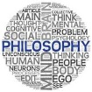
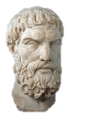
Religious Responses to the Problem of Evil

To begin...

Note down any reasons you can think of that theists might put forward to suggest suffering and evil do not prove God does not exist.

What is a theodicy?

A typical defence of against the problem of evil is that God’s goodness is a different concept from our own, and that as a temporary part of his plan his goodness might allow him to tolerate the existence of what we consider to be evil. In this case there is no contradiction in supposing that God is omniscient, omnipotent and omnibenevolent, and has a reason for evil to exist. A number of philosophers have come up with theodicies to explain what reason this might be.

‘Theodicy’ literally means the ‘justice of God’. When applied to the problem of evil it is more helpful to think of it as ‘justification of God’. A theodicy seeks to explain the existence of evil and at the same time retain the three attributes of the God of classical theism. These have included considering evil and suffering as an illusion.

Augustinian Theodicies.

St Augustine (354-430) based his arguments on the Bible, in particular the Creation and Fall accounts in Genesis, and on philosophical tradition. His theodicy is based on two major assumptions;

- Evil did not come from God since God’s creation was faultless and perfect.

- Evil, having come from somewhere else, God is justified in allowing it to stay.

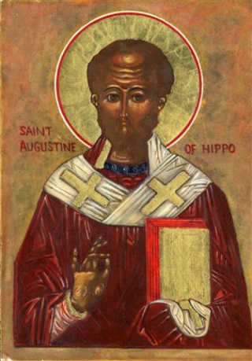
Augustin converted from Manichaeism to Christianity, this would influence his theodicy. Manichaeism taught that two opposing natures existed - light (good) and dark (bad), both of equal power. A human is the battle ground for the power of light and darkness; the good is the soul, and the dark is the body. The soul is incorruptible and is under domination from the body. Humans are said to be saved if they come to know and identify themselves with their soul. Matter is evil and traps the human spirit, but there is said to be a divine ‘spark’ which must escape the material world to join the Ultimate Good.
Augustine rejected the dualism of Manichaeism in favour of the God of classical theism. However he took the Manichaeism concept of Good as that which brings tranquil pleasure associated with God’s creation, and the dark becomes the evil which disrupts the harmony of creation. However, God preserves the order in his creation. Wickedness and mortality in Manichaeism, become ‘sin’ and the punishment for Augustine. Humans inherit sin as a punishment for the original sin of Adam and Eve therefore personal evil is inevitable.

