BD05729_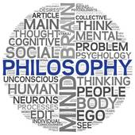

**AS RS - What is Religious Experience?**

# Starter Task.

1. Write down two statements that you believe to be true as a direct result of your own experience or that of other people.
2. Would you be as happy to believe the statements if you had not had the experience yourself but heard about it from someone else? Explain your answer.
3. What do you think might affect your decision whether or not to believe something other people do not believe?

Personal Experience.

BD07491_We often rely on our own experience to decide whether something is true or not. If we have seen, heard or experienced something, we accept the ‘truth’ of whatever that may be. The term ‘religious experience’, conjures up many diverse images and ideas. It could mean anything from saying a prayer to worshipping, to ‘hearing the voice of God’.

# Task One.

Read the abridged version of Acts 2: 2-46 and complete the tasks (overleaf).

# Task Two.

1. Write a definition of the term ‘religious experience’ from what you have learnt.

Religious Experience.

* A religious experience is a non-empirical occurrence and may be perceived as supernatural.
* It can be described as a ‘mental event’, which is undergone by an individual.
* Such as experience can be spontaneous or it may be brought about through intense training and self-discipline.
* BD07708_People who claim to have had religious experiences usually say what has happened to them has ‘drawn them into’ a deeper knowledge or awareness of God.
* An experience is not a substitute for the divine, but a vehicle that is used to bring people closer to God.
* The experience that each individual has is unique.
* ‘Genuine’ religious experiences seem to be positive; they do not condemn the individual but help them to live a better live or help others.
* Experiences are sometimes ineffable – cannot be explained; beyond human words.



Task three - Signs of a religious experience...

Use pictures to explain and outline eight signs of religious experience.

BD05729_

**Types of Religious Experience**

*Different types…*

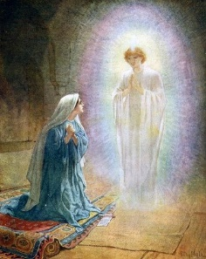

* Propositional – knowledge revealed directly from God; fits in with the

teachings of the Church.

* Non-Propositional – believers recognise God in human history and in

nature; indirect revelation of God, faith is needed to believe such

experiences.

* Mediated – experiences through rituals, special people, objects and the natural world.
* Immediate – God is experienced directly with no intervention.
* Mystical - Most religious experiences are said to be *mystical*. This means the recipient feels a sense of union with the divine.
* Prayer - Many religious experiences are classed as *prayer* experiences. This refers to experiences brought about by prayer and meditation.
* Conversion - The effects of religious experiences are often permanent and life changing. Such experiences are often classified as *conversion* experiences.

The development of religious belief and worship over the past hundred years has placed an increasing emphasis on the idea that one can experience and communicate with God.

Task four - Example of a religious experience...

1. Use pictures to outline the story of Paul.
2. Explain, with reasons what type(s) of religious experience this was.

Religious Experience as an Argument for the existence of God.

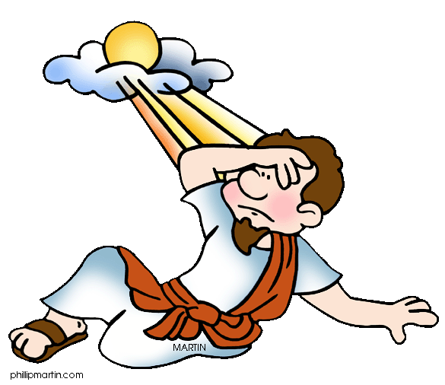

As we have seen religious experiences are claims of a personal experience with God and they can take many forms from prayer to a revelation via an angel from God himself or a miracle. Most people are likely to believe something if it has been experienced. Most people are likely to believe something if it has been experienced therefore for people that have had these experiences, God exists.

Another way of ‘proving’ a religious experience are the effects that experience. Saul/Paul is a good example. Saul was a Jew who persecuted Christians, he had an experience of Jesus and as a result converted to Christianity. He went on to travel across the Roman Empire spreading the Christian faith and setting up churches. Several books of the New Testament document these travels. Paul became a martyr when he was executed in Rome for refusing to deny his Christian faith. Such an extreme conversion suggests Paul must have been certain that his experience was genuine and therefore God exists.



Task five - Can religious experiences prove that God exists?

Explain an answer to the above question including an example in your answer.

There is not one grace of the Spirit of God, of the existence of which… Christian practice is not the most decisive evidence. The degree in which our experience is productive in practice shows the degree in which our evidence is spiritual and divine.

Jonathon Edwards, Treatise on Religious Affections (1985).

BD08228_

Edwards is suggesting that experience of God is the best evidence we have that He exists. The evidence for such experiences is not empirical or logical, but spiritual and divine. He is also suggesting that it is the effects of the experience are evidence of the spiritual and divine nature of the experience.

Task six - Examples of religious experiences...

1. Note down and explain the key part of Jonathon Edward’s quotation.
2. Read the different examples of religious experiences. Choose 3 of the examples to complete a table giving brief descriptions, useful quotations and evidence for proving the existence of God.
3. Make comparisons (common elements + differences) between the experiences you have looked at. You could do this as a triad diagram.



**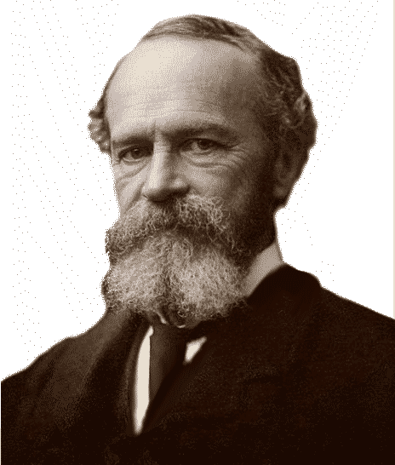William James (1842 – 1910).**

James is probably the most famous commentator on religious experience. He was an American doctor, not a theologian, but he had a deep interest in philosophy and psychology. His most famous work *The Varieties of Religious Experience (1902)* was originally a series of lectures given at Edinburgh University.

BD05245_

In the first of his lectures James distinguished between *existential judgements* (the primary questions concerning the ‘what’ & ‘how’ questions – origins, content, reality and function) and *value judgements.* (the ‘why’ questions, concerning meaning, importance and significance). He suggested that value judgements could also be considered as *spiritual judgements* as they involved our personal interpretation. The distinction between existential and value/spiritual judgements is important when considering religious experience as we are essentially asking two questions:

* What happened?
* What does it mean?

Task seven.

1. Apply James’ existential judgements and value judgements to one of the religious experiences we have looked at.
2. Does considering these judgements help to ‘prove’ religious experiences or the existence of God? Explain your answer with evidence.

James was aware that many people during the late nineteenth and early twentieth centuries were happy to dismiss alleged religious experiences as a product of a ‘faulty’ mind. This is a view that people still have today and James also accepted this view, but saw no problem with it. He spoke of ‘religion and neurosis’ as perfectly compatible, and to some degree, necessary partners. He said;

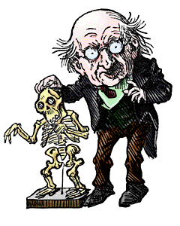

In the natural sciences and industrial arts, it never occurs to anyone to refute opinions by showing up their author’s neurotic constitution.

William James. The Varieties of Religious Experience (1902).

There are many advocates of different branches of scientific understanding that would be unhappy by James’ suggestion. In defence of his point James quotes Dr H.M. Maudsley.

What right have we to believe nature (which could be read in context as God), under any obligation to do her work by complete minds only? She may find an incomplete mind a more suitable instrument for a particular purpose.

Dr H.M. Maudsley in William James’ Natural Causes and Supernatural Seemings (1886).

# Task eight.

1. Explain the meaning of James’ terms; *existential judgements* and *value/spiritual judgements.*
2. What was James saying about how we should view someone’s claim that they have had a religious experience?
3. *Medical Materialism* is an approach to medical science to aims to classify everything in physical terms. How do you think a ‘medical materialist’ would explain the experience of St. Paul on the road to Damascus?



‘The Reality of the Unseen’.

In a later lecture, James considers many testimonies of people who have claimed to have had religious experiences. It is the *sheer certainty* in these testimonies that is most compelling.

God surrounds me like the physical atmosphere. He is closer to me than my own breath. In Him, literally, I live and have my being.

*I have the sense of a presence, strong, and at the same time, soothing, which hovers over me. Sometimes it seems to enwrap me with sustaining arms.*

William James, The Varieties of Religious Experience, 1902.

Some would question both the nature of these ‘experiences’ and any attempt to use them as evidence for the existence of God. James defends their credibility;

These feelings of reality … are as convincing to those who have had them as any direct, sensible experiences can be, and they are, as a rule, much more convincing that results established by mere logic ever are.

William James, The Varieties of Religious Experience, 1902.

Induced Experiences.

Some experiences could be confused with the effects of consuming alcohol or drugs. James also recognised this;

j0092787

The drunken consciousness is one bit of the mystic consciousness, and our total opinion of it must find its place in our opinion of that larger whole.

William James, The Varieties of Religious Experience, 1902.



It seems apparent, then, that mystical experiences are states of consciousness, which are either spontaneous or induced. Whilst ‘under the influence’, mystics feel a greater depth of understanding. Although this understanding may be lost as the influence fades, a sense of profound feeling is retained. No matter what ties may connect different people – social, cultural or religious, their experiences are unique.

# Task nine.

Consider any powerful emotion – love, hate, joy, jealousy. These feeling often seem irrational or illogical.

a) Do we accept the reality and results of these feelings? Why do you think this is, or, is not the case?

b) How can such a consideration help in an assessment of religious experience as evidence for the existence of God?

c) How might a prior belief in God affect your understanding of an apparent religious experience?

The Conclusions of William James.

Looking at the conclusions James came to, we can find out how he saw people’s religious experiences as potential evidence for the existence of God. James said that religious life centred on certain beliefs;

* BD07744_The world we see around us is part of something much bigger (something spiritual), which we consider to be very important.
* Union with that spiritual ‘something’ is our ultimate purpose.
* Communication/prayer with that higher spiritual thing is something, which produces real effects and enables real work to be done.

He also said that religious experience produces the following results;

* A new enthusiasm for life, often leading to profound and significant changes.
* A sense of peace and security and of great love for others.

The significant thing about all these ideas is James’ emphasis on the *reality* of the experiences and their effect.

Many people argue that because there are so many different faiths in the world, religious experiences cannot be authentic. People who encounter these experiences portray the being revealed to them differently. For example stigmata is linked with Jesus, Muhammad’s revelation was a message from Allah. James rejects this objection;

I do not see how it is possible that creatures (people) in such different positions (places and cultures) and with such different powers… should have exactly the same functions and the same duties. No two of us have the same difficulties, nor should we be expected to work out identical solutions.

William James, The Varieties of Religious Experience, 1902.

j0158055

People have also pointed out that religious experience is very like emotion – it is personal response, which means that any form of empirical testing is useless. James countered this in two ways. Firstly he sees no problem with the fact that religious experience can be considered as emotion. He says that it is only the theories of religions that make them different. The feelings and the conduct inspired by those feelings are remarkably similar. As emotions and feelings are an integral part of religion, James considered it perfectly reasonable to accept it as ‘evidence’.

The feelings on the one hand and the and the conduct on the other are almost the same for Stoic, Christian and Buddhist saints, are practically indistinguishable in their lives.

William James, The Varieties of Religious Experience, 1902.

# Task ten.

1. If someone said to you ‘I know God exists because I have seen him’, you would naturally be suspicious. What questions might you ask the person to try to validate their experience?
2. Explain how James argued against those who claimed that religious experiences could not be authentic because there are many different religions? What are the implications of this?

j0124743The Science of Religion.

James disputed the idea that science cannot be used when considering religion. He suggests that one can investigate the ‘science of religion’ by considering different hypotheses. Regardless of which religion is being studied James said we would always find two universal areas;

* A certain uneasiness, (a feeling that there is something wrong with us).
* The solution to this, (the way in which we can be saved from this ‘wrongness’).

BD07236_

James argues that they way we find this solution is that we become conscious of a being ‘higher’ than us. He goes on to say that this ‘higher’ being may be thought of (in psychological terms) as our subconscious self. James claimed that the ‘doorway’ to this ‘higher’ being/self was religious experience in the form of mysticism, prayer and conversion. He pointed out that, even scientifically, there could be no doubt that some of the effects of this alleged involvement of the higher being in peoples’ lives were real. He concluded;

That which produces effects within another reality must be termed a reality itself, so I feel as if we had no excuse for calling the unseen or mystical world unreal.

William James, The Varieties of Religious Experience, 1902.

In other words the cause of the experiences which people seem to have, and are undoubtedly affected by, is *real*; if that cause is believed to be God, then God exists.

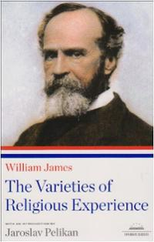Religious Experiences are good for your Health!

James also concluded that things that are true tend to lead to *‘consistency, stability, and flowing human intercourse’.* Put another way, if something is real and true, it is likely to improve a person’s life, whereas that which is false is more likely to restrict and damage a person’s life. James noted that those who claimed to have had a religious experience seemed to be more generally fulfilled and purposeful in their understanding of the world and their place in it, that those who subscribed to atheist theories.

**James summed up religious experiences by giving four distinct descriptions (PINT):**



P: passivity - you are not in control of the experience

I: ineffable - the experience cannot be described in human language

N: noetic - the experience leads to a greater understanding

T: transient - the experience is temporary

# Task eleven.

1. How might an atheist interpret the testimony that someone had had a religious experience?
2. Explain James’ main conclusions that religious experiences were potential evidence for the existence of God.
3. Why did James say it was acceptable to use emotions and feelings as evidence of religious experience?
4. How did James dispute the idea that science cannot be used when considering religious experiences?
5. What affect did James claim religious experiences have on peoples’ lives?
6. How might this suggest proof of God’s existence?

**Philosophers on Religious Experience**

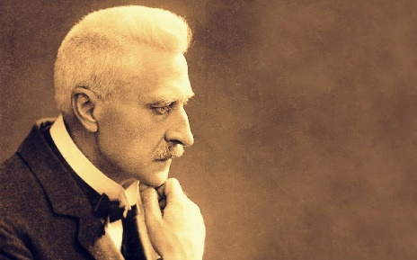**Rudolf Otto**

Rudolf Otto (1869 - 1937) was an eminent theologian and religious scholar. Based on his research and observation, Otto developed the notion of the “numinous” to express the reality of the sacred as the defining element of religious experience. Otto stressed the unique and essentially non-rational nature of religious reality.

*The Idea of the Holy - The Sacred and the Numinous.*

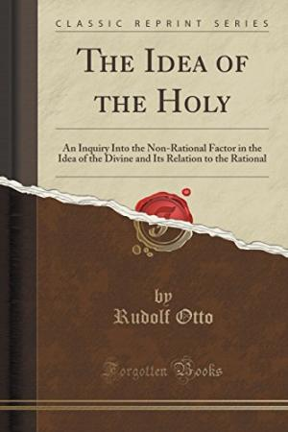Otto's most famous work was, ‘The Idea of the Holy’. The book’s title, is followed by the sub-title, “On the irrational element in the Idea of the Divine and its relationship to the rational element”—which clearly reflects Otto’s intent to account for both elements in defining the Sacred. Otto concludes that none of the notions used to define the Sacred in terms of human qualities, such as goodness, even heightened to the utmost degree, was adequate to describe it. Otto coined the expression of the numinous to describe the unique, different content of the religious experience—one that could not possibly be expressed in rational language, but only described analogically through “ideograms” or symbols.

*The Wholly Other*

The numinous element was linked to the notion of the Wholly Other—that which transcends all our rational understanding and imposes itself upon perceptive human beings. Otto’s perspective did not apply only to the Christian faith, but to all world religions. Rather, large portions of his main work consist of detailed descriptions of how the numinous or Wholly Other manifests itself in the world’s various religious traditions.

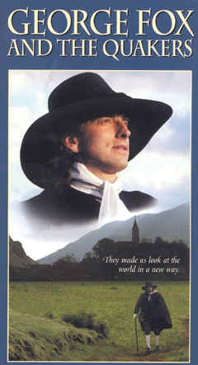*The mysterium tremendum et fascinans*

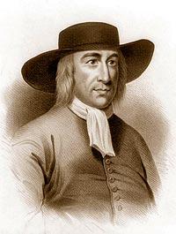To further define the content of the numinous, Otto uses the equally famous expression of the mysterium tremendum et fascinans, the mystery that is both awe-inspiring and fascinating. In many ways, the experience of the “trembling” is the quintessential religious experience, one that touches the believers directly.

Otto presents the tremendum component of the numinous experience as having three elements:

* Awefulness – inspiring awe, a sort of profound unease.
* Overpoweringness – that which, among other things, inspires a feeling of humility.
* Energy or urgency – creating an impression of immense vigour, compelling.

The mysterium component has two elements:

* The wholly other – totally outside our normal experience.
* Fascination – causes the subject of the experience to be caught up in it.

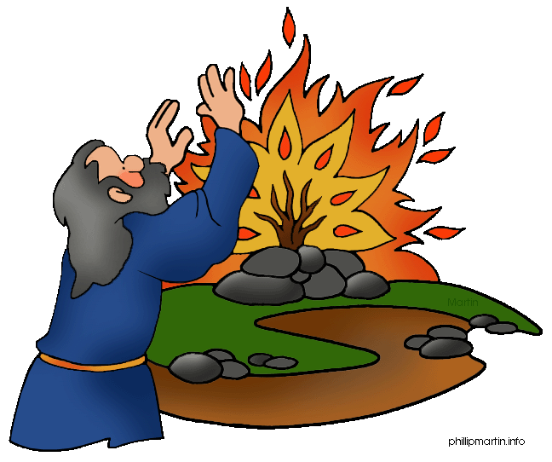Examples Otto used to illustrate his theories include the experience of Moses at the Burning Bush in Exodus 3:6. Another example would be George Fox and the religious experience he had that led to the foundation of the Quakers (Religious Society of Friends).

*Divination*

What Otto calls divination is precisely the quality, developed by some and missing in many, to perceive the manifestation of the Divine or, as Christians would put it, listen to the testimony of the Holy Spirit. The “natural man,” says Otto, is totally closed to that realm of the human mind and is thus unable to understand the essence of religion.

*Appraisal and response*

Most recently, the scholar, Ninian Smart acknowledged Otto, while making a difference between the numinous experience and the mystical experience. For Smart, the numinous is typical of theism, where God is perceived as an other-worldly, towering presence, while the mystic consciousness, typical of Buddhism, represents and inward experience of oneness with the transcendent. But, as Smart himself acknowledges, the two are often interconnected.

# Task twelve.

1. Why did Otto coin the expression of the ‘numinous’?
2. Explain Otto’s idea of ‘The Holy Other’.
3. Explain the tremendum and mysterium components of the numinous experience.
4. Look up Exodus 3:6. Explain how Moses’ experience illustrates Otto’s theories.
5. What does Otto’s term ‘divination’ mean?
6. Explain how a religious experience can be mystical and numinous, and how this can mean religious experiences can apply to any religion.
7. Use Otto’s arguments to suggest that God exists.

**Richard Swinburne**

**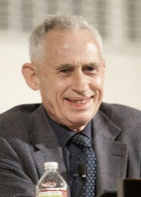**

**Richard Swinburne believes that religious experiences help prove the existence of God. He believes that it is important to categorise the two types of experience:**

*Public experiences*

Ordinary, interpreted experiences such as the beauty of the sky.

Extraordinary experiences, such as Jesus walking on water.

*Private experiences*

Experiences that are describable in normal language.

Experiences that are ineffable (cannot be explained in language).

More importantly, Swinburne puts forward two principles to support the argument for religious experience:

The Principle of Credulity - if someone appears to be present, it makes logical sense to say that they are so, unless the observer is under particular circumstances (intoxicated, has a mental illness etc.)

However, some argue that religion itself is a particular circumstance, and that you are more likely to see things which aren't there if you belong to a religious group.

The Principle of Testimony - it makes sense to believe what people tell you, since the majority of people tell the truth.

However, this can be criticised as a view that is far too optimistic and idealistic for mankind.

Swinburne also argues for the priory probability argument, whereby he states that the probability of the existence of a cosmological God is higher than that of, say, the existence of UFOs, so the likelihood should be taken seriously.

Antony Flew criticises Swinburne's prior probability argument, accusing him of simply adding up theories to create a 'cumulative case'. Using the analogy of ten leaky buckets, Flew stated that arguments for God make a 'bucket', but the flaws of all these arguments put holes in the buckets; it is pointless trying to fill up a bucket with holes in it!

# Task thirteen.

1. Explain how Swinburne categorises religious experiences.
2. Outline Swinburne’s two principles in support of religious experiences.
3. Explain how Swinburne’s arguments could lead to proof that God exists.
4. Suggest criticisms for Swinburne’s arguments.

**John Hick**

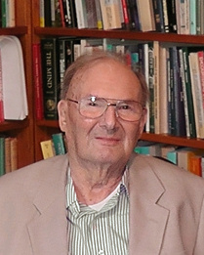

Instead of describing faith as propositional assent to certain beliefs, Hick describes faith as the interpretive element in religious experience or “experiencing-as”—experiencing the world as not only natural and ethical but as the sphere of the religious as well. His book, ‘Faith and Knowledge’, rather than demonstrating that God does in fact exist, Hick’s aim is to describe how God is known to humans, if God does exist, and how such knowledge relates to other forms of human knowledge. According to Hick, the difference between faith and other forms of knowledge is the level of reality known.

In arguing for his experience-based understanding of faith, Hick argues that for the ordinary believer, religious knowledge is gained by experiencing God for oneself. Religious knowledge, then, is mediated through our experience of the world, in much the same way that the rest of the knowledge we have about the world is gained. Hick calls this aspect of our human experience of the world “significance,” which he further defines as “that fundamental and all pervasive characteristic of our conscious” as the “correlative mental activity by which [significance] is apprehended,” stating;

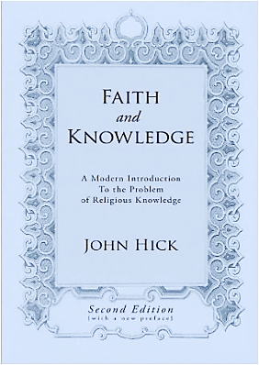*We shall find that interpretation takes place in relation to each of the three main types of existence....the natural, the human, and the divine; and that in order to relate ourselves appropriately to each, an act of interpretation is required which, when directed toward God, has traditionally been termed “faith.” Religious interpretation is thus a perception of significance rather than an inference from or to certain propositions.*

As Hick further explains*…*

*the primary religious perception is not to be described as either a reasoned conclusion or an unreasoned hunch that there is a God. It is, an apprehension of the divine presence within the believer’s human experience. It is a “divine-human encounter,” a mediated meeting with the living God.* (FK, 115)

Religious interpretation, as Hick argues, becomes evident that every experience of the world—natural, ethical, and religious—involves an act of interpreting significance. Religious interpretation is simply the highest order of experiencing the world.

Hick summarizes his argument for the possibility of religious experience, stating, “The human person is more than a physical organism, and it cannot be excluded that there may be a non-physical supra-natural reality, perhaps of the limitless significance that the religions claim, and also an answering non-physical aspect of our own nature”. He thus invokes the principle of critical trust, in which we take our experiences to be true unless and until there is reason to reject their reality. He notes that we all live by the principle of critical trust in our everyday experience of the natural world.

# Task fourteen.

1. Explain how Hick suggests religious knowledge is gained.
2. Use a quotation from Hick’s publication, ‘Faith and Knowledge’, to make an argument for God’s existence.
3. Summarise the basis of Hick’s argument for religious experience.

**Michael Persinger**

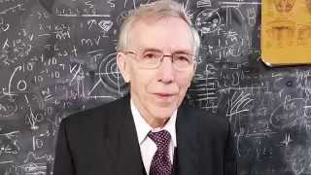

Michael A. Persinger (born 1945) is a cognitive neuroscience researcher. He is primarily notable for his experimental work in the field of neurotheology, work which has been increasingly criticized in recent years.

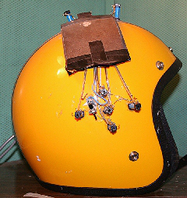*Research in neurotheology – The God helmet*

During the 1980s Dr. Persinger stimulated human test subjects' temporal lobes with a weak magnetic field, to see if a religious state can be induced. Persinger claimed that properly tuned magnetic fields can produce the sensation of "an ethereal presence in the room".

The God Helmet was not specifically designed to elicit visions of God, but to test several of Persinger's hypotheses about brain function, to study creativity, religious experience and the effects of subtle stimulation of the temporal lobes. Persinger reports that many subjects have reported "mystical experiences and altered states" while wearing the God Helmet.

The God Helmet experiments were used to validate the idea that religious and mystic experiences are artefacts of temporal lobe function.

Persinger theorises that many paranormal experiences, feelings of having lived past lives, felt presences of non-physical beings, ghosts and other "spiritual beings", are examples of interhemispheric intrusions.

This research has received wide coverage in mainstream media, with high profile visitors to Persinger's lab Susan Blackmore (famous for investigations of near death experiences) and Richard Dawkins reporting positive and negative results respectively.

The first published attempt to replicate these effects failed to do so and concluded that subjects' reports correlated with their personality characteristics and suggestibility.

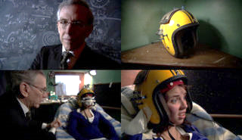Other researchers succeeded in replicating the effects of one of Persinger's early studies. They reported that their experiment had ruled out suggestibility as an explanation for Persinger's effects, and that analysis of their subjects’ verbal reports revealed significant differences between those of subjects and controls, and also less robust effects for suggestion and expectation. However, the psychologist Richard Wiseman has written that the "scientific jury is unconvinced".

*Geomagnetic Theories*

Persinger has also come to public attention due to his 1975 Tectonic Strain Theory (TST) of how geophysical variables may correlate with sightings of UFOs or Marian apparitions. Persinger argued that strain within the Earth's crust near seismic faults produces intense electromagnetic (EM) fields, creating bodies of light that some interpret as glowing UFOs or The Virgin Mary. Alternatively, he argued that the EM fields generate hallucinations in the temporal lobe, based on images from popular culture, of alien craft, beings, communications, or creatures.

# Task fifteen.

1. Explain the purpose of the ‘God Helmet’.
2. What did Persinger claim were the results of the God Helmet experiments?
3. Explain how Persinger suggests religious experiences could be a result of seismic faults.
4. Suggest some criticisms of Persinger’s theories.

**Richard Dawkins.**



Dawkins states that such experiences boil down to nothing more than that the brain is good at interpreting external data, even random inputs like wind blowing through a keyhole, and making it into something meaningful.

He assumes that the fact that one can explain some phenomena in one way means that that way must be correct.

Dawkins’ main argument against the existence of God is based on evolution and what he calls his ‘Ultimate Boeing 747’ idea. He dismisses the idea that the universe could have been created and designed by a Supreme Being because that Being would need to be even more complex, even more intricate than the universe he created – in other words God would need to be even more complex than the laws of physics, or the human brain or a virus or a Boeing 747.

Dawkins argues that such a complex God explains nothing, because something else is then required to explain how such a complex God could himself arise. Dawkins draws his conclusion based on his own experience of the world and his belief that complex things can only arise from simple things through natural selection or the laws of physics.

*Criticisms*

But Dawkins has no experience of things that occur outside of the known universe. It is just not valid to dismiss the possibility of a creator God in this way. Something had to exist ‘in the beginning’ – even if it was just the laws of physics or the quantum singularity. Dawkins is like the eighteenth century Indian maharajah who stated categorically that it was impossible for water to support the weight of an elephant walking across a river. Of course, he had never seen ice – it was simply something that was completely outside of his experience of the tropical climate of India. In the same way, the possible origin of the universe is outside our direct experience, limited as we are to living within it.

For example, consider the subsection entitled, "The Argument from Personal Experience." Although Dawkins doesn't dispute the phenomenon of people having religious experiences, Dawkins doesn't ever present an actual philosophical argument about the reliability of religious experience which he can then rebut. He simply says that people claim their so-called religious experiences as proof of a supernatural God and then summarily discounts any and all religious experiences, whether individually or group witnessed; at best, they are misinterpreted optical or aural illusions. He writes:

This is really all that needs to be said about personal "experiences" of gods or other religious phenomena. If you've had such an experience, you may well find yourself believing firmly that it was real. But don't expect the rest of us to take your word for it, especially if we have the slightest familiarity with the brain and its powerful workings.

# Task sixteen.

1. Explain why Dawkins says religious experiences are not a real phenomenon and how this leads to a belief that God does not exist.
2. What are some of the criticisms of Dawkins arguments?

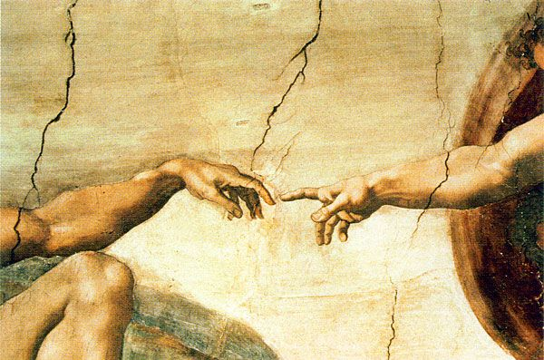

**Freud & Marx on Religious Experience**

Freud and Marx both rejected the idea that religious experiences prove that God exists and both provide alternative theories for what religious experiences are.

**Sigmund Freud (1856 – 1939).**

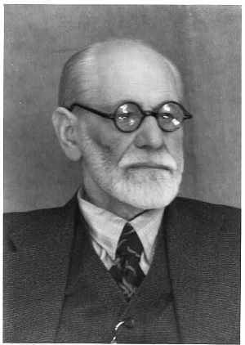

Freud believed that if we could understand everything about the physical and biological side of life we would fully understand human beings. This rules out a metaphysical existence and the existence of a soul. Freud believed that the urge people felt for religion was no more than a psychological obsession.

Freud saw religious experiences as illusions. He believed that they were projections of the ultimate, oldest and profound ideas that people had. For example, if someone claimed to have ‘been on the cross with Jesus’, a Christian who accepted mystical experiences might have no problem with the claim at face value. Freud would claim that the recipient of the experience was simply projecting his or her ultimate beliefs about suffering, helplessness and separation along with salvation, hope and the desire to be united with one’s parent (in this case, portrayed as God). As Freud was not concerned with the truth of religious claims he obviously dismissed religious experiences as evidence for the existence of God.

**Karl Marx (1818 – 1883).**

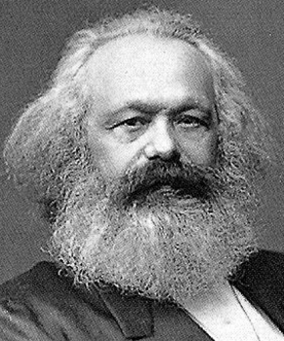

Marx was influenced by two philosophers – Hegel and Feuerbach. Hegel believed there was an ‘*absolute spirit’* working throughout history to bring humanity to its ultimate fulfilment. Feuerbach rejected this idea, believing that the ideas of religion are produced by men because they are dissatisfied or ‘*alienated*’ in their practical lives. Therefore they need to believe in the ‘*fantasy*’ of religion. Marx went on to describe religion as *‘the opium of the people.’*

Marx was forced out of Germany and went to Paris in 1843, then to Brussels in 1845. During this period he formulated his ‘*Materialistic Theory of History’*. This stated that ‘alienation’ was not metaphysical or religious but really social and economic.

Marx considered God as an imaginary projection of people’s needs and the qualities that people thought were the most important (moral perfection, omnipotence, omniscience, pure love etc). Therefore if someone claimed to have an experience of God, Marx would argue that it was not the case that some ultimate power had chosen to contact them. Rather, the person in question was someone (consciously or unconsciously) was absolutely intent on reflecting on their own needs as a human being and the perfections that they ultimately desired. In other words, religious experiences and even religion itself were purely illusory.

# Task seventeen.

1. Explain why Freud thought why religious experiences were not evidence for the existence of God.
2. Why do you think Marx described religion and ‘the opium of the people.’
3. What does this suggest about Marx’ beliefs about the validity of religious experiences and the existence of God?

**Can Religious Experience prove that God exists?**

**Arguments for…**

* Many people are more likely to believe something if it has been experienced. Experience of God is the best evidence we have that God exists.
* Richard Swinburne’s principle of credulity states “If it seems to a subject that X is present, then probably X is present; what one seems to perceive probably is so” Therefore, if a person believes God was present we should accept what a person experiences unless you can prove otherwise.
* Swinburne’s principle of testimony Swinburne appeals to a basic rational and verifiable idea - that people usually tell the truth. The principle of testimony suggests that we should accept the statement of what was experienced unless we can demonstrate positive grounds showing it to be mistaken.
* William James observes that religious experiences tend to have a profound effect on the lives of people and even whole societies, implying that such effects cannot reasonably be attributed to hallucinations. Instead, it is much more reasonable to believe that a real God is responsible for religious experiences than to attribute the profound effects of those experiences to a mere imaginary being.
* James also argues that normal people have religious experiences and, since ‘seeing is believing’, then God — as the object of religious experiences — must be real.



* There are a countless number of people throughout the world claiming to have had a religious experience. For many, the sheer amount of testimony is proof that God is responsible for the experience and therefore probably exists.

**Arguments against…**

* The finite cannot experience the infinite which means it is impossible for a human to experience God. God is not material, He has no body therefore it is impossible to prove the existence of something we cannot experience.
* Religious experiences are regarded as subjective because no objective criteria can be applied to them in order to judge to their authenticity. A subjective experience cannot be offered as ‘scientific’; that is, as empirical or intellectual proof which means we can’t prove God’s existence.
* Individuals rather than groups undergo religious experiences. As a result, we only have one person’s testimony as to what has happened. We cannot corroborate the account so cannot accept if it is true.
* In many cases, drugs or alcohol can produce very similar effects to a religious experience. We also have physiological problems such as temporal lobe epilepsy. Therefore, it is difficult to prove the source of the experience to be God.
* People argue that just as you can encounter a table, you can also encounter God, but the two are very different. E.g. God is not material, nor does he have a definite location. Also, claims can be checked of encounters with objects, but when the object is God, they are not verifiable.