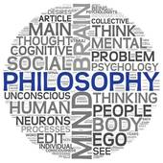

**St. Teresa of Avila**

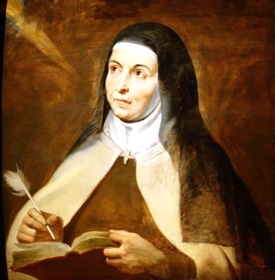

Saint Teresa of Ávila, also called Saint Teresa of Jesus (28 March 1515 – 4 October 1582), was a prominent [Spanish mystic](https://en.wikipedia.org/wiki/Spanish_mystics), [Roman Catholic](https://en.wikipedia.org/wiki/Roman_Catholic) [saint](https://en.wikipedia.org/wiki/Saint), of contemplative life through [mental prayer](https://en.wikipedia.org/wiki/Mental_prayer).

Her books, which include her autobiography (*The Life of Teresa of Jesus*) and her influential work [*El Castillo Interior*](https://en.wikipedia.org/wiki/El_Castillo_Interior) (*The Interior Castle*), are an integral part of [Christian mysticism](https://en.wikipedia.org/wiki/Christian_mysticism) and [Christian meditation](https://en.wikipedia.org/wiki/Christian_meditation) practices.

When Teresa was 14 her mother died, Teresa was grief-stricken. This prompted her to embrace devotion to the [Virgin Mary](https://en.wikipedia.org/wiki/Virgin_Mary) as her spiritual mother. Teresa was sent for her education to the [Augustinian](https://en.wikipedia.org/wiki/Augustinian) nuns at [Ávila](https://en.wikipedia.org/wiki/%C3%81vila,_Spain). In the monastery she suffered greatly from illness. In her sickness, she experienced periods of religious ecstasy.

She claimed that during her illness she rose to the "devotions of ecstasy" - perfect union with God. During these experiences, she said she frequently experienced a rich "blessing of tears." She says she came to understand the awful terror of sin and the true nature of original sin. She also became conscious of the necessity of absolute subjection to [God](https://en.wikipedia.org/wiki/God).

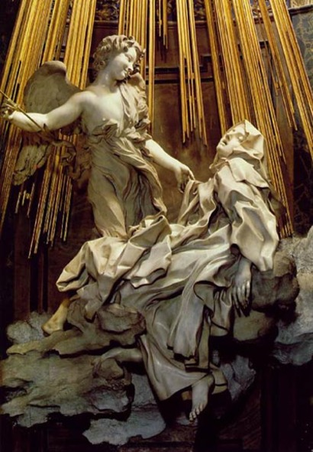In 1559, Teresa became firmly convinced that [Jesus Christ](https://en.wikipedia.org/wiki/Jesus_Christ) presented himself to her in bodily form, though invisible. These visions lasted for more than two years. In another vision, a seraphdrove the fiery point of a golden lance repeatedly through her heart, causing an ineffable spiritual-bodily pain.

*‘I saw in his hand a long spear of gold, and at the point there seemed to be a little fire. He appeared to me to be thrusting it at times into my heart, and to pierce my very entrails; when he drew it out, he seemed to draw them out also, and to leave me all on fire with a great love of God. The pain was so great, that it made me moan; and yet so surpassing was the sweetness of this excessive pain, that I could not wish to be rid of it...’*

This vision was the inspiration for [Bernini](https://en.wikipedia.org/wiki/Bernini)'s famous work, the [*Ecstasy of Saint Teresa*](https://en.wikipedia.org/wiki/Ecstasy_of_Saint_Teresa) at Santa Maria della Vittoria in Rome.

The memory of this episode served as an inspiration throughout the rest of her life, and motivated her lifelong imitation of the life and suffering of Jesus, epitomized in the [motto](https://en.wikipedia.org/wiki/Motto) usually associated with her: *Lord, either let me suffer or let me die*.

[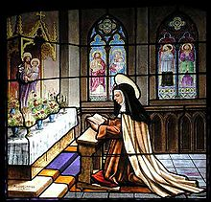](https://en.wikipedia.org/wiki/File:TeresaAvila.jpg)**Activities as reformer**

Teresa entered a Monastery in [Ávila](https://en.wikipedia.org/wiki/%C3%81vila,_Spain), Spain, in 1535. She found herself increasingly in disharmony with the lack of spirituality in the convent, with daily invasion of visitors, frivolous concerns and vain conversations. These violations of the solitude absolutely essential to progress in genuine contemplative prayer grieved Teresa to the extent that she longed to do something. She resolved to found a reformed Carmelite convent. Where poverty and renunciation of property. For the first five years, Teresa remained in seclusion, engaged in writing. During the last three years of

*Church window at the*

*Convent of St Teresa.*

her life, Teresa founded sixteen convents, and as many men's cloisters

were due to her reform activity of twenty years.

**Death and canonization.**

She died in 1582 on 15 October which is celebrated as her feast day.

Her last words were: "*My Lord, it is time to move on. Well then, may your will be done. O my Lord and my Spouse, the hour that I have longed for has come. It is time to meet one another.*"



**The Prophet Muhammad.**

Muslims believe that Islam is a faith that has always existed and that it was gradually revealed to humanity by a number of prophets. The final and complete revelation of the faith was made through the Prophet Muhammad in the 7th century CE.

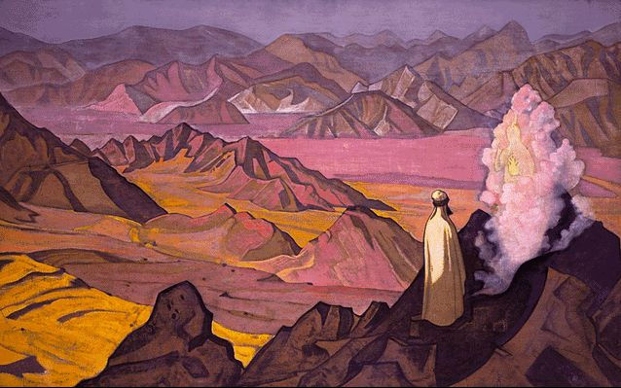Muhammad was born and raised in Mecca. When he was nearly 40, he used to spend many hours alone in prayer. He was concerned with social unrest, injustice and discrimination (particularly against women). The moral degeneration of his fellow people, and his own quest for a true religion further lent fuel to this, with the result that he now began to withdraw periodically to a cave named Mount Hira, near Mecca, for contemplation and reflection. During this period Muhammad began to have dreams of great spiritual significance and this was the commencement of his divine revelation.

**The first revelation**

*"It is no less than inspiration sent down to him:*

*He was taught by one Mighty in Power, Endued with Wisdom: for he appeared (in stately form); While he was in the highest part of the horizon:*

*Then he approached and came closer, And was at a distance of but two bow-lengths or (even) nearer;"*

The event took place in the year 610 CE while on retreat in a cave called Hira, near Mecca. Archangel Gabriel appears and commands him to recite the first lines of chapter 96 of the Quran. Muhammad's experience is mentioned in the Quran 53:4–9. "Read", upon which he replied, "I am unable to read". The angel caught hold of him and embraced him heavily. This happened two more times after which the angel commanded Muhammad to recite:

*"Proclaim! (or read!) in the name of thy Lord and Cherisher, Who created – Created man, out of a clot of congealed blood”.*

*“I heard a voice from heaven saying, “O Muhammad! thou art the apostle of God and I am Gabriel.” (Ibn Ishaq, Sirat Rasul Allah, p. 106)*

Perplexed by this new experience, Muhammad made his way to home where he was consoled by his wife Khadijah, who also took him to her cousin Waraqah who was familiar with Jewish and Christian scriptures. Waraqah said: "O my nephew! What did you see?" When Muhammad told him, Waraqah replied: "This is Gabriel that Allah sent to Moses.”

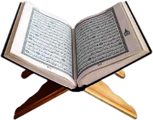

**The Qur'an**

During the rest of his life Muhammad continued to receive these revelations. The words were remembered and recorded, and form the text of the Holy Qu'ran.

Believing that God had chosen him as his messenger Muhammad began to preach what God had revealed to him. The simple message of Islam, that there is no God but Allah, and that life should be lived in submission to Allah, was attractive and popular to many people.

**The Hijrah**

Muhammad's popularity was seen as threatening by the people in power in Mecca, therefore he took his followers from Mecca to Medina in 622. This journey is called the Hijrah, the event was seen as so important for Islam that 622 is the year the Islamic calendar begins.

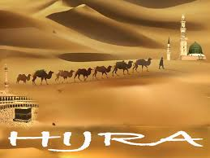**The return to Mecca**

Within ten years Muhammad had gained so many followers that he returned to conquer Mecca. From this time on he was generally accepted by the faithful as the true final Prophet of God.

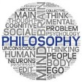

**St Bernadette of Lourdes**

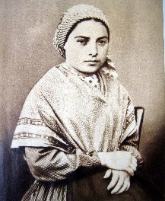

Saint Marie- Bernadette Soubirous (7 January 1844 – 16 April 1879) was the daughter of a miller from Lourdes, France, and is venerated as a saint in the Catholic Church. Bernadette is best known for the Marian apparitions of a "small young lady". The apparitions are said to have occurred between 11 February and 16 July 1858.

Despite initial scepticism from the Catholic Church, Bernadette's claims were eventually declared "worthy of belief" after an investigation, and the Marian apparition is now known as Our Lady of Lourdes. In 1933, Pope Pius XI declared Bernadette Soubirous a Saint of the Catholic Church. Her feast-day is observed on the date of her death, 16 April.

On 11 February 1858, Bernadette, then aged 14, was out gathering firewood with her sister Marie and a friend near the grotto of Massabielle when she experienced her first vision. She she heard the sound of rushing wind, but nothing moved. A wild rose in a natural niche in the grotto, however, did move. From the niche, *"came a dazzling light, and a white figure"*. This was the first of 18 visions. Her sister and her friend stated that they had seen nothing.

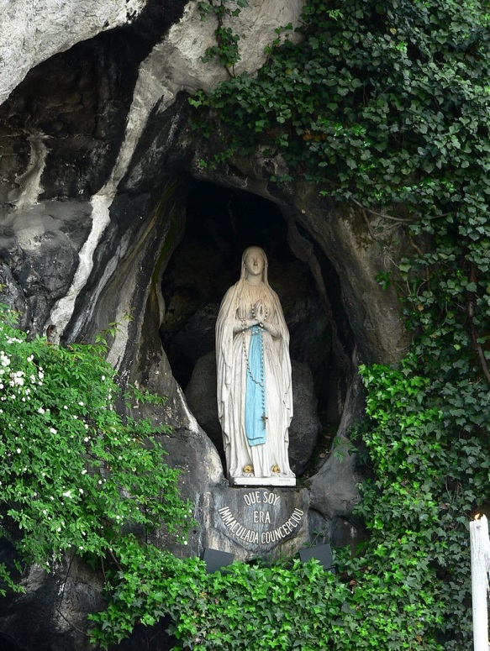On 14 February, after Sunday Mass, Bernadette and her sister returned to the grotto. Bernadette had another vision and fell into a trance. On her next visit, 18 February, she said that "the vision" asked her to return to the grotto every day for a fortnight. Initially, her parents, were embarrassed and tried to forbid her to go. Bernadette described the lady as wearing a white veil, a blue girdle and with a yellow rose on each foot — compatible with "a description of any statue of the Virgin in a village church".

Other visions were simple and focused on the need for prayer and penance. On 25 February the vision told her "to drink of the water of the spring, to wash in it," as an act of penance. In the thirteenth apparition, the lady told Bernadette that "a chapel should be built and a procession formed". During her 16th vision, Bernadette again asked the woman for her name but the lady just smiled back. She repeated the question three more times and finally heard the lady say, "I am the Immaculate Conception".

**Results of her visions**

Bernadette joined the Sisters of Charity in Nevers where she spent the rest of her brief life. She was admired for her humility and spirit of sacrifice. On her deathbed, her final words were, "Blessed Mary, Mother of God, pray for me! A poor sinner, a poor sinner-"

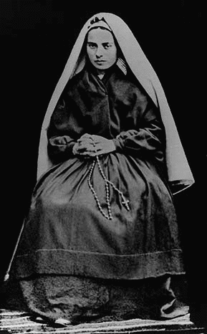After investigation, Church authorities confirmed the authenticity of the apparitions in 1862. In the 150 years since Bernadette’s visions, 69 cures have been verified by the Lourdes Medical Bureau as "inexplicable" — after what the Church claims are "extremely rigorous scientific and medical examinations" that failed to find any other explanation. Bernadette said that it was faith and prayer that cured the sick.

The Sanctuary of Our Lady of Lourdes is now one of the major Catholic pilgrimage sites in the world. Close to 5 million pilgrims from all over the world visit Lourdes every year to pray and to drink the miraculous water, believing they obtain from the Lord healing of the body and of the spirit.



**Siddhartha Gautama - Buddha**

The history of Buddhism is the story of one man's spiritual journey to Enlightenment, and of the teachings and ways of living that developed from it.

**Siddhartha Gautama - The Buddha**

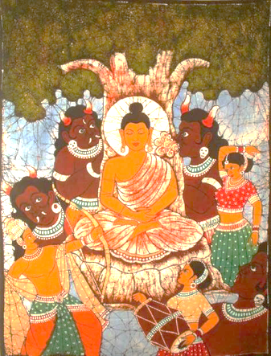

By finding the path to Enlightenment, Siddhartha was led from the pain of suffering and rebirth towards the path of Enlightenment and became known as the Buddha or 'awakened one'.

Siddhartha Gautama lived, from around 490 BCE until circa 410 BCE. He was born into a royal family in the village of Lumbini in present-day Nepal, and his privileged life insulated him from the sufferings of life; sufferings such as sickness, age and death.

One day, after growing up, marrying and having a child, Siddhartha went outside the royal enclosure where he lived. When he went outside he saw, each for the first time, an old man, a sick man, a corpse and later, a holy man (the Four Sights), discovering the cruel realities of life. This greatly disturbed him, and he learned that sickness, age, and death were the inevitable fate of human beings.

**Becoming a holy man**

On seeing the Holy man, Siddartha decided this was a sign that he should leave his protected royal life and live as a homeless holy man.

Siddhartha's travels showed him much more of the suffering of the world. He searched for a way to escape the inevitability of death, old age and pain first by studying with religious men. This didn't provide him with an answer. Siddhartha encountered an Indian ascetic who encouraged him to follow a life of extreme self-denial and discipline.

The Buddha also practised meditation but concluded that in themselves, the highest meditative states were not enough. Siddhartha followed this life of extreme asceticism for six years, but he still had not escaped from the world of suffering.

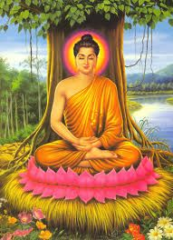

**The middle way**

He abandoned the strict lifestyle of self-denial and ascetism, but did not return to the pampered luxury of his early life. Instead, he pursued the Middle Way, which is just what it sounds like; neither luxury nor poverty.

**Enlightenment**

One day, seated beneath the Bodhi tree (the tree of enlightenment) Siddhartha became deeply absorbed in meditation, determined to penetrate the truth about life. He went through a series of experiences revealing the causes of suffering and how to defeat suffering. He finally achieved Enlightenment and became the Buddha. The Mahabodhi Temple at the site of Buddha's enlightenment, is now a pilgrimage site.

**The Teacher**

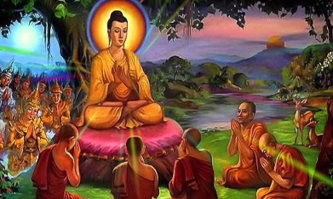Buddha set in motion the wheel of teaching the dharma and set up centers for this purpose.

For the next 45 years of his life the Buddha taught many disciples, who became Arahants or 'noble ones', who had attained Enlightenment for themselves.