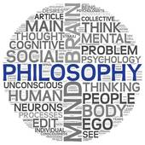
Religious Experiences
Name | Brief description & type | Circumstances | Quotation(s) | Results | Proof of God? | Problems

