BD05729_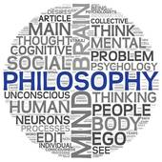

**What is Philosophy?**

1. What does philosophy *not* deal with?
2. What does the word tangible mean?
3. What is philosophy concerned with?
4. What kind of questions does philosophy ask? Include some examples.
5. How do we discover philosophical ‘answers/truths’?
6. Why is asking questions important?
7. Why is it difficult to avoid philosophical questions?
8. Why is having views about such questions important for us and our development?
9. How do we decide what our philosophical views are?
10. What are the recurring questions and topics that philosophers debate?
11. What are the five main areas of philosophical debate?
12. In your opinion which of these areas are the most important for (a) everyday life and (b) religious believers.