BD05729_

**Religious Experience in the Bible**

**Acts 2 New International Version (NIV)**

*The Holy Spirit Comes at Pentecost*

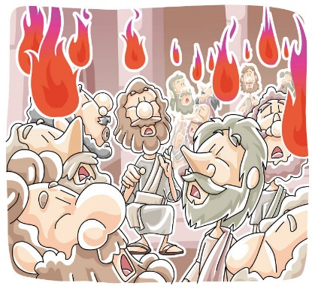

2 When the day of Pentecost came, they were all together in one place. 2 Suddenly a sound like the blowing of a violent wind came from heaven and filled the whole house where they were sitting. 3 They saw what seemed to be tongues of fire that separated and came to rest on each of them. 4 All of them were filled with the Holy Spirit and began to speak in other tongues as the Spirit enabled them.

*Peter Addresses the Crowd*

14 Then Peter stood up with the Eleven, raised his voice and addressed the crowd: “Fellow Jews and all of you who live in Jerusalem, let me explain this to you;

22 “Fellow Israelites, listen to this: Jesus of Nazareth was a man accredited by God to you by miracles, wonders and signs, which God did among you through him, as you yourselves know. 23 This man was handed over to you by God’s deliberate plan and foreknowledge; and you, with the help of wicked men, put him to death by nailing him to the cross. 24 But God raised him from the dead, freeing him from the agony of death, because it was impossible for death to keep its hold on him.

36 “Therefore let all Israel be assured of this: God has made this Jesus, whom you crucified, both Lord and Messiah.”

37 When the people heard this, they were cut to the heart and said to Peter and the other apostles, “Brothers, what shall we do?”

38 Peter replied, “Repent and be baptized, every one of you, in the name of Jesus Christ for the forgiveness of your sins. And you will receive the gift of the Holy Spirit.

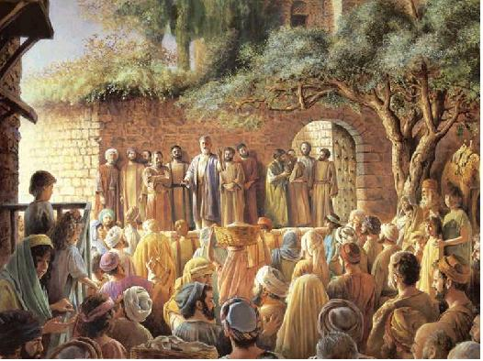41 Those who accepted his message were baptized, and about three thousand were added to their number that day.

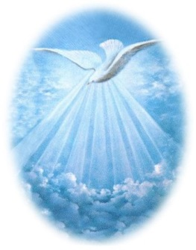42 They devoted themselves to the apostles’ teaching and to fellowship, to the breaking of bread and to prayer. 45 They sold property and possessions to give to anyone who had need. 46 Every day they continued to meet together in the temple courts.

Questions;

1. Explain a very brief outline of the story.
2. Explain different reasons why this was a religious experience.
3. What were the effects of this experience?
4. Why do you think it was one of the most significant religious experiences for the Christian Church.