**..\WINDOWS\Application Data\Microsoft\Media Catalog\Downloaded Clips\cl68\j0260331.wmf..\WINDOWS\Application Data\Microsoft\Media Catalog\Downloaded Clips\cl68\j0260331.wmf**

**Mahayana Buddhism.**

Mahayana is an umbrella term which describes a number of different schools, the earliest of which emerged between the 1st century BCE and the 1st century CE. Mahayana is seen by modern scholars as a new movement which developed its own vast collection of scriptures between the first and fifth centuries CE, which include different interpretations of the Buddha’s teachings. Mahayana also developed different forms of worship to Theravada Buddhism. Mahayana gave rise to two main philosophical schools of Buddhism – Madhyamaka and Chittamatra. Over the years Mahayana spread to other countries and other schools of Buddhism developed from it such as Zen and Pure Land, popular in Japan and China.

Mahayana Buddhism

After about 500 years Buddhism spread to China, Korea and Japan. In these countries people were usually encouraged to marry and work to support themselves and their

families. For these reasons there are fewer monks and nuns in

countries. The main Buddhist tradition practiced in these areas is

Mahayana Buddhism. The name means ‘**Greater Vehicle**’

which suggests that it aims to help many people move along the

Buddhist path, whether they are monastic or lay Buddhists.

There are different types of Mahayana Buddhism including Zen

and Pure Land Buddhism, both popular in Japan.

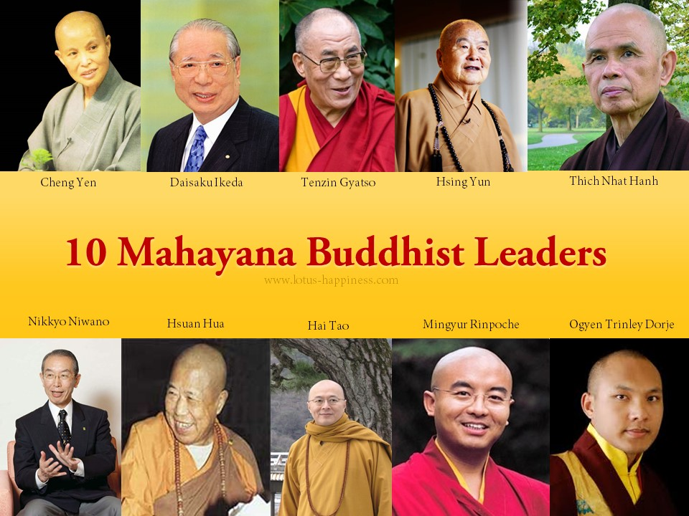

All Buddhists follow the Eightfold Path, however, Mahayana Buddhists also follow the Bodhisattva Path which is divided into ten stages (*bhumis,* literally meaning ‘grounds’). These are the ten perfections (*paramitas*).

1. Generosity
2. Moral discipline
3. Patience
4. Diligence
5. Concentration/meditation

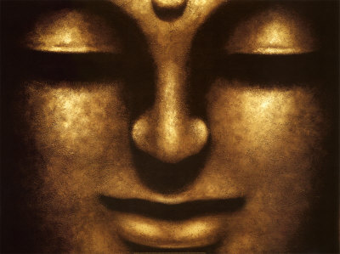

1. Wisdom (*prajna*)
2. Skilful means
3. Strength/power
4. Aspiration
5. Primordial wisdom (*jnana*)

After the tenth stage one attains Buddhahood. A ***bodhisattva*** is someone who follows the path in order to attain enlightenment for themselves and for others. The bodhisattva reaches his/her goal by arousing ***bodhichitta***, the awakened mind and taking the vows of the Bodhisattva.

Things to do.

1. Explain two main differences between Mahayana and Theravada Buddhism.
2. Why are there fewer monks and nuns in countries where Mahayana is the main school of Buddhism?
3. What does the title, ‘Greater Vehicle’ suggest about Mahayana Buddhism?
4. Note down and then explain the ten perfections.
5. Note down key words and their definitions.



Mahayana view of the Buddha.

From the Mahayana perspective Buddha was already enlightened when

he was born as Siddartha Gautama. His decision to take a physical form

was a voluntary one. Whereas Theravada Buddhism see the Buddha as a

historical figure, Mahayana Buddhists believe that Buddha remains

active and can influence the world. He can be encountered through

meditation and even visions. He can manifest himself in many different

forms, times and places.

Buddha-nature and attaining Buddhahood in the Mahayana Tradition.

At a basic level Buddha-nature refers to the idea that everyone has the essence of a Buddha already inside them. But, because a person’s Buddha-nature is hidden by desires, attachments, ignorance and negative thoughts, it is not realised. Only when people come to truly understand the Buddha’s teachings and the nature of reality, do they experience the Buddha-nature that was always there.

*One example given in Buddhist scripture to help explain Buddha-nature is as follows;*

Honey is sweet and tasty, but as long as it is surrounded by bees, it isn’t possible to get the honey, even though it has been there all the time. The only way to get it is to get rid of the bees.

Mahayana Buddhists aim to gain Buddhahood, to become a Buddha – an enlightened being. They believe everyone can do this because everyone has an inherent Buddha-nature.

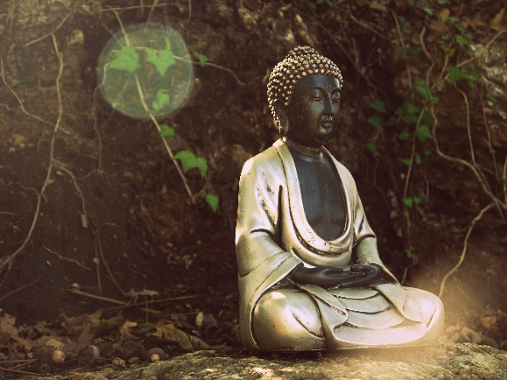



Sunyata.

An important concept in Mahayana Buddhism is sunyata, which is often translated as ‘emptiness’. For Mahayana Buddhists, understanding sunyata is essential for achieving enlightenment. Sunyata could be understood to be a restatement of anatta. It emphasises that not only do human beings not have a fixed, independent, unchanging nature, but in fact all things are like that. Nothing exists independently but only in relation to and because of, other things. A wave, for example cannot be separated from the sea.

*A computer helps explain this concept;*

A computer does not have a soul, instead it is made up of many different parts which rely on each other and work together to form the whole computer. The computer relies on other people to make the parts, put them together and to keep them working. This makes the computer interdependent and interrelated. It is also impermanent as the computer will eventually break down.

For Buddhists realising that everything depends on and interlinks with everything else can lead to trust, compassion and selflessness. Realising that everything is impermanent is important for reducing the suffering that results in becoming too attached to things. These realisations are important for becoming enlightenment.

Buddhism in the West.

All forms of Buddhism are practised in the West. However there is a group

called ‘Friends of the Western Buddhist Order’ (FWBO). It uses the teachings

and practices from Theravada, Mahayana and Tibetan Buddhism.



Distinctive practices and emphases of Mahayana Buddhism and how they shape and express religious identity

b) The extension of the concept of the Buddha to include the Buddha and creation. The specific concept of the Buddha as a cosmic presence that influences the world.

c) The Buddha nature in every person. The centrality of Buddha Gautama, especially in their use of images and stupas.

The different schools of Mahayana should be explored in the context of the countries in which they developed and are practised.

With reference to the ideas of A Basham and the 14th Dalai Lama.