**..\WINDOWS\Application Data\Microsoft\Media Catalog\Downloaded Clips\cl68\j0260331.wmf..\WINDOWS\Application Data\Microsoft\Media Catalog\Downloaded Clips\cl68\j0260331.wmf**

**Mahayana & Theravada Buddhism.**

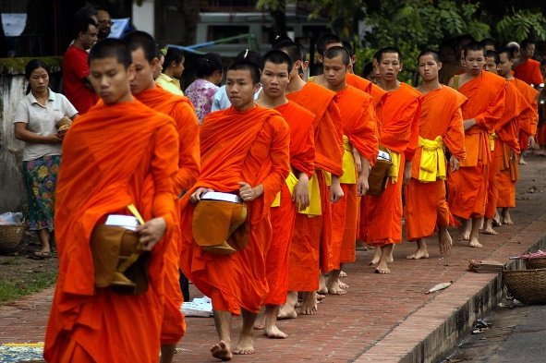There are about 350 million Buddhists in the world and although most are in Asian countries such as India, Sri Lanka, Thailand etc. Buddhism is now practised worldwide. As Buddhism spread outwards from India, it gradually adapted to meet the needs of different peoples and cultures. As a result there are several different kinds of Buddhism.

Theravada Buddhism

For the first two hundred years Buddhism spread throughout India, then, helped by the Buddhist Emperor Ashoka (273-232BCE) it was taken to Sri Lanka, Burma and Thailand. In these countries, Theravada Buddhism is practised. This means ‘**the tradition of the elders**’. It follows teaching handed down by senior monks from the beginnings of Buddhism. Monastic life is very important in these countries. There is a close interaction between the lay sangha and the monastic sangha. The lay sangha support the monastic sangha by providing food and offerings, the monastic sangha support the lay sangha by providing spiritual guidance, education and opportunities to gain merit. Theravada Buddhists suggest that the monastic way of life is the ideal way to follow Buddha’s teachings, free from distraction (hence some of the rules in the Pattimokka). However, they realise that the monastic life is not for everyone, so the lay sangha gain good karma by supporting the monastic sangha.

In this tradition a boy may spend a short while in a monastery living as a monk. This gives him the chance to learn about his religion and get a general education. He can choose to leave the monastery when he is older or stay on.

Things to do.

1. How did Buddhism spread to Sri Lanka?
2. Why is Theravada Buddhism so called?
3. Explain how the lay Sangha supports the monastic Sangha in Theravada Buddhism, and vice versa.
4. Why do Theravada Buddhists believe the monastic lifestyle is the best way to achieve enlightenment?
5. Note down key words and definitions on your key terms sheet.

Theravada Buddhism & its significance as the only survivng form of Nikaya.

Nikāya is a Pāḷi word meaning volume or collection. It is most commonly used in reference to the Buddhist texts of the Sutta Piṭaka but can also refer to the monastic divisions of Theravāda Buddhism. In addition, the term Nikāya is sometimes used in contemporary scholarship to refer to early Buddhist schools.

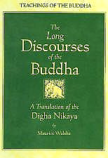*Text collections*

In the Pāli Canon, particularly, the "Discourse Basket" or Sutta Piṭaka, the meaning of nikāya is roughly equivalent to the English collection and is used to describe groupings of discourses according to theme, length, or other categories. For example, the Sutta Piṭaka is broken up into five nikāyas.

*Monastic divisions*

Among the Theravāda nations of Southeast Asia and Sri Lanka, nikāya is also used as the term for a monastic division or lineage; these groupings are also sometimes called monastic fraternities. For example in Burma, nikaya monastic orders have emerged in response to the relative conservativeness with which the Vinayas are interpreted.

Rejection of The Three Vehicles of Buddhism



To clarify the variations between the many different schools and traditions of Buddhism, the schools are often divided into the three Yanas, meaning 'Vehicles'. These three are: the Nikaya (Hinayana/ lesser), Mahayana (greater) and Tantrayana (Vajrayana). Within the various vehicles, much variation can still exist, like Zen, Pure Land and Tibetan Buddhism. Nikaya Buddhism has flourished ever since the Buddha died, Theravada is the only surviving school of Nikaya Buddhism.



A major reason for this development of different schools within Buddhism may be that the Buddha taught for decades. Given the vast amount of teachings it is not easy to unanimously decide what the exact interpretation of all teachings should be.

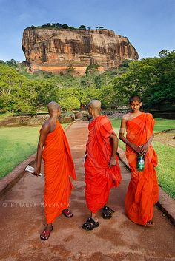The Theravada tradition is based on the set of teachings decided by the Third Buddhist Council to contain the teachings of the Buddha. After the Third Buddhist Council, the Tripitaka collection of sutras were taken to Sri Lanka. About a century after the Buddha passed away, monasteries became the main mechanism for preservation of the teachings.

The teachings on the Four Noble Truths and meditation form the basis of Theravada practice.

**Theravada Buddhists reject the model of the Three Vehicles as they do not accept that the teachings were given by Gautama Buddha.**

Things to do.

1. Explain the meanings of the term Nikaya in terms of Buddha’s teachings and the monastic community.
2. What are the Tree Vehicles and why do Theravada Buddhists reject this idea?
3. Why are there different schools of Buddhism?
4. On what is the Theravada tradition based?
5. What is the main basis for Theravada practice?

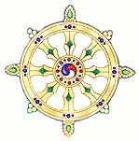

The centrality of Gautama Buddha, especially in their use of images and stupas.

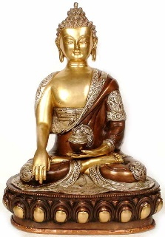

Theravada Buddhism places great importance and veneration of the Buddha.

The Temple of the Tooth in Sri Lanka is an important place of pilgrimage for Buddhists as it holds a relic of the Buddha – a tooth. Buddharupas (statues of Gautama Buddha) are used as a focus on a shrine for meditation, symbolic offerings are placed on the shrine.

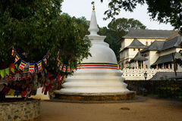

Stupas are tiered towers, designed to symbolise the elements of earth, water, fire, air and wisdom. They are used to house holy relics, particularly those of Gautama Buddha. The lower part of a stupa symbolises earth and the uppermost point symbolises wisdom.

The imagery and symbolism helps Theravada Buddhists focus on Buddha and his teachings.

The goal of nibbana and parinibbana as a central teaching alongside an emphasis on renunciation, including the four stages to becoming an arahant.

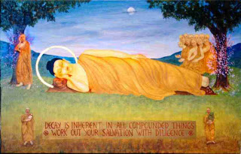Theravada Buddhists believe the monastic life is the best way to achieve enlightenment and nibbana – a state of peace and liberation from suffering. In Buddhism, the term parinibbāna is used to refer to nirvana-after-death, which occurs upon the death of the body of someone who has attained nirvana during his or her lifetime. It implies a release from the Saṃsāra, karma and rebirth as well as the dissolution of the skandhas.

An ***Arahant*** is a fully enlightened being. Buddha recognized four distinct levels of realization, each marked by a deep and unmistakable experience of selflessness, followed by certain changes in outlook and behaviour.

The experience generally occurs during intensive meditation, when the attention has become one-pointed, and follows extensive study and understanding of the basic truths of Buddhism.

The four stages of enlightenment are Sotapanna, Sakadagami, Anagami and Arahant. The teaching of the four stages is a central element of the early Buddhist schools, including Theravada Buddhism.

The 4 Stages of Enlightenment (becoming an arahant)

Stream-enterer

The first stage is that of Sotāpanna literally meaning “one who enters the stream,” with the stream being the Noble Eightfold Path regarded as the highest Dharma.

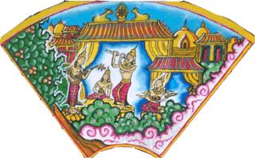The stream-enterer is also said to have “opened the eye of the Dharma” and is guaranteed enlightenment after no more than seven successive rebirths, possibly fewer. The stream-enterer can also be sure that he will not be reborn in any of the unhappy states or rebirths (an animal, a preta, or in hell). He can only be reborn as a human being, or in a heavenly realm. The stream-enterer has attained an intuitive grasp of Buddhist doctrine - “right view”, has complete confidence in the Three Jewels of Buddha, Dhamma, and Sangha, and has good moral behaviour (Sila).

When you become a stream-enterer, your experience eliminates the illusion that you’re really a separate self.

In everyday life, you may still get caught up by greed, anger, ignorance, and other negative feelings. However, the stream-enterer also has unshakable confidence and dedication to the Buddhist spiritual path.

Once Returner

The second stage is that of the Sakadāgāmī, literally meaning “one who once comes”. The once-returner will return to the human world only one more time, and will attain Nirvana in that life.

After you become a stream-enterer and after a period of time (generally years of devoted practice) in which your concentration gets even stronger and your mind becomes even more tranquil, you have another direct insight into no-self.

This insight brings a significant reduction in attachment and aversion and the suffering that accompanies these states of mind. For example, occasional irritation and preference replace hatred and greed, which no longer have any hold over the once-returner.

Never-returner

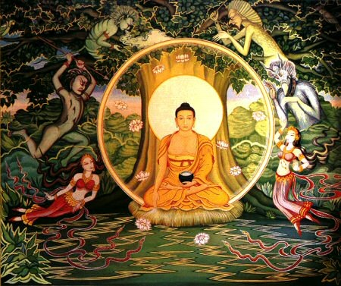

The third stage is that of the Anāgāmī, literally meaning “one who does not come. The non-returner does not come back into human existence, or any lower world, after death. Instead, he is reborn in one of the “Pure Abodes”, where he will attain Nibbana; some of them are reborn a second time in a higher world of the Pure Abodes, but in no case are born into a lower state.

An Anāgāmī has abandoned the restraints that bind the mind to the cycle of rebirth, and is thus partially enlightened, and on the way to perfect and complete Enlightenment.

After entry to this stage, all of the worst hindrances, such as hatred, greed, jealousy, and ignorance, completely drop away, but a hint of a self-sense still remains — and with it, the slightest trace of restlessness and dissatisfaction sticks around as well. These people appear to be extremely content, peaceful, and without desire, but the subtlest preference for positive rather than negative experiences remains.

Arahant

The fourth stage is that of Arahant, a fully enlightened human being who has wholly abandoned saṃsāra, and who upon decease Parinibbāna will not be reborn in any world.

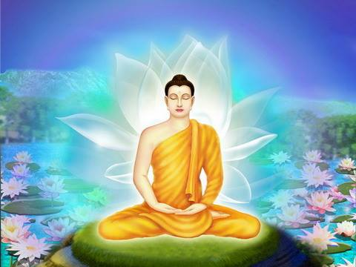At this stage, the path bears ultimate fruit in nibbana — any residual trace of a separate self falls away for good. The experience, frequently accompanied by unimaginable bliss, has been compared to falling into the depths of a cloud and disappearing. At this point, the circumstances of life no longer have the slightest hold over you. As Buddha said, all that needed to be done has been done. There’s nothing further to realize. The path is complete, and no further rebirths are necessary.

Things to do.

1. What is a Buddharupa and how is it used?
2. Explain what a stupa is and what a stupa symbolises.
3. What is the difference between nibbana and parinibbana.
4. What is an arahant?
5. Briefly explain the four stages of becoming an arahant.



The distinctive teachings of Theravada; their interpretation and application in light of the life and teachings of the Buddha and other traditions of Buddhism and their different emphases.

Theravada Buddhism is sometimes regarded as ‘orthodox’ (original) Buddhism, with a focus on sticking to Buddha’s original teachings and practices, particularly on meditation and monasticism. Some Theravadans also believe in the transfer of their merit to someone else. This is important when someone dies. The family gather and transfer their merit to the deceased in the hope of a favourable rebirth.

Theravadans also believe in the five aggregates or skandhas, the five aspects people are made up of;

Perception

Consciousness

Form

Sensation

Mental Formations

Five

Skandhas

* Form – material and physical objects (e.g. a person’s body)
* Sensation – the feeling one has when someone comes into contact with something (physical or emotional)
* Perception – how people recognise what things are.
* Mental formations – this refers to a person’s thoughts and opinions – responding to their experiences.
* Consciousness – awareness of the world around us.

*For example* – you go into a room and see a cake; you begin to feel desire for the cake; you’ve recognised it as a cake as you have seen cake before; you begin to form an opinion of the cake to decide whether or not to eat it; all of this things are connected by your general understanding and awareness of the world.



Things to do.

1. Why is Theravada Buddhism sometimes referred to as ‘orthodox Buddhism’?
2. Explain the practice of ‘merit transfer’.
3. Note down the Five Skandhas and explain how they work in practice.





