

**Eightfold Path**

The last of the Four Noble Truths is to put an end to suffering by following the Noble Eightfold Path. The different steps along this pathway are rather like the spokes on a wheel. Although each has its own separate identity, they gain their real strength from their unity. This is where we get the symbol of Buddhism. The Eightfold path provides the path which guides Buddhists to defeat greed and hatred, the main causes of suffering. It encourages a person to think about their actions and do the right thing.

The Fourth Noble Truth is also known as the Noble Eightfold Path or the Middle Path. It avoids the extremes of sensual pleasure and self-deprivation, eternalism and nilism, optimism and pessimism. The Path leading to the End of Dukkha It is a planned course of inward culture and progress and is not practised out of any fear of the supernatural or a god.

Noble Eightfold Path is a means and never an end. It brings about dispassion and detachment by the gradual elimination of the desire for sensual pleasure. It leads to the development of compassion and the cultivation of a selfless love for all that lives. The Path leads from selfishness to altruism, from the unreal to the Real.

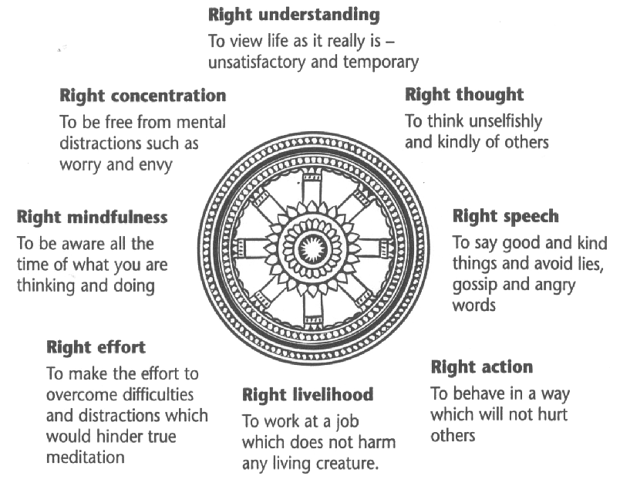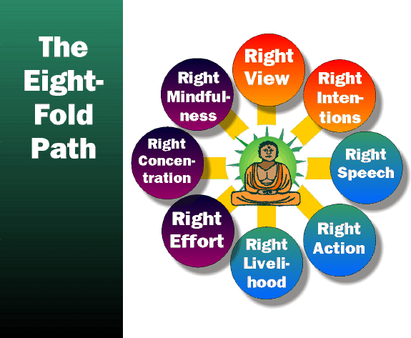

The eight divisions of the Eightfold Path are grouped into 3 sections – Wisdom (Panna); Morality (Sila) and Meditation – also referred to as mental discipline or concentration. (Samadhi).

**For your notes….**

**Explain using examples, how (a) Wisdom; (b) morality; and (c) meditation could**

**lead to happiness.**

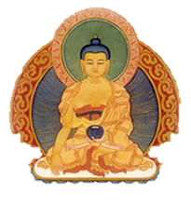Nibbana.

If the Eightfold Path is followed fully then Nibbana - Enlightenment can be achieved. Buddhists say that it is not possible to describe Nibbana. There is a Buddhist story about a fish and a turtle who were friends. The fish asked the turtle to describe what life was like on land. The turtle tried but the fish could not imagine air or trees or grass or anything else that the turtle was talking about. Buddhists say that trying to describe Nibbana is like this.

The only way is to say what it is not like. Nibbana really means no suffering. It means being free of greed and anger, and the end of everything that is imperfect. For a Buddhist it is the only way to be free.

Things to do.

1. Explain how wisdom, mental training and morality can lead to happiness.
2. Note down, each part of the Noble Eightfold Path in an outline of a

Dharmachakra with a picture to illustrate the meaning of each one.

1. It has been said that, ‘suffering can teach ordinary people extraordinary things’.

What do you think suffering teaches people?

4. Explain how the story of the fish and the turtle attempts to explain Nibbana.

*SILA* (Morality) is based on love and compassion for all beings. Both qualities, compassion and wisdom should be developed equally to become perfect.

*Right Speech (Samma Vaca)* is speech that is truthful, affectionate, helpful, and which promotes harmony, and unity. It reflects inner wisdom, clear vision, and Buddha-nature and represents the Ideal of Human Communication. Imperfect Speech or Wrong Speech is untruthful, harsh, harmful, and which promotes discord, disharmony and disunity. It also means that we are honest with ourselves. Honest communication and mutual understanding is the essence of good relationships

*Right Action (Samma Kammanta)* Two aspects: What we do and what we refrain from doing. Right action aims at promoting moral, honourable and peaceful conduct. One should refrain from: harming and destroying life; Stealing and dishonesty; sexual misconduct; taking intoxicants; Right action means to perform deeds which do not cause suffering to oneself and others.

*Right Livelihood (Samma Ajiva)* Avoid occupations/trades which cause suffering to oneself and others. One should refrain from trade dealing in: Arms/lethal weapons; intoxicating drinks; poisons; killing animals; etc. The guiding principle is to work for the happiness of oneself and others. The work must be ethically wholesome, for example teaching, caring and medical professions; social work etc.

The Buddhist ethical and moral conduct aims at promoting harmony and happiness for the life of the individual and society. Morality also forms the indispensable foundation for all higher spiritual attainments.

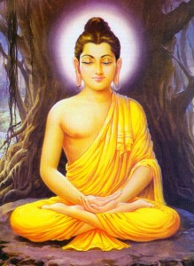

*SAMADHI* (Mental Discipline) This group of the Noble Eightfold Path deals with the human mind. Samadhi means mental discipline. There are three factors: Right Effort Right Mindfulness Right Concentration.

*Right Effort (Samma Vayama)* Endeavour to live a moral and blameless life. Effort should be made to overcome evil and promote the good. Right Effort plays a very important part in developing wisdom through cultivation of virtue and mental discipline.

*Right Mindfulness (Samma Sati)* is to be mindful of our thoughts, speech and actions. With mindfulness, we are less inclined to be thoughtless and careless. We establish harmony and peace by cultivating the alertness of the mind and awareness of the potential results of our actions.

The Buddha told us that when anger arises, don’t think “I’m angry”, as if the anger belongs to us but to be aware of the arising of anger and the state of an angry mind, and realise that it is impermanent. By doing so, the anger loses its compelling power and quickly subsides. This is the technique of nipping anxiety and other negative thoughts and cultivate positive feelings such as love, compassion, mental purity, equanimity and happiness.

*Illustration of a Thinking Smiley Stock Photo - 12107062*

*Right Concentration* (Samma Samadhi). Meditation is not just reflecting upon, thinking about a subject and pondering. It is observing with alertness and keeping the attention on the subject without wavering of the mind.



*PANNA* (Wisdom) This group of the Noble Eightfold Path deals with wisdom and has two factors: Right Understanding Right Thought.

*Right Understanding (Samma Ditthi)* As a person gains more and more insight, they develop an unshakeable confidence in the Buddha Dhamma, when he realises for himself how true the words of the Buddha are.

What needs to be understood? Understanding the Three Signs of Being; Four Noble Truths; realisation that we are the owner of our Karma, understanding the intentions or our actions.

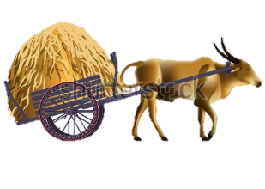*Right Thought (Samma Samkappa)* Eliminating evil thoughts. Developing pure thoughts. Dhammapada Verse 1 states: “Mind precedes all mental states Mind is their chief; they are all mind-wrought. If with an impure mind a person speaks or acts, suffering follows him like the wheel that follows the foot of the ox.”

Good and evil forces are latent in all of us. The evil forces will rise to the surface at unexpected moments. Greed and hatred, coupled with ignorance, are the chief causes of all evil. The Dhammapada Verse 251 states: “There is no fire like lust, no grip like hate, there is no net like delusion, no river like craving.”

In the Noble Eightfold Path, the Buddha has provided a map of the road leading to Nibbana. This is the only path to get out of Samsara.

**Exam Questions**

1. Explore the teachings of the Buddha about morality. *(8 marks)*

2. Analyse the significance of meditation as central to the Noble Eightfold Path. *(20 marks)*

Ideas for Q2.

*Introduction*

* Meditation – Part of 8fold Path - mental discipline.
* Overall purpose of 8fold Path.

*Main developments*

* Strength of the Path is in following all of it.
* Link Right Concentration to Right Effort and Right Mindfulness with explanations of how meditation aids each.

*However*

* Other aspects of the 8fold Path could also be said to be central to the Path.
* Morality – key aspects – why could these be said to be central to the key purpose of the Path (include examples).
* Wisdom - key aspects – why could these be said to be central to the key purpose of the Path (include examples).

*But*

* Meditation helps Buddhists focus on and work out what is the most moral thing to do in a situation (explain how, with examples)
* Wisdom/understanding/mindfulness is aided through meditation (explain how…)

*Conclusion*

* Overall – All parts are important
* Equally important?
* Meditation underpins the rest of the Path – give a reason.

***Don’t forget to explain your points and adopt a discussion style, avoiding a ‘for & against’ approach.***

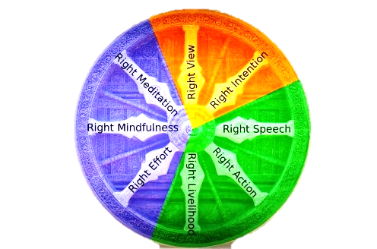

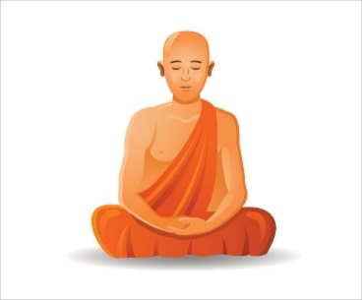

|  |  |  |
| --- | --- | --- |
| Aspect of the Path  **Eightfold Path** | Explanation | Image result for dharma wheel and lotus flowerExamples |
| Morality - *Sila* |  |  |
|  |  |  |
|  |  |  |
|  |  |  |
| Mental Discipline - *Samadhi* |  |  |
|  |  |  |
|  |  |  |
|  |  |  |
| Wisdom - *Panna* |  |  |
|  |  |  |
|  |  |  |