The Four Noble Truths
Buddha taught the Four Noble Truths in his first sermon at the Deer Park in Sarnath near Varanasi.

The Four Noble Truths.

- Dukkha - Suffering is part of life.
- Samudaya - Suffering is caused by desire.
- Nirodha - Suffering can end when desire stops.
- Magga - The way to end suffering is to follow the Noble Eightfold Path.

These Truths are usually explained as follows;
All life includes suffering. Dukkha is caused by tanha (‘thirst’, desire, attachment, craving). Tanha can be overcome, therefore Dukkha can be overcome. Tanha can be overcome by following the Path.

Another way this can be expressed is; ‘The disease, the cause, the cure, the medicine.’

The First Noble Truth is also the first lakshana or mark of existence. It is the Buddhist description of the human condition, or put it another way, it is the diagnosis of the ‘illness’ from which we suffer. Buddhists see this analysis as neither pessimistic nor optimistic, it is simply realistic. The recognition that life is dukkha is the first step to overcoming it.

The positivity of Buddhism comes from the subsequent three truths, not only is the problem diagnosed, but a cause is identified and a cure is at hand. All conditioned things have a cause, and dukkha is caused by tanha. It is easy to have a superficial understanding of the relationship between tanha and dukkha but according to Buddhists, it is the work of possible many lifetimes to understand it fully.
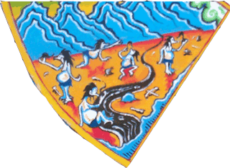
It is a cliché that money cannot buy happiness, and rich people (especially if they are greedy) can be amongst the most miserable. Buddhists would say it is our greed that creates our satisfaction. We want ever more, bigger, better and suffer because of our lack. We are never satisfied with what we have and constantly crave for more. This state is particularly well depicted by the example
of the realm of the hungry ghosts (pretas) in the Wheel of Life. Their large bellies indicating insatiable appetites and their small mouths and necks, their inability to ever be satisfied. They are plagued by raging thirst but can drink only from flaming infested waters.

Material desire, however, is only one of many forms of tanha and it is, perhaps one of the most easy to deal with. Other forms of attachment include attachment to people or to particular beliefs. On the surface it may seem a good thing to be attached to a person, but Buddhism says that these attachments are unhelpful if they are defined by what you can get from them. If they are ‘giving’ relationships, they are positive. If they are ‘taking’ relationships then they are negative and feed dukkha.
Things to do.
- Using the template you will be given explain each of the Four Noble Truths making sure you include the Sanskrit words. You could use pictures or symbols to illustrate each Truth if it helps you remember their meaning.
- Explain why the pretas are a good illustration of dukkha caused by greed.
- Make sure the words in italics are added to your key word sheet with definitions.

Attachment to particular beliefs is also a dukkha-causing form of tanha. The Buddhist understanding of the Middle Way is not only about avoiding extremes of luxury and asceticism; it is also about avoiding extreme views about the nature of existence such as nihilism and eternalism, or whether there is a creator or life after death. Buddha classed these ideas as metaphysical speculation. They are speculation because we cannot prove them one way or another, neither will it help in the struggle to overcome dukkha. This idea is illustrated by the parable of the poisoned arrow;

Parable of the Poisoned Arrow.

It is as if there was a man struck by an arrow that was smeared thickly with poison; his friends
would send for a doctor, and the man might say, ‘I will not draw out this arrow as long as I do not
know whether the man by whom I was struck was a Brahmin, a Kshatriya, a Vaishya or a Shudra … as long as I don’t know his name and his family, whether he was tall, short or of medium height …’ that man would not discover these things, but that man would die.

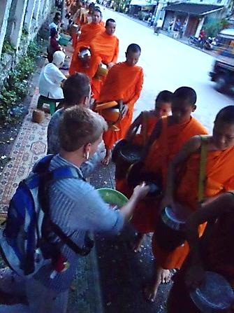
As well as these attachments there is also the attachment to the idea of oneself. This attachment takes many forms. It can involve attachment to the body, or to ideas about one’s prosperity or success. Vanity about one’s physical appearance makes the problem of attachment worse.

Some Buddhists consider it helpful to meditate on the transient and unpleasant nature of the body, many Buddhist temples own skeletons so that people can sit and contemplate them. Buddhists, however, warn that this type of practice can be unhelpful and even dangerous for someone who is depressed or has an overly negative view of the body anyway. As always in Buddhism, a teaching is only worthwhile if it actually helps to eliminate craving.

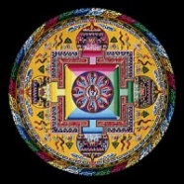
The third Noble Truth - nirodha (cessation), is that tanha can be overcome and therefore dukkha can be overcome. This is sometimes described as the ‘good news’ of Buddhism, and it is a truth that derives from the Buddhist view of connectedness, sometimes stated in the formula, ‘when this arises, that arises. When this ceases, that ceases.’ Release from dukkha does not mean that physical pain no longer occurs. It means that the psychological suffering that often comes along with physical pain does not arise (i.e. that is does not lead to further craving). Someone who has perfected non-attachment lives just like anyone else, except that they no longer experience the dukkha associated with craving and ignorance.
How do Buddhist monks detach themselves from vanity about their physical appearance?

The Fourth Truth - magga (the way) contains the teachings designed to root out craving, ignorance, greed and hatred and so providing the conditions for enlightenment. The key teachings are formulated into the Noble Eightfold Path.

Things to do.

Use the picture of the monks receiving alms to explain how monks detach themselves from vanity about their physical appearance.
Explain also how the monks allow people to gain good karma and help people along the path to nibbana.

Also;
- Explain how the Parable of the Arrow illustrates the idea that beliefs can cause dukkha.
- Explain what is sometimes referred to as the ‘good news’ of Buddhism.

