**The Four Noble Truths.**

The First Noble Truth.

The Second Noble Truth.



The Third Noble Truth.

The Fourth Noble Truth.

Instructions.

1. Using the template explain each of the Four Noble Truths making sure you include the Sanskrit words. You could use pictures or symbols to illustrate each Truth if it helps you remember their meaning.

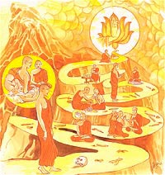

**The Four Noble Truths**

|  |  |  |
| --- | --- | --- |
| Pessimistic | Realistic | Optimistic |
|  |  |  |
| Examples | Examples | Examples |