Buddhist Beliefs – Three Marks of Existence
The Three Marks of Existence

The teaching of the three characteristics or marks of existence (lakshanas) is a teaching which is accepted by all Buddhist schools. It is an analysis of the First Noble Truth, the doctrine of dukkha (suffering). The three characteristics simply provide a more detailed explanation of what is meant by dukkha, and in what sense our unenlightened experience of the world is one of suffering, frustration, or unsatisfactoriness.

The three characteristics are as follows:

- Impermanence (anicca)

- Insubstantiality or “no-self / no soul” (anatta)

- Suffering (dukkha)

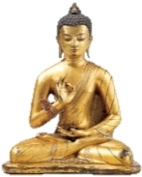
They are all interlinked and interdependent. Samsaric existence is frustrating because we experience not only suffering, but pleasures which are impermanent and insubstantial. We, the experiencers of the pleasures, are also ourselves impermanent and insubstantial. It is our continual failure to take this into account which makes us unenlightened.
Recognition of the three characteristics, like awareness of the rest of the Four Noble Truths, is part of wisdom. To gain wisdom we have to fully realise the reality of these characteristics in the whole of our experience, not just abstractly or intellectually accept them.

Explain.

- Briefly explain the links between dukkha, anicca and anatta.
- Explain how realising the reality of the Marks of Existence can aid wisdom.

Impermanence (anicca)
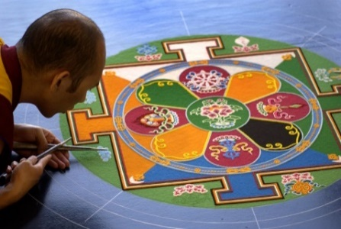
Impermanence is simply the fact that everything changes. Everything is conditioned (except nirvana itself), because it is dependent on other things for its continued existence in a given form, and conditions keep changing. Hence everything is constantly changing form, and is made up of smaller parts which are constantly changing in relation to each other. Although we like to think of objects as stably existent things, when we look a little closer we find that they are not so stable.

Impermanent things.

This is easy to comprehend first in relation to material things. Some things, like waves in the sea, are constantly changing before us. A sandwich, say, left in the open air for a week in warm conditions, will become a mass of mould. Even something we think is relatively safe like a house, will start to deteriorate if left un-maintained for ten years, and in a few hundred years (if not destroyed, rebuilt or renovated) will probably be a pile of ruins. Even the least changeable object in the world, a diamond, can be cut by a skilled person, and will eventually wear away, even if it takes millions of years.

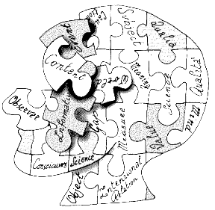
Then if we think of our own bodies, change is constant. Nearly every cell in our body dies out and is replaced every few years. We are also constantly changing physically in dependence on things like what we have eaten, how well we have slept, and how healthy we are. This is even more obvious in relation to our minds, as mental states keep changing from minute to minute. One moment we are happy, another sad; one moment concentrated, another distracted and forgetful: all in accordance with conditions. The Buddha claimed that it was even more of a mistake to think of the mind as unchanging than the body, since at least the body has a certain degree of consistency and stability over time, but more than that of the mind.

Explain….

- Explain, with examples why material things are impermanent.
- Explain with examples why human beings/life are/is impermanent.

Acceptance of impermanence

It is relatively easy to accept this idea of impermanence but harder to really bear in mind that things are impermanent when we make decisions in our lives. For example, people who buy the latest piece of hardware or software for their computer rarely reflect on how quickly it will become obsolete, and people starting love affairs rarely think about how the other person is bound to change from the one they fell in love with. Being aware of impermanence in these situations doesn’t necessarily mean not buying software or not falling in love (though it might), but it will at least add a tinge of realism to our decisions in these situations, and help to put things in their real perspective. The effect of this should be to make everyone happier in the long run.
We not only need to be aware of impermanence to gain wisdom in the Buddhist understanding, but to accept it. For example, parents may be acutely aware of the fact that their children are growing up, but it is still often difficult for them to adjust to this fact emotionally by giving up their attachment to having control over their children’s lives.

Bereavement is another effect of impermanence which it is very difficult for many people to adjust to, but accepting that a death has in fact occurred and that the world is no longer the same seems to be the key to it.
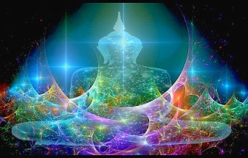
Impermanence forms an important component of dukkha, either because things changing is directly painful to us, or because things we enjoy come to an end. Impermanence may also contribute to a sense that life is meaningless or to existential suffering, if we think that the only things that can give life meaning must be permanent. Ultimately, then, the only solution to impermanence is to find meaning and purpose in what is permanent, that is nirvana. This is expressed in a famous passage in the Udana in the Pali Canon:

The basic mistake we make as regards impermanence, then, is not simply to put our faith in things that are impermanent, but to put our faith in impermanent things even when there is a permanent alternative. This 'permanence' may just consist in a different attitude to what is impermanent, though exactly how it should be interpreted is a matter of debate.

Criticisms

Criticisms of the doctrine of impermanence from non-Buddhists tend to come from two directions. On the one hand there are those who deny that all things except nirvana are impermanent. On the other are those who accept this point but deny that the recognition of impermanence is a positive move.

Those who would disagree that all things are impermanent would include most theists. They would claim that God is permanent and that there may also be other spiritual things that are permanent, such as the soul.

Those with a materialist view are more likely to accept that all material things constantly change, but they may see the point of life as consisting in struggling against this rather than accepting it. For example, human ingenuity may be able to design more durable objects or even cheat human death. Too much acceptance of death may be seen as passive or morbid.

Explain...

1. How can acceptance of anicca help to reduce suffering.
Use examples to aid your explanation.

2. Explain clearly why anicca links to dukkha.

Discussion and notes…

- Does there seem to be anything at all that is permanent?
- Do you agree with the Buddhist teaching that it is positive to understand and accept impermanence?

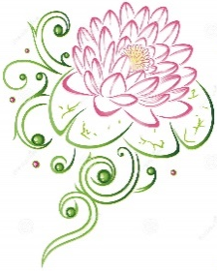

No-self/no soul (anatta)

Denial of the atman
Anatta is the denial of the teaching that there is an atman, which roughly translated means a soul. Atman is the word given in Hinduism to the true self which continues to exist eternally, and which travels from one body to another in the process of reincarnation (as opposed to rebirth in Buddhism). One of the ways in which the Buddha challenged the teaching of the Brahmins (Hindu priests) of his day was by challenging this orthodox Hindu belief in the self. For this reason anatta is often translated as 'no self'.
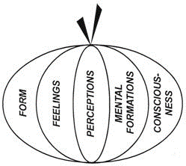
However, the Buddha does not claim that there is definitely not a self, only that the self we tend to identify with is not fixed. Instead, we consist in a process. The teaching of impermanence points out that we are always changing, and this also implies that there is no fixed part of ourselves which remains unchanged. If nothing remains unchanged, there is nothing which can contain a fixed or final identity.
There are various aspects of our bodies and minds which we may identify with and believe to be our true selves, but the Buddhist teaching is that we should avoid attachment to the idea of any of these as really ourselves. It is this which has led to the teaching of the Five Skandhas, which provides an analysis of what we might suppose to be ourselves in order to show that it is all merely process.

Explain...

- Explain the Buddhist idea of ‘no-self’.
- How does the idea of anatta link to the idea of anicca?
- How do the Three Marks of Existence link to each other?

Exam Questions…

- Explore the Buddhist teaching of the Three Marks of Existence. (8 marks)

- Assess the importance of the Three Marks of Existence. (9 marks)

The Five Skandhas

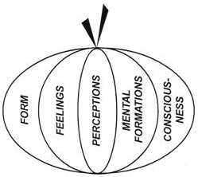
The five skandhas are the five aspects of being which make up (which are) dukkha in its most basic form. The word 'skandha' is sometimes translated as 'aggregates'.
'Aspects of being' may be the best short explanation: they are the five things which, put together, give us the impression of 'I': of a being. According to Buddhism, there is no self or soul I can point to when I want to show what 'I' means, because it is the result of all five skandhas together. Remove one of the skandhas and I would not have any sense of being a self or an individual. Not only are the skandhas interdependent, but they are impermanent and constantly changing. But we constantly try to make a fixed identity out of this shifting flux. This is why we are fundamentally deluded - because we are constantly trying to make something permanent out of what is impermanent. The mismatch between our identity and reality is the cause of sankhara dukkha.

These are the Five Skandhas:
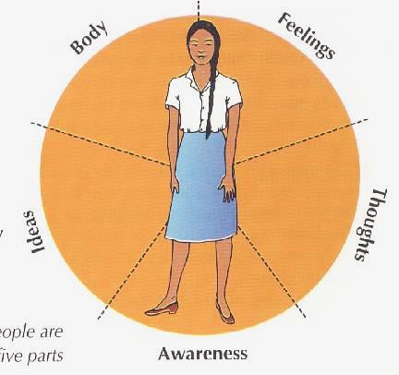
1. Form (Rupa)

Form means all the physical material in the universe, including all the elements, our bodies, our sense-organs (eye, ear, nose, etc.) and the objects which they sense. Everything, in short, which seems to be beyond ourselves or which we can see, hear, feel, touch or taste.
The anatta teaching addresses our assumption that we are our bodies by pointing out the impermanence and insubstantiality of our bodies. It is therefore a mistake to identify too much with the body, which is simply a useful tool for life.

2. Sensations/Feelings (Vedana)

Sensations are what arises from the contact of our sense-organs with the material world. In traditional Buddhism there are 6 senses: sight, hearing, touch, smell, taste and thought. Hence thoughts and ideas are as much objects of sense as things that can be seen or touched. Sensations are the raw data given to us by the eye, ear, mind etc., which have not yet been sorted or identified.
Buddhist teaching will point out that our sensations are constantly changing as the things around us change, and as our sense-organs change. We cannot claim to be our sensations.

3. Perceptions (Sañña)

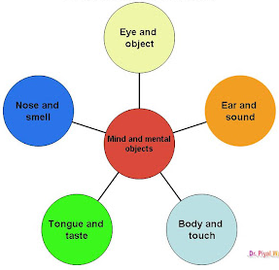
Perception is the recognition of forms provided by the six senses. We compare our sensations with our previous experience and by doing so give them some order. Sensation does not have any meaning without this additional step of perception. Someone who is said to be 'observant' has a good faculty of perception - it may not necessarily be that he/she can actually see better than others.
Our perceptions, like our sensations, are changing. We can also only identify things by comparing them with other things, and never penetrate to what a thing is in itself. We identify things because of their usefulness to us rather than because of what they 'really' are, or because of what we 'really' are.

4. Mental Formations (Sankhara)

This is the crucial stage where we produce a response to our perception. Our will becomes involved so that mental formations are said to include volition – the thought process by which one decides on and commits to a particular course of action.
It is these mental formations which give rise to karma (the mechanism which leads from our action to some kind of moral effect which rebounds back on us). We are responsible for our mental formations, so if we react in the best way ("skilfully") to what we perceive, good moral effects will follow, which will move us towards enlightenment. If we react 'unskilfully', bad moral effects will follow, which will keep us bound to the cycle of samsara.
Our mental formations are what are believed to create the causal connection between one birth and another in Buddhist rebirth. However, since they are always changing, created by new actions or 'expended' by new effects, they can’t possibly be the basis of a fixed self.

5. Consciousness (Viññana)

This is the state of mind brought about by our successive mental formations, providing us with a tendency to react in certain ways. Consciousness is dependent on the other skandhas in the same way as a fire is dependent on its fuel, but the other skandhas are also dependent on it: without the awareness which consciousness provides there can be no perception or mental formations. Consciousness is not thought of as the seat of a soul (unlike in other religions), and it is just as impermanent and fluctuating as all the other skandhas. Not only the objects of consciousness, but the level of our consciousness, fluctuates continually in response to changing conditions.

Things to do.

- Draw and label a diagram to symbolise the Five Skandhas.
- Explain briefly what each of the Five Skandhas are.
- Explain what sankhara dukkha is and how the Skandhas can cause suffering.

Insubstantiality of all objects

Although anatta is often thought of primarily in relation to the absence of a soul in our experience, it can also be applied to any other object. We tend to think about things as having fixed identities, but these identities have been constructed out of what we perceive according to our needs.
Impermanence provides one reason for insubstantiality (lack of substance or reality). Things are not what we usually take them to be, because they are constantly changing and we don’t usually take this into account. For example, if we fall in love with someone else, we rarely have a realistic idea of the way they are liable to change, but rather tend to see them as fixed as they are now.
However, there is more to insubstantiality than impermanence. Another thing we tend not to take into account is the fact that each thing we identify could be described in many other ways than the way we choose to describe them. A 'car' for example, we take to be a distinct object, but it could be described as a collection of metal and other parts, as a collection of atoms, as part of a traffic system, or as part of the earth. When we drive a car we also tend to see ourselves as something separate from the car although we are inside it: but an alien landing on earth for the first time might well see things quite differently, seeing the car as the basic 'thing' and us as a part of it. In The Hitch-hiker’s Guide to the Galaxy, Ford Prefect, makes precisely this mistake, thinking that cars are the dominant life-form on earth and almost getting run over for his pains!
There is also the problem of what is the essential part of an object and what is not. You could remove all the parts of a car bit by bit and it would not be very clear exactly when you ceased to have a car there. For example, would it be a car if it had no engine, or no wheels? Whoever you asked would probably disagree about what the essential features of a car are. From a Buddhist point of view, this all goes to show that there are no essential features, and the labels we give to things are just a matter of convention.
The Ship of Theseus (an old philosophical riddle)

Theseus has a ship which he puts in dry dock. He gets his men to remove the parts of the ship one by one, and with those parts they gradually reconstruct the ship in a different dry dock nearby. However, as the parts are removed, they are replaced, so that when all the old parts have been removed there is still a ship in the original dry dock too. There are now two ships, one constructed out of the parts of the original one, but the other continuous with the original ship in the same place.
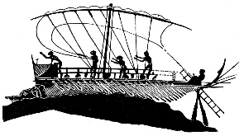
Which of them is Theseus’ original ship?
What would be a Buddhist solution to this riddle?

Anatta and rebirth
There is a traditional problem in reconciling no-self with rebirth. If there is no self, how can you be reborn in a different body? This is a problem if you think of rebirth along the lines of reincarnation, or if you identify with your 'self' in a future life or in a past life. Some Buddhist scriptures appear to do this and thus be contradictory. However, the traditional answer is that rebirth is not the rebirth of a soul or any kind of fixed thing, but merely the continuation of a process whereby karmic formations cause future effects. The reborn self is 'you' in the same sense that a mango tree is the same as the mango it came from, but in no stronger sense.

Dukkha

Dukkha is the First Noble Truth, greater depth can be added to an understanding of dukkha by considering the implications of impermanence and no-self. Dukkha can be analysed into three types according to their relationship with dukkha alone, anicca or anatta.

Dukkha-dukkha is suffering in its straightforward form. It consists of pain and directly unpleasant experience generally. We do not need to appeal to impermanence or insubstantiality to appreciate the presence of dukkha-dukkha, but it does not usually account for our whole experience because we also experience happiness and pleasure.

Viparinama-dukkha is the frustration which arises due to the fact that pleasant experiences are impermanent. When the pleasant experiences end, we continue to want more of them, and thus experience disappointment and mortification. This type of dukkha has a necessary condition in tanha or craving, which continues to operate even when the source of the pleasure does not.

Sankhara-dukkha is the unsatisfactoriness that we experience due to insubstantiality. Even apart from the fact that they are impermanent, things in samsara are not quite satisfying because they don’t fulfil our expectations completely. A new computer doesn’t work as we expect, a holiday isn’t quite as blissful as the brochure led us to expect, and a person has vices that we didn’t take into account at first. This term can also be applied to a sense of dissatisfaction about our whole lives, sometimes called 'existential dukkha', when life as a whole seems meaningless.

Things to do.

- Explain, with examples, each of the different types of suffering.

- How do you think the three laksanas and the three types of dukkha relate to the three poisons (greed, hatred and ignorance)?

- Some early Western commentators on Buddhism rejected the anatta doctrine and claimed that the Buddha could not possibly have taught it because it was so contrary to common sense. Why do you think the doctrine caused so much trouble, and do you think the rejection was justified?

- Non-Buddhist critics tend to argue that the three laksanas make Buddhist doctrine pessimistic. Buddhists would claim it is simply realistic. Which side would you most agree with and why?

Video
As an introduction, watch the Clear Vision DVD Buddhism Today sections on the Three Marks.

Read the passage from The Questions of King Milinda on this (Buddhist Scriptures p.149-151). Are you convinced by Nagasena’s explanation of this problem?

Read the analogy of the chariot from the Questions of King Milinda (Penguin 'Buddhist Scriptures' p.147-149) and make notes. Would you agree with Nagasena’s claims here?

