**..\WINDOWS\Application Data\Microsoft\Media Catalog\Downloaded Clips\cl68\j0260331.wmf..\WINDOWS\Application Data\Microsoft\Media Catalog\Downloaded Clips\cl68\j0260331.wmf**

**Buddhist Scriptures – In More Detail**

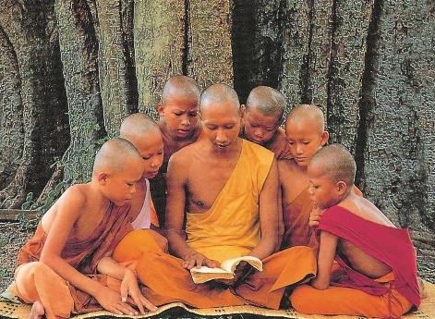

The Vinaya Pitaka.

This scripture contains numerous rules set out by the Buddha in order to produce a cohesive and orderly monastic sangha (community).

It is divided into three sections;

* ***Suttavibhanga***: this is the first book of the Theravadan Vinaya Pitaka. It is a commentary on the Pattimokka - the 227 rules for monks and includes moral rules, rules of etiquette and organisation. These rules deal with eight different types of offences. This includes four rules which, if broken, can lead to expulsion from the order. These are sexual intercourse, theft, murder and falsely claiming supernatural powers. There are then 13 rules which, if broken may include a temporary suspension and require a meeting of the monastic sangha to deal with. Offences in this category would include lesser sexual offences such as masturbation and caressing a woman, offences that would be an abuse of the position of a monk, for example, asking for special treatment, causing quarrels in the community and making false accusations about other monks. Offences against other rules such as accepting money or preaching to a woman alone, may require confession, repentance and penance. There is also a section of rules for nuns which are very similar but stricter in some respects. The pattimokka is recited (uposatha), in full every two weeks by the monks.
* ***Khandhaka***: this contains rules governing the organisation of the sangha, rather than the conduct of individual monks. It covers topics such as admission to the order, the uposatha, ceremonies, rules about dress, furniture, looking after the sick bhikkus, how to deal with splits in the community, procedures for reinstating suspended monks, the ordination of nuns. The khandhaka also includes an account of the first two Buddhist councils after Buddha’s death.
* ***Summary***: this contains a summary of all the rules arranged as a catechism (a series of questions and answers) for instruction and examination purposes.

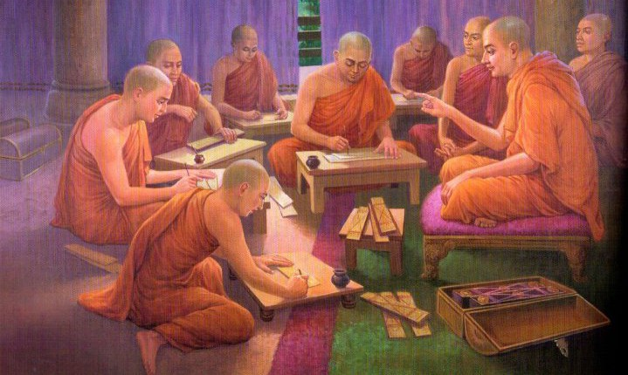

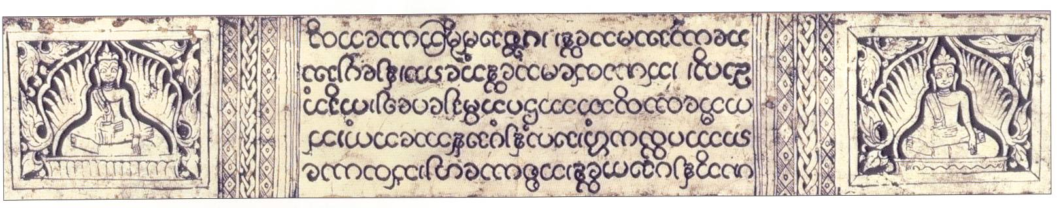

# *Summarise...*

…The main points of each of the three parts of the vinaya pitaka.

*Explain…*

…how does the Vinaya Pitaka aim to produce a cohesive community?



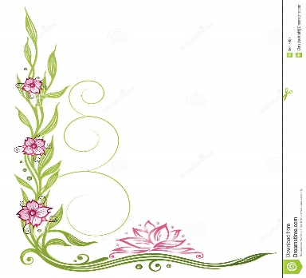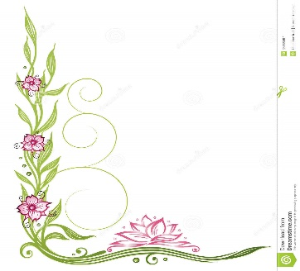

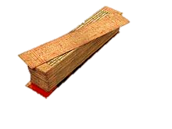

The Sutta Pitaka.

This scripture contains the discourses of Buddha (plus a few sermons by various disciples of Buddha). It is divided into 5 sections;

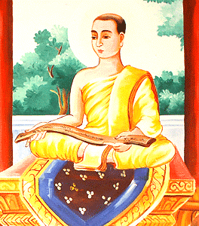***Digha Nikaya***: (collection of long dialogues) this book contains 34 of Buddha’s sermons covering topics such as; false teachings; the advantages of the homeless life; super natural powers and higher states of consciousness; the evil of animal sacrifices; the issues of the soul; the ethics of teaching; the stories of six previous Buddhas; the twelve links of causation; the parinivarna of Buddha and his last words; four types of meditation; why Buddha does not work miracles or explain the origins of the universe; the 32 marks of a great man. It also contains a sermon by Ananda about morality, meditation and wisdom.

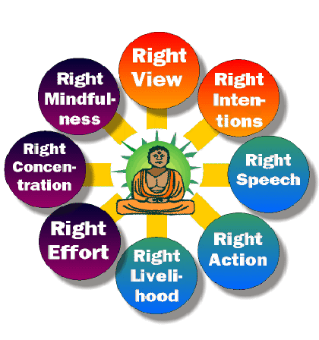***Majjhima Nikaya***: (collection of medium length dialogues) this book contains 152 sermons, divided into 15 subsections. Many of these discourses are about Buddha, his life and his enlightenment. For example discourse 4 gives Buddha’s account of his enlightenment; discourse 21 gives the simile of the saw - that one should maintain compassionate love and self-control even under the worst of circumstances, you should love your enemies even if they would saw you into pieces. Discourse 26 gives an account of Buddha’s renunciation, search and attainment of enlightenment. The Digha Nikaya also contains a sermon (number 44) by a female disciple of the Buddha, showing how women have had an importance place in Buddhism from the start. Discourse 55 explains Buddha’s position on eating meat – animals should not be killed for food, but one can accepts meat if it is offered but not specially killed for that person. Discourse 117 explains the Noble Eightfold Path; 129 explains rewards and punishments after death for good and bad actions in life; 141 outlines the Four Noble Truths.

***Samyutta Nikaya***: (collection of ‘grouped’ discourses) this book contains 2,889 short discourses covering the demon Mara; the twelve links of paticcasamuppadda (dependent orgination); the five skandhas; the different levels of jhana; nirvana; the 37 qualities leading to enlightenment; the Eightfold Path and the Four Noble Truths.

***Anguttara Nikaya***: (collection of ‘gradual sayings) this book contains 2,308 short sayings on topics such as the Buddha; two types of karma (those fulfilled in this life and those fulfilled in the next life); the three good acts; the four types of love; four wrong views 0f belief; four good results of making offerings to monks; the four pilgrimage sites and the 5 mental hindrances.

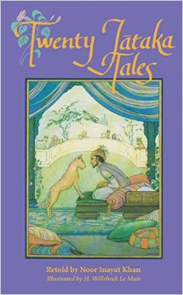

***Khuddaka Nikaya***: (collection of small texts and some of the most famous) this book contains 15 works including sermons on the threefold refuge formula; the metta sutta on loving kindness; the Dhammapada; parables such as the Blind men and the Elephant; the definition of nirvana; descriptions of the temptations of Mara; the Jataka tales (Buddha’s past lives) etc.

The Abidharma Pitaka.

This scripture is not the direct word of the Buddha, but a philosophical treatment of the Dharma presented by the Buddha. Abidharma means higher teaching and is for the more advanced, scholarly Buddhists. It is thought to have been composed at the Third Council in the 3rd century when the community was concerned with the purity of the scriptures. It consists of seven different works including an analyses the nature of existence; categories of different types of human personality (important for teaching meditational techniques); an analysis of Buddhist psychology and an investigation of the workings of causation and interdependence.

*Explain…*

1. What does Abidharma Pitaka mean?
2. How is it different to the other parts of the Tipitaka?
3. When did it come about and why?
4. Note down some of the main works within the Abidharma Pitaka.

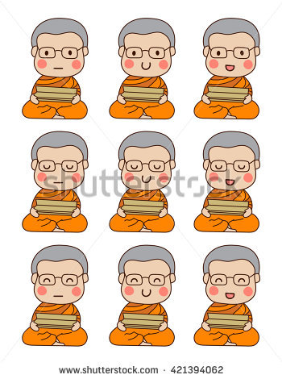

How is the Tipitaka (Pali Canon) used?

The Buddhist scriptures are numerous and as such few Buddhists sits down and reads them in their entirety. Don’t forget the Tipitaka is one of a number of other Buddhist scriptures and is itself very detailed. Lay Buddhists are more likely to rely on monks to pass on and explain the teachings.

As there are many types of literature in the Tipitaka, they have different uses in Buddhist life. The Vinaya are kept by the monastic sangha and the 227 rules are recited every

fortnight. Some parts of the Sutta are known by the majority of Buddhists such as

the parables, the triple refuge formula, the story of Buddha’s life, the Jataka

Tales and advice on meditation. Other parts of the Tipitaka, such as the

Abidharma Pitaka are most known and used by scholars.

Sometimes Theravada Buddhists certain scriptures as a form of protection in times of trouble (recitals known as paritta). For example the Karaniya Metta Sutta (on universal love). It is still considered meritorious to learn sections of the scriptures by heart, as it was originally intended. Selections from the Canon are used in the morning and evening chanting of Theravadan monastic communities.

The Dhammapada is a favourite of modern lay Buddhists and the most likely portion of the scriptures to be found in a lay Buddhist’s home.

Copies of the Canon are treated with great respect. Ancient scriptures are considered to be relics of the Buddha and are buried under stupas.



