**..\WINDOWS\Application Data\Microsoft\Media Catalog\Downloaded Clips\cl68\j0260331.wmf..\WINDOWS\Application Data\Microsoft\Media Catalog\Downloaded Clips\cl68\j0260331.wmf**

**AS Buddhism – Buddha’s Enlightenment**

The Four Stages of Buddha’s Enlightenment.

1. He was visited by a demon called Mara, who liked to see people suffering.

He saw Siddartha meditating. He tried to frighten Siddartha with his army of

devils, with floods and thunderbolts, and to tempt him with feasts and

beautiful women. Siddartha ignored it all and continued meditating.

2. He remembered his past lives on earth.

3. He realised that nothing is permanent, that everything changes and

dies. He saw that everything is kept in a cycle of rebirth and this can only

be set free if we stop wanting things. He discovered that suffering is caused by craving and wanting things – if we see something nice, we can run after it. If we see something nasty we push it away. Because of this we are never satisfied.

4. He defeated a cockerel (symbolising greed), a snake (symbolising

hatred) and a pig (symbolising ignorance), and then he felt completely at

peace. This was enlightenment.

****

D:\mhp\Common\MSShared\Clipart\std4prem\std4dir6\j0110748.wmf



D:\mhp\Common\MSShared\Clipart\std2prem\std2dir1\AN03970_.WMFD:\mhp\Common\MSShared\Clipart\std2prem\std2dir1\AN00180_.wmf



Things to do.

1. Explain the symbolism of the cockerel the snake and the pig in Buddhism.
2. Give examples of actions that may result from being (a) greedy (b) full of hate, and (c) ignorant.

Things to do.

1. What do the cockerel the snake and the pig symbolise in Buddhism? You may draw and label pictures of each if you wish.
2. Give examples of actions that may result from being (a) greedy (b) full of hate, and (c) ignorant. You may do this in cartoon strip form if you wish.

Things to do.

1. What do the cockerel the snake and the pig symbolise in Buddhism? You may draw and label pictures of each if you wish.
2. Give examples of actions that may result from being (a) greedy (b) full of hate, and (c) ignorant. You may do this in cartoon strip form if you wish.

The Significance of Buddha’s Enlightenment.

It should be understood that the Noble Eightfold Path was not created by the Buddha; rather the Path was discovered by the Buddha. The Path is the means to enlightenment. When Buddha rediscovered the Path he made it known again to the world. This is the special and unique function of any Buddha.

From one angle the discovery of the Noble Eightfold Path might be called the primary significance of the Buddha's enlightenment.

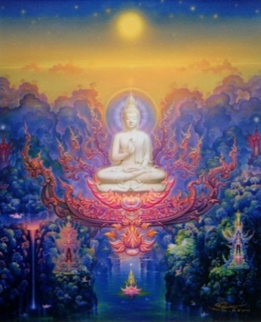Even before Siddartha left the palace he had recognized the unsatisfactory nature of existence. He had discovered the hard facts of old age, sickness and death, lost his worldly complacency, his desire for power, fame and sense pleasures and found compassion. Therefore even from the start he had an intuition, a confidence, that there was a way out of suffering, a state of liberation beyond the cycle of birth and death. What he did not know was the path to escape suffering and with the discovery of the path he was able to escape the trap of ignorance, to reach enlightenment, to attain his own liberation and to guide others to liberation.

Explain...

1. Explain what Siddartha recognised before going on his spiritual journey.
2. What is, perhaps the most important discovery of Buddha’s enlightenment? Why is this?

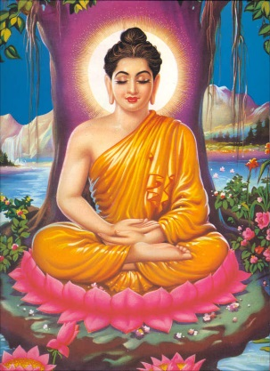After the Enlightenment

Siddhartha's mind was calm and relaxed. As he sat under the tree his concentration deepened and his wisdom grew brighter. In this clear and peaceful state of mind he began to examine the nature of life. "What is the cause of suffering", he asked himself, "and what is the path to everlasting joy?"

He saw how everything was linked together in a constantly changing pattern: growing, decaying and growing again. Everything was related. Nothing happened without a cause and every cause had an effect on everything else (interdependence).

He looked deeply into himself and discovered that his life as Siddhartha the Prince was just the latest in a series of lifetimes that had no beginning - and that the same was true of everyone. He saw that death is only the separation of the mind from its present body. After death the importance of Karma is central to the next journey. After death the mind goes on to find a new body. When one life ends, another begins - and in this way the wheel of death and birth keeps spinning around and around. This is ***samsara***.

He also saw that we are constantly changing and affecting one another (interdependence). Our roles change as we move from life to life. Occasionally we experience pleasure, but more often we find ourselves with problems.

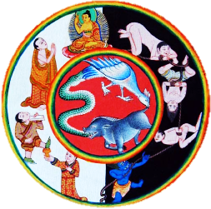

Explain...

1. How did Buddha feel after his enlightenment? What did he believe he had to do next?
2. Explain the idea of interdependence in the Buddhist sense.
3. Briefly explain the concept of Samsara.

Then he looked at all of the suffering in the world. He saw how everyone runs after pleasure, only to end up with dissatisfaction. When we do not find what we are searching for we are miserable, and even when we do find the pleasure we seek it soon fades and we have to look for something else.

He saw how living beings create their own misery and joy. Blind to the truth that everything is always changing, they do anything to get the things that they want, even though these things can never give them the lasting happiness they desire. The more their minds fill with greed and hate, the more they harm each other - and themselves! Each harmful action leads them to more and more unhappiness. They are searching for peace yet find nothing but pain.

Finally, Buddha discovered the way to end all this suffering. If a person could see the truth clearly then the running after pleasure and away from pain would stop. Without any more greed and hatred in our mind, we should never do anything to harm anyone else. With our hatred and selfishness removed, our hearts will fill with love, and this love will bring us complete peace and happiness.

After his realisation he rose from his meditation with a calm and peaceful smile. He understood the meaning of existence. Siddhartha had found the truth, he established the principles of Karma. Now he was the Buddha, the awakened one, enlightened. The search of six years had ended. It was a day when the full-moon shone, a day in the month of Vesak (May).

Explain...

1. According to Buddha, why are we never fully satisfied? Use examples in your answer.
2. How did Buddha say we can end suffering?
3. Explain the concept of karma. Use examples in your answer.

Whom to Teach?

Buddha felt he should teach others about his discovery but he thought, "It was so difficult for me to reach the end of suffering and become a Buddha. Who will be able to follow the teaching I have to give? Who will try hard and long enough?" He thought of the five men who lived with him in the forest. "They are ready to understand the truth." he thought. "I shall teach them first."

He knew that he would find these men in the Deer Park at Sarnath near Varanasi, the holiest city of ancient India. "I shall go there," Buddha proclaimed, "and begin the work I came to do."

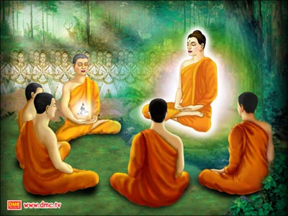

Buddha’s teaching consisted of the knowledge the Dharma, of nibbana, of his own previous lifetimes, knowledge of the passing away and rebirth of all living beings, and finally insight into the Four Noble Truths. He saw that beings are reborn according to the morality of their thoughts, words, and deeds. The morality of one's views and intentions determines the result of one's actions (karma).

What Buddha's Enlightenment means now.

Knowledge of the role that karma plays in life is empowering. It means that what we do, say, and think *does* matter. Buddha’s enlightenment lets us see that the choices we make have consequences. This helps us to face the events we encounter in life because we know that we had a hand in creating them. Feelings of guilt can be countered with the knowledge that with each new choice we can always make a fresh start.

As Buddha says in describing his enlightenment, *"Ignorance was destroyed; knowledge arose; darkness was destroyed; light arose”.* In other words, he gained liberating knowledge through qualities that we can all develop - awareness, focus and compassion. The implications of this suggest that a life devoted to wealth, status, or sensual pursuits is one of spiritual poverty. It also forces us to take a hard look at other more "worthwhile" goals, such as social acceptance, meaningful relationships, stewardship of the planet, etc. These, too, will inevitably lead to suffering. The interdependence of all things cannot be a source of security or comfort. It only makes sense that we invest our efforts and whatever mental and spiritual resources we have towards enlightenment as this is the only freedom from suffering. Buddha’s enlightenment can assure us that happiness comes from developing qualities within ourselves that we can be proud of, such as kindness, sensitivity, calmness, mindfulness, conviction, determination, and discernment. This is a very different message from the one we pick up from the world telling us that in order to gain happiness we have to gain material possessions; self-aggrandizement, etc.

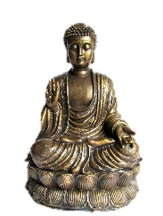

Explain...

1. What did Buddha do following his enlightenment?
2. What did his main teaching consist of at this time?
3. How did Buddha describe his enlightenment? Explain using a quotation.