**..\WINDOWS\Application Data\Microsoft\Media Catalog\Downloaded Clips\cl68\j0260331.wmf..\WINDOWS\Application Data\Microsoft\Media Catalog\Downloaded Clips\cl68\j0260331.wmf**HH01472_

**AS Buddhism – The Life of Siddartha Gautama**

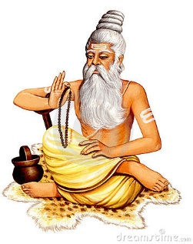Siddartha Gautama was born in northeast India about two and a half thousand years ago. Before he was born his mother, Queen Mahamaya had a dream. She dreamt that her child would either be a powerful king or a holy man. Her husband, King Suddhodama, was very worried. He did not want his son to become a sadhu or holy man. When Siddartha was born the king ordered that he must be kept away from ordinary people and made sure he did not see any person or creature suffering. Siddartha was surrounded by luxurious things, but he was kept within the palace grounds. When he was old enough he was married to a beautiful princess called Yashoda and they later had a son.

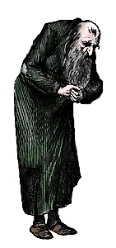j0127130j0137905Despite all his luxuries Siddartha was curious about life outside the palace. So he asked his driver, Khanna to take him beyond the grounds of the palace. The first thing they saw was an old man. They then saw a sick man and then a funeral cortège. Siddartha could not understand why these people were suffering. Then they saw a holy man who had given up his possessions to try to understand what life meant. Siddartha decided that he must give up all his worldy possessions and follow a spiritual journey towards the meaning of life. After a long time seeking the truth without success Siddartha sat under a pipal tree and meditated. Eventually he achieved enlightenment, he had realised the truth about life. The pipal tree became known as the Bodhi tree and Siddartha became known as Buddha, the enlightened one. Through his enlightenment Buddha came to believe that life was full of suffering but through enlightenment that suffering could end.

Questions.

1. What was the life Siddartha Gautama was born into like?

2. Why did the king keep Siddartha away from any form of suffering?

3. After seeing the Four Sights, Siddartha embarked on his spiritual journey for the ‘truth’.

How did he do this? Why did this not work?

4. Was does the word ‘Buddha’, mean?

5. What do you think it means to become enlightened?

6. Why is Buddha important to Buddhists? Explain at least 3 reasons for your answer.

The symbolism of a Buddharupa.

Explain the symbolism in the statue of Buddha (Buddharupa) on this page. Focus on the following;

* The tree
* The way Buddha is sat
* The expression on his face
* The long ear lobes
* The circle of light around Buddha’s head
* The mudra (hand position)

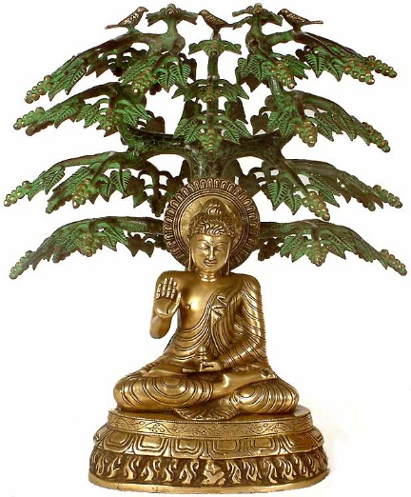

How does this symbolism show the significance of Buddha for Buddhists?

