Paper 4, Option 4A: Buddhism

1. Religious beliefs, values and teachings

  - The Four Noble Truths as the basis of Buddhism and the centrality of such for different Buddhists

a) The Three Poisons.

b) the Buddha’s teaching on suffering and the cessation of craving/desire in the Four Noble Truths: dukkha, samudaya/tanha, nirodha and magga. Including reference to the nature of Enlightenment and nibbana.

c) The Eightfold Path: its summary in the Three-fold Way: ethics, meditation and wisdom the ethical principles of the Noble Eightfold Path: right action, right speech, right livelihood the qualities of metta, karuna and khanti.

d) The relationship between these principles and the Four Noble truths.
How these are understood in Theravada and Mahayana, both historically and in the contemporary world.

With reference to the ideas of D Keown and B Bodhi.

  - How the three marks and the Five khandas are understood in Theravada and Mahayana, both historically and in the contemporary world, including how they may be linked to the rejection of the idea of the self and the non-existence of God.
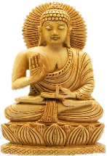
a) The three marks of existence and how these are reflected throughout existence and also through Buddhist teachings. The importance of this in understanding the nature of reality, the ultimate reality, and the meaning and purpose of life.

b) The Five khandas in Theravada; death and the afterlife: the concept of rebirth, Nibbana, karma and the search for Enlightenment. The importance of this in understanding the nature of reality, the ultimate reality, and the meaning and purpose of life.

With reference to the ideas of Buddhaghosa in the Visuddhimagga and T W Rinpoche.

  - The meaning and significance of the three refuges: the Buddha, dhamma and the sangha

a) The significance of each of these for a place of refuge within Buddhism.

b) The interrelationship between these three refuges.

c) Different interpretations of the role and nature of the sangha and the role and nature of the Buddha.

d) The implications of the refuges for worship and daily life.

How these are understood in Theravada and Mahayana, both historically and in the contemporary world. With reference to the ideas of B Bodhi and T Bhikkhu.

  - Key Moral Principles
a) The Five Precepts.

b) How these are understood in Theravada and Mahayana both historically and in the contemporary world.

With reference to the ideas of P Harvey and B Bodhi.

2. Sources of wisdom and authority

2.1 The life and work of the Buddha, its meaning and significance in its historical, religious and social context and the important teachings that his life exemplifies.

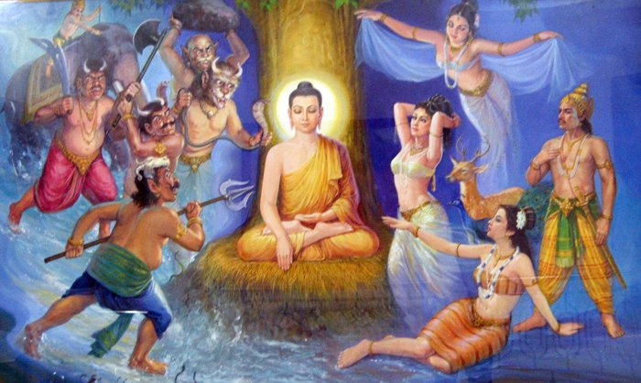
a) The key events of his life, including birth, childhood, the four sights, life as an ascetic, search for Enlightenment, founding of the sangha, preaching, his death and parinibbana.

b) Links with a range of religious groupings at this time, including their beliefs and practice.

c) Understanding and assessment of sacrifices, caste systems, social and economic groupings and changes; types of authority and kingship.

With reference to the ideas of K Armstrong and N Bhikkhu.

2.2 The significance, interpretation, use and treatment of the Tipitaka.

a) The status of the Tipitaka as the teachings of the Buddha and its collection and formation.
b) The different sections, along with their context and:

o Vinaya Pitaka and how this aims to produce a cohesive community
o Sutta Pikata and the search for Enlightenment
o Abhidhamma Pitaka and interpretation and understanding of the Buddha’s teachings and a consideration of whether this is the work of the Buddha himself.

c) The significance of the Tipitaka as the source of the Buddha’s teachings and its use, importance and impact as a source of wisdom in Buddhism.

With reference to the ideas of D Keown and M Meghaprasara.

3 Practices that shape and Express religious identity

3.1 Distinctive practices and emphases of Theravada Buddhism and how they shape and express religious identity.

a) Its significance as the only surviving form of Nikaya

b) Rejection of the idea of the Three Vehicles.

c) The centrality of Buddha Gautama, especially in their use of images and stupas.

d) The goal of nibbana and parinibbana as a central teaching alongside an emphasis on renunciation, including the four stages to becoming an arahant.
e) The distinctive teachings of Theravada; their interpretation and application in light of the life and teachings of the Buddha and other traditions of Buddhism and their different emphases.

With reference to the ideas of R Gombrich and H Gunaratana.

3.2 Distinctive practices and emphases of Mahayana Buddhism and how they shape and express religious identity
a) Its development and context in the second century BCE and the first century.

b) The extension of the concept of the Buddha to include the Buddha and creation. The specific concept of the Buddha as a cosmic presence that influences the world.

c) The Buddha nature in every person. The centrality of Buddha Gautama, especially in their use of images and stupas.

The different schools of Mahayana should be explored in the context of the countries in which they developed and are practised.

With reference to the ideas of A Basham and the 14th Dalai Lama.

3.3 The different types and purposes of meditation, their context and application and how they shape and express religious identity.

a) The different types of meditation in Buddhism.

b) The place and context of meditation as part of the Noble Eightfold Path, links to wisdom and morality, including the influence of types of meditation on moral development.

c) The practice and purpose of dhyana, samatha and vipassana as types of meditation, including accounts of meditation techniques, their purposes and context.

d) Understanding of the purposes of meditation in terms of Enlightenment and the relative importance of some aspects of meditation. The practices of chanting, giving and study to understand Buddhism as it is lived by laypeople as well as monastics.

With reference to the ideas of T Bhikkhu and J Goldstein.

