Born Again by Josh Garrels
https://www.youtube.com/watch?v=iBWeRK-j0Hw
Lyrics
[verse 1]
I came into the world, into the wild
No place for a child
Used my voice to howl
With the ghouls of night
In the dying light
Had to learn to get what I need
In the dark, empty instincts are guiding me
Like a beast to some blood
And I can’t get enough
I’m losing control; my body, my soul
Are slowly fading away
But I’m ready now
To feel the power of change

[Chorus]
I’m my mother’s child I’m my father’s son
It took me awhile
But my time has come
To be born again

[Verse 2]
Running scared in between what I hate
And what I need
Savior and enemy are both trying
To take my soul
And I can’t hide no more
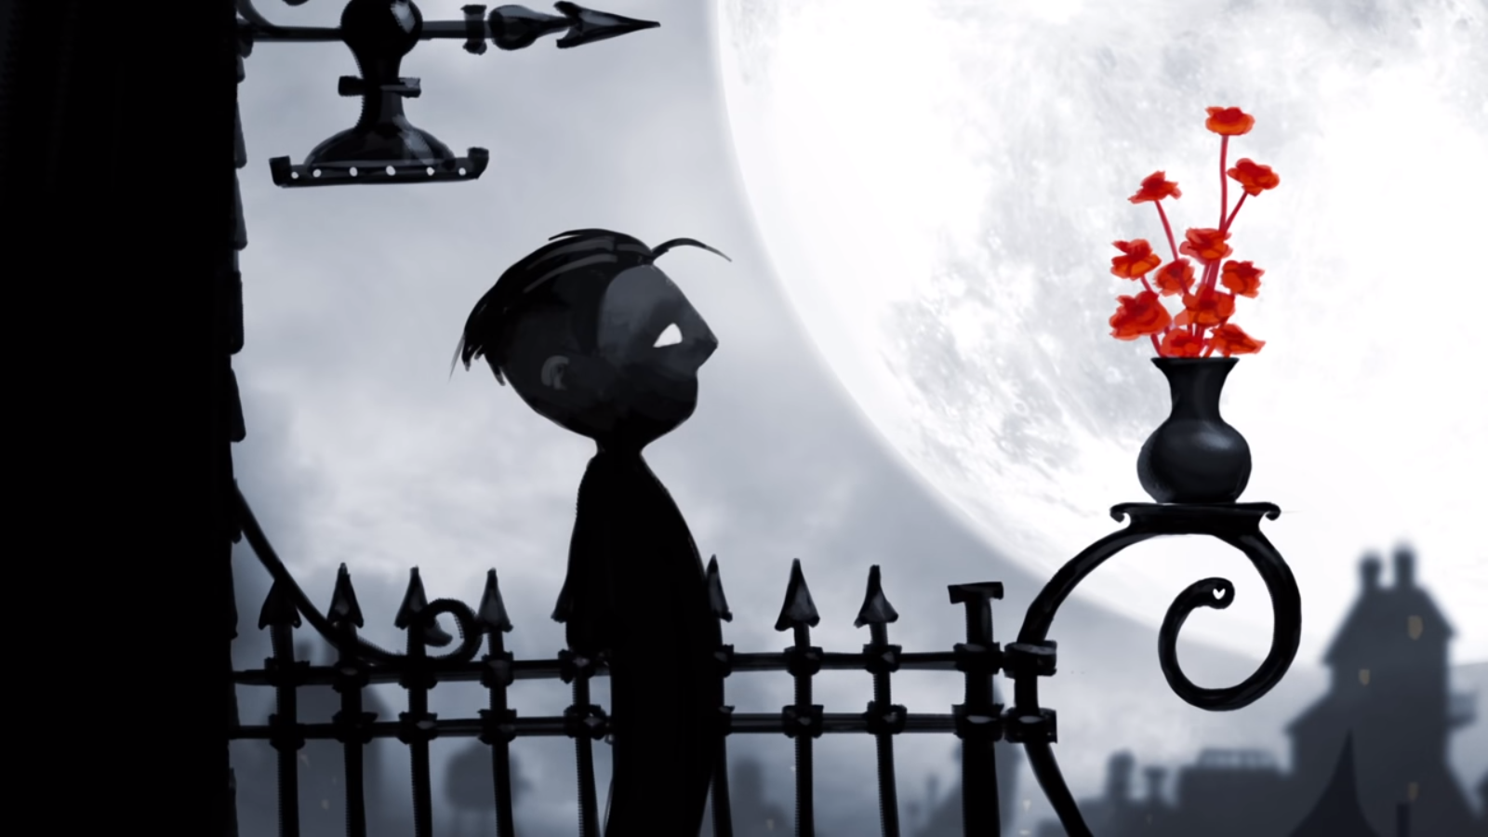Stumble out to the light
Raise my fist up to fight
Then I catch your eye
So full of love Lord, what have I done?
I cry at your feet, wounded for me
And all of the monsters and men
But here in your light
We can begin again

[Chorus]
I’m my mother’s child
I’m my father’s son
It took me a while
But my time has come
To be born again

Visit Josh Garrels website for more information: http://joshgarrels.com
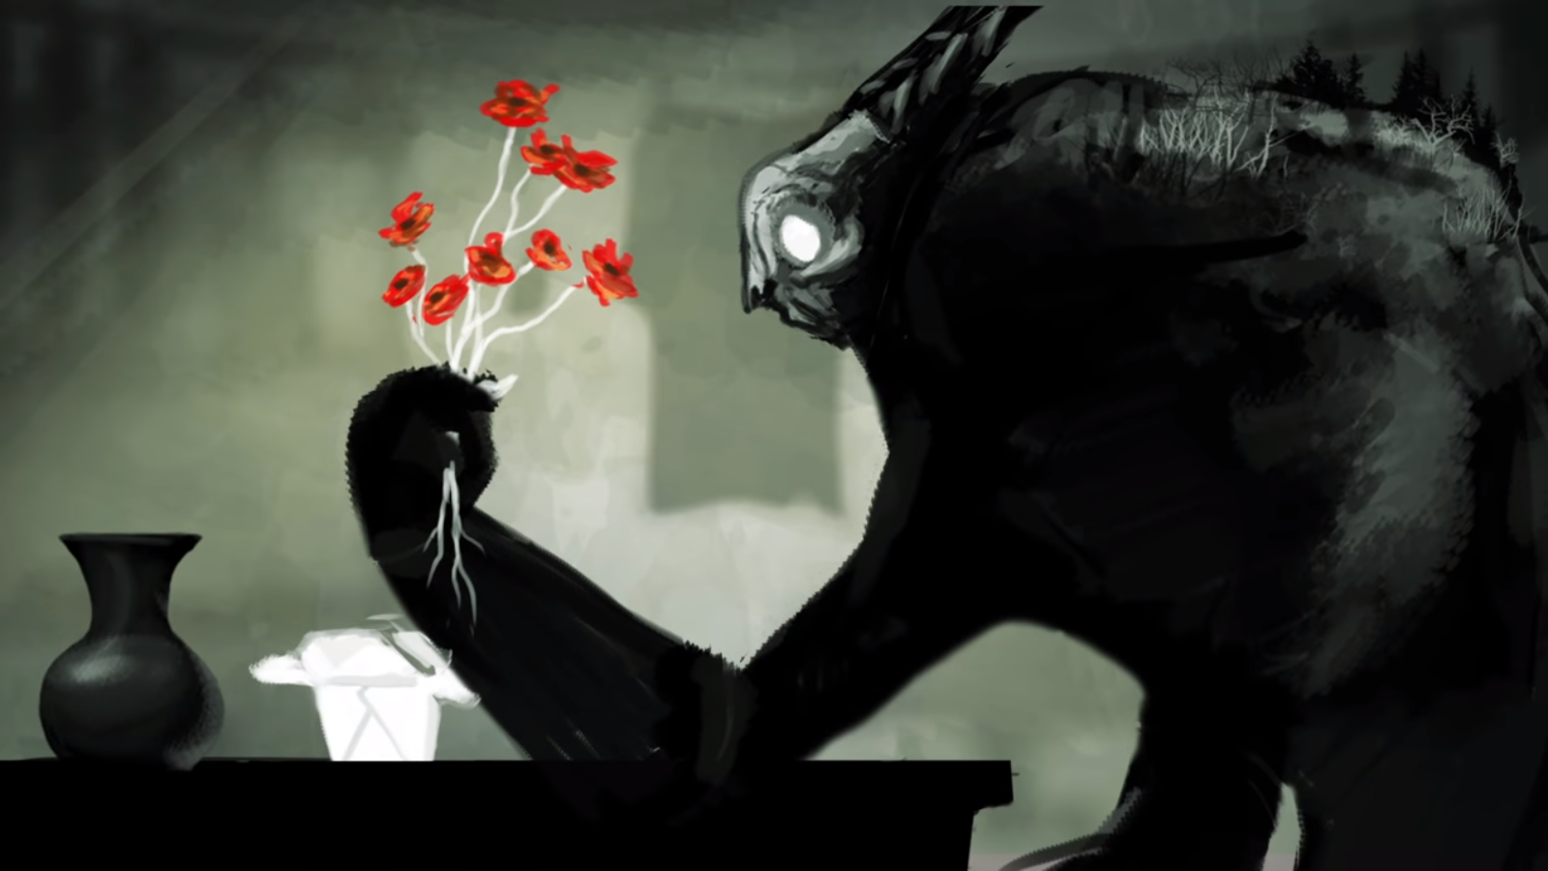
Born Again by Josh Garrels
Born Again by Josh Garrels
- What is the relationship between the boy/man and the monster?
- In verse 1 what does Josh Garrels mean when he says, ‘In the dark, empty instincts are guiding me like a beast to some blood and I can’t get enough,’?
- How does the video show the boy being corrupted by sin?
- What social issues are referred to in the music video?
- In verse 2 what does it mean, ‘Running scared between what I hate and what I need, Savior and enemy are both trying to take my soul,’?
- In verse 2 he raises up his fist to fight but what stops him?
- Why were ‘your feet wounded for me and all of the monsters and men,’?
- What optimism about crime is there in this song?
- What Christian doctrine might Josh Garrels be referring to when he says, ‘I’m my mother’s child, I’m my father’s son,’?

- What is the relationship between the boy/man and the monster?
- In verse 1 what does Josh Garrels mean when he says, ‘In the dark, empty instincts are guiding me like a beast to some blood and I can’t get enough,’?
- How does the video show the boy being corrupted by sin?
- What social issues are referred to in the music video?
- In verse 2 what does it mean, ‘Running scared between what I hate and what I need, Savior and enemy are both trying to take my soul,’?
- In verse 2 he raises up his fist to fight but what stops him?
- Why were ‘your feet wounded for me and all of the monsters and men,’?
- What optimism about crime is there in this song?
- What Christian doctrine might Josh Garrels be referring to when he says, ‘I’m my mother’s child, I’m my father’s son,’?
Born Again by Josh Garrels
- What is the relationship between the boy/man and the monster?
- In verse 1 what does Josh Garrels mean when he says, ‘In the dark, empty instincts are guiding me like a beast to some blood and I can’t get enough,’?
- How does the video show the boy being corrupted by sin?
- What social issues are referred to in the music video?
- In verse 2 what does it mean, ‘Running scared between what I hate and what I need, Savior and enemy are both trying to take my soul,’?
- In verse 2 he raises up his fist to fight but what stops him?
- Why were ‘your feet wounded for me and all of the monsters and men,’?
- What optimism about crime is there in this song?
- What Christian doctrine might Josh Garrels be referring to when he says, ‘I’m my mother’s child, I’m my father’s son,’?

Born Again by Josh Garrels
- What is the relationship between the boy/man and the monster?
- In verse 1 what does Josh Garrels mean when he says, ‘In the dark, empty instincts are guiding me like a beast to some blood and I can’t get enough,’?
- How does the video show the boy being corrupted by sin?
- What social issues are referred to in the music video?
- In verse 2 what does it mean, ‘Running scared between what I hate and what I need, Savior and enemy are both trying to take my soul,’?
- In verse 2 he raises up his fist to fight but what stops him?
- Why were ‘your feet wounded for me and all of the monsters and men,’?
- What optimism about crime is there in this song?
- What Christian doctrine might Josh Garrels be referring to when he says, ‘I’m my mother’s child, I’m my father’s son,’?

