[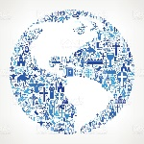](https://www.google.co.uk/url?sa=i&rct=j&q=&esrc=s&source=images&cd=&cad=rja&uact=8&ved=0ahUKEwjdlcj2_9_YAhVMCMAKHZ1YAcEQjRwIBw&url=https://www.istockphoto.com/vector/globe-christianity-and-religion-vector-illustration-gm696954798-129038863&psig=AOvVaw00Oh_CJ_7V4iixZpFULYQR&ust=1516312873096652)

**Church Growth**

Christian numbers.

Approximately ____ __________ of the world’s population claim some

sort of Christian faith. This figure includes __________________________

____________________________________________________________

____________________________________________________________

The Church grew rapidly from the time of Christ and is still doing so in ___________ ________________, _____________ and _____________.

This is not the case in the _______ and _____________ or in countries

where Christians are __________________.

In 2017 the number of ______________ in the world was reported to be

1.28 billion, making it the biggest of the Christian denominations. It is

estimated that Church membership in Africa is increasing by __________

per _______! Worldwide that number is ___________ per day!

Ways in which the Church gets its message to people.

1. _____________________________________________________
2. _____________________________________________________
3. _____________________________________________________
4. _____________________________________________________
5. _____________________________________________________

Discipleship.

The Great ________________ as described by ___________ *(Matthew 28:19)* was to make ________________, not just new _______________. So the Christian mission involves _________________ and also training new ______________ in the way of following ___________ which includes _________________ the ___________.

*35*

Christ for all Nations (CfaN).

This organisation began in __________. It has held __________________

missions throughout the ____________ and particularly in ___________.

CfaN was started by Richard ____________ who believed _______ called

him to be an ___________________ in Africa. He has held evangelistic

meetings across ____________. At first attendances were ____________

but he had dreams in which he believed ________ spoke to him and said,

‘Africa shall be ___________’. This inspired him to organise large

___________. His open air meetings now attract ________________ of

___________________ of people. One rally in ______________ was

estimated to have had _______________ people attending.

CfaN produces ___________ and ______________ which have been

translated into over _______ languages and nearly ________ million have

been printed. They claim that over _____ million people worldwide have

filled in _____________ _________ to follow __________ at its meetings.

[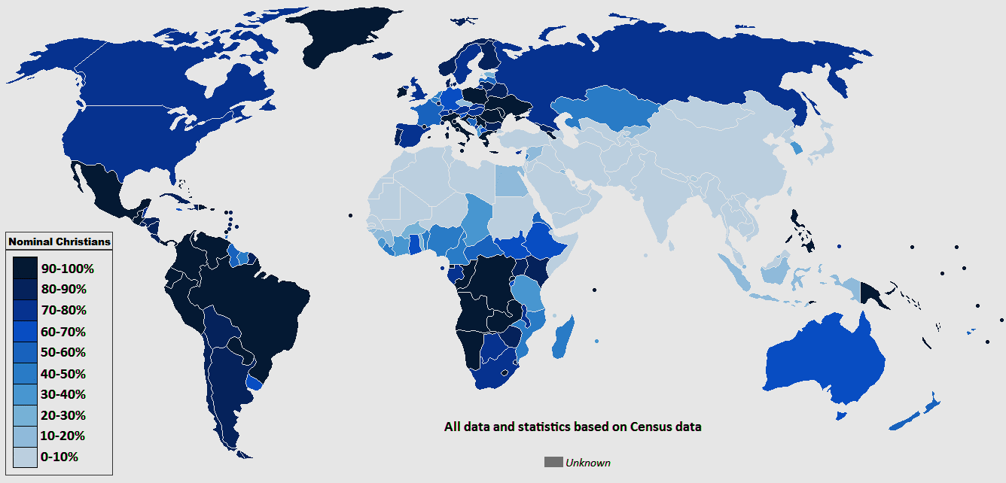](https://www.google.co.uk/url?sa=i&rct=j&q=&esrc=s&source=images&cd=&cad=rja&uact=8&ved=0ahUKEwj04PHl-t_YAhXMJ8AKHfJABakQjRwIBw&url=https://www.reddit.com/r/MapPorn/comments/2eybd7/global_map_of_christianity_1336x642/&psig=AOvVaw1LI_WqBr1xjW6FhBTmR7YV&ust=1516311395733756)

*36*



*37*

Research – I.L.

Find out about the God Channel and explain how this

channel is evangelical and helps the spread of Christianity.

Their Mission _____________________________________________

_________________________________________________________

_________________________________________________________ _________________________________________________________ _________________________________________________________

Their Vision ______________________________________________ _________________________________________________________ _________________________________________________________ _________________________________________________________ _________________________________________________________

What they believe _________________________________________ _________________________________________________________

_________________________________________________________ _________________________________________________________ _________________________________________________________ __________________________________________________________________________________________________________________ _________________________________________________________ _________________________________________________________ __________________________________________________________________________________________________________________ _________________________________________________________ _________________________________________________________ __________________________________________________________________________________________________________________ _________________________________________________________ _________________________________________________________ _________________________________________________________