[](https://www.google.co.uk/url?sa=i&rct=j&q=&esrc=s&source=images&cd=&cad=rja&uact=8&ved=0ahUKEwjR6M3P4sDYAhUjBMAKHUPUCgsQjRwIBw&url=https://www.irishchurches.org/news/4539/winter-general-meeting-of-bishops-concludes-in-maynooth&psig=AOvVaw1xLDt6Phaji0HguXeVM6Kq&ust=1515239773602374)

Pilgrimage is the ___________________________________________

________________________________________________________.

**Christian Practice – Pilgrimage**

Christians go on pilgrimage to many places across the world the

_______ Land, particularly ________________ is one of those places.

Christians go there because __________________________________

_________________________________________________________

_________________________________________________________

Five reasons why Christians go pilgrimage …

1. _______________________________________________________

_______________________________________________________

2. _______________________________________________________

_______________________________________________________

3. _______________________________________________________

_______________________________________________________

4. _______________________________________________________

_______________________________________________________

5. _______________________________________________________

_______________________________________________________

Three possible results of Christian pilgrimage …

1. _______________________________________________________

_______________________________________________________

2. _______________________________________________________

3. _______________________________________________________

*19*

l

**Iona**

Two reasons why Iona became a place of pilgrimage (1) ___________

__________________________________________________

____ __________________________________________________

_________________________________________________________

(2) ______________________________________________________

_________________________________________________________

_________________________________________________________

Today pilgrims to the Iona Community will ______________________

_________________________________________________________

_________________________________________________________

_________________________________________________________

**Lourdes**

Lourdes became a place of pilgrimage because __________________

__ ________________________________________________

__ ________________________________________________

_________________________________________________________

_________________________________________________________

_________________________________________________________

_________________________________________________________

Pilgrims go to Lourdes today to _______________________________

_________________________________________________________

_________________________________________________________

_________________________________________________________

_________________________________________________________

[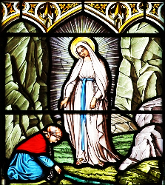](https://www.google.co.uk/url?sa=i&rct=j&q=&esrc=s&source=images&cd=&cad=rja&uact=8&ved=0ahUKEwi38OHtn8HYAhXqJMAKHbt7DegQjRwIBw&url=http://www.sspeterandpaulsparishathlone.com/diocesan-pilgrimage-to-lourdes/&psig=AOvVaw1JO41ZI_kjEyCrHetvXaRA&ust=1515256269660226)

[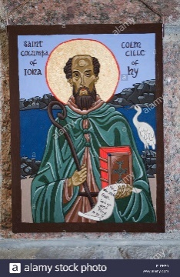](https://www.google.co.uk/url?sa=i&rct=j&q=&esrc=s&source=images&cd=&cad=rja&uact=8&ved=0ahUKEwi9-uyB4sHYAhWhCsAKHQi6CiAQjRwIBw&url=http://www.alamy.com/stock-photo-bishops-house-chapel-iona-wall-hanging-icon-depicting-st-columba-argyll-87164476.html&psig=AOvVaw22LdV8kDhg9V0ey9hIREjf&ust=1515274086613279)

*20*

**I.L. – Research two testimonies (experiences) of Christians on different pilgrimages.**

Example 1: Name of Pilgrim __________________________________

Place of Pilgrimage _________________________________________

Testimony________________________________________________

_________________________________________________________

_________________________________________________________

_________________________________________________________

_________________________________________________________

_________________________________________________________

_________________________________________________________

_________________________________________________________

_________________________________________________________

_________________________________________________________

Example 2: Name of Pilgrim __________________________________

Place of Pilgrimage _________________________________________

Testimony________________________________________________

_________________________________________________________

_________________________________________________________

_________________________________________________________

_________________________________________________________

_________________________________________________________

_________________________________________________________

_________________________________________________________

_________________________________________________________

_________________________________________________________

g

*21*