[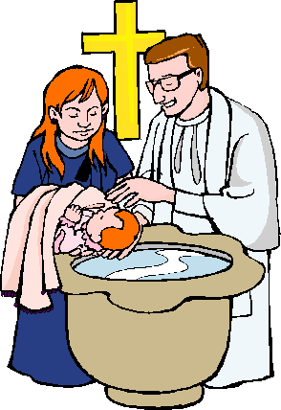](https://www.google.co.uk/url?sa=i&rct=j&q=&esrc=s&source=images&cd=&cad=rja&uact=8&ved=0ahUKEwjjupHJyLTYAhWmAMAKHRlJDSwQjRwIBw&url=http://laoblogger.com/religious-baptism-clipart.html&psig=AOvVaw1Eg-Ex7H4KYDVkkkoocPye&ust=1514820470265604)

**Christian Practices**

**The sacraments - Baptism**

**baptism**

***What are sacraments?***

Sacraments are ___________ ______________ that ______________

_________________________________________________________

________________________________________________________.

***Sacraments in the Catholic Church.***

In the Catholic Church there are ___________ sacraments which they

believe were initiated by _________________.

1. ______________________ 2. ___________________________

3. __________ ____________________ 4. ___________________

5. __________ _______________ (becoming a _____________ etc)

6. _____________________ 7. ________________ the ________.

*9*

***Sacraments in the Protestant churches.***

Many Protestant churches ___________________________________

_________________________________________________________

_________________________________________________________

Some churches practise _____________________ _______________

but do not _______________________________________________.

*9*

***Sacraments in the Non-conformist churches.***

Some churches such as the Salvation Army and the Quakers ________

________________________________________________________.

*9*

*10*

[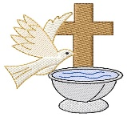](https://www.google.co.uk/url?sa=i&rct=j&q=&esrc=s&source=images&cd=&cad=rja&uact=8&ved=0ahUKEwjysv6upLnYAhVpLsAKHSgqCpMQjRwIBw&url=https://www.greatnotions.com/pr/embroidery/grand-slam-designs/baptism-logo/1/icg419.aspx&psig=AOvVaw1Ef3MxjlEllAoh_Y5mpdPE&ust=1514982649667488)

**The sacraments - Baptism**

Baptism is ________________________________________________

_________________________________________________________

________________________________________________________.

In Baptism a person is formally _______________________________

_________________________________________________________

________________________________________________________.

John the Baptist baptised _____________ in the river _____________

this set an ________________ for _____________________________

_______________________________________________________ in

order to receive the _____________ _______________.

*11*

*Infant Baptism*

Catholic Christians baptise babies because they believe ___________

_________________________________________________________

________________________________________________________.

They believe infant baptism removes ___________________ _______

*Three things that are part of the infant baptism ceremony are …*

1. _______________________________________________________

_______________________________________________________

2. _______________________________________________________

_______________________________________________________

3. _______________________________________________________

_______________________________________________________

*Believers’ (Adult) Baptism*

Baptist Christians do not baptise babies because they think that …

_________________________________________________________

_________________________________________________________

________________________________________________________.

They believe infant baptism removes ___________________ _______

*Three things that believers’ baptism involves are…*

1. _______________________________________________________

_______________________________________________________

2. _______________________________________________________

_______________________________________________________

3. _______________________________________________________

_______________________________________________________

s

[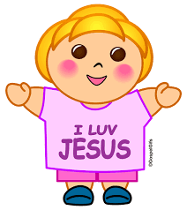](https://www.google.co.uk/url?sa=i&rct=j&q=&esrc=s&source=images&cd=&cad=rja&uact=8&ved=0ahUKEwiqsJy48LnYAhUBDcAKHcmJD-UQjRwIBw&url=http://clipart-library.com/colorful-christian-cliparts.html&psig=AOvVaw0ReHDRj5AmpwcFI80KAF8C&ust=1515003021079528)

[](https://www.google.co.uk/url?sa=i&rct=j&q=&esrc=s&source=images&cd=&cad=rja&uact=8&ved=0ahUKEwj3woCluLnYAhVrDcAKHYrnDIsQjRwIBw&url=http://tvtropes.org/pmwiki/pmwiki.php/Main/ThePigPen&psig=AOvVaw0kH1LdYj2PDkmVTFmadcn1&ust=1514987902247312)

[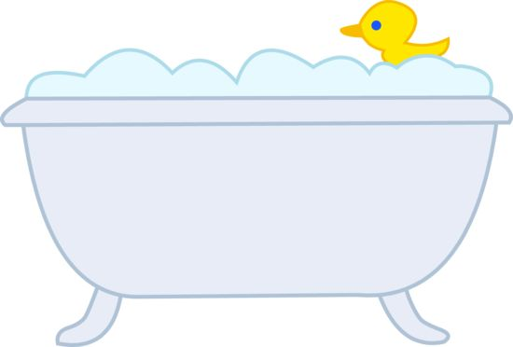](https://www.google.co.uk/url?sa=i&rct=j&q=&esrc=s&source=images&cd=&cad=rja&uact=8&ved=0ahUKEwj7-_bFuLnYAhWmKcAKHRY2DjkQjRwIBw&url=http://weclipart.com/bath%2Bclipart&psig=AOvVaw0L89qExoGFMromkC9b6g36&ust=1514988078292314)

Coming out of the water symbolises… __________________________________________

Going into the water symbolises… __________________________________________

Being in the water symbolises… __________ ____________________ ____________________

*12*

In the boxes above, explain the symbolism of Believers’ baptism.