

**Christian Practices - Prayer**

[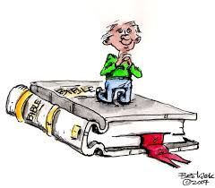](https://www.google.co.uk/url?sa=i&rct=j&q=&esrc=s&source=images&cd=&cad=rja&uact=8&ved=0ahUKEwiy5vGbn7TYAhWLLMAKHQTyAZsQjRwIBw&url=http://clipart-library.com/clipart/2044806.htm&psig=AOvVaw0P3l0FV5ge4qf2eOd323FJ&ust=1514808888308540)[](https://www.google.co.uk/url?sa=i&rct=j&q=&esrc=s&source=images&cd=&cad=rja&uact=8&ved=0ahUKEwjol9iynrTYAhUDC8AKHV8TAdUQjRwIBw&url=http://clipart-library.com/clipart/695972.htm&psig=AOvVaw0P3l0FV5ge4qf2eOd323FJ&ust=1514808888308540)Why do Christians pray? Complete the spider diagram. [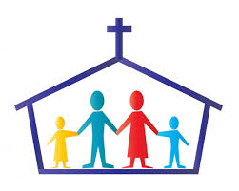](https://www.google.co.uk/url?sa=i&rct=j&q=&esrc=s&source=images&cd=&cad=rja&uact=8&ved=0ahUKEwjIl82w4LLYAhWFLcAKHVFgBVAQjRwIBw&url=http://www.unitedfaithmortgage.com/2016/09/14/life-after-bankruptcy/&psig=AOvVaw0J5WknO67Y3rH7GDpvP1y2&ust=1514758231360134)

[](https://www.google.co.uk/url?sa=i&rct=j&q=&esrc=s&source=images&cd=&cad=rja&uact=8&ved=0ahUKEwjIl82w4LLYAhWFLcAKHVFgBVAQjRwIBw&url=http://www.unitedfaithmortgage.com/2016/09/14/life-after-bankruptcy/&psig=AOvVaw0J5WknO67Y3rH7GDpvP1y2&ust=1514758231360134)

**Christian**

**Prayer**

[](https://www.google.co.uk/url?sa=i&rct=j&q=&esrc=s&source=images&cd=&cad=rja&uact=8&ved=0ahUKEwi074iKnbTYAhXHDsAKHf_KA-IQjRwIBw&url=http://www.thinkstockphotos.co.uk/image/illustration-praying-kids/185618186&psig=AOvVaw0P3l0FV5ge4qf2eOd323FJ&ust=1514808888308540)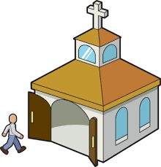

[](https://www.google.co.uk/url?sa=i&rct=j&q=&esrc=s&source=images&cd=&cad=rja&uact=8&ved=0ahUKEwjIl82w4LLYAhWFLcAKHVFgBVAQjRwIBw&url=http://www.unitedfaithmortgage.com/2016/09/14/life-after-bankruptcy/&psig=AOvVaw0J5WknO67Y3rH7GDpvP1y2&ust=1514758231360134)

Prayer is ________________________ ______________ __________.

There are set prayers, for example ____________________________

________________________________________________________.

There are also ______________________ ____________________.

[](https://www.google.co.uk/url?sa=i&rct=j&q=&esrc=s&source=images&cd=&cad=rja&uact=8&ved=0ahUKEwjIl82w4LLYAhWFLcAKHVFgBVAQjRwIBw&url=http://www.unitedfaithmortgage.com/2016/09/14/life-after-bankruptcy/&psig=AOvVaw0J5WknO67Y3rH7GDpvP1y2&ust=1514758231360134)

Different Christians pray in different ways, for example, Catholics may use _______________ __________. Anglicans may ______________

and Orthodox Christians use ______________ (religious pictures).

*5*

*1*



There are different types of prayer;

• Adoration - offering praise to God thanking him for his creation,

greatness and power.

• Confession – confessing sins and asking God for forgiveness.

• Intercession - praying to God in behalf of someone else. Through

prayer Christians become more aware of the needs of others so they

pray for the sick, homeless, hungry, poor etc.

• Petition - asking God for something.

**Christian Practices - Prayer**

[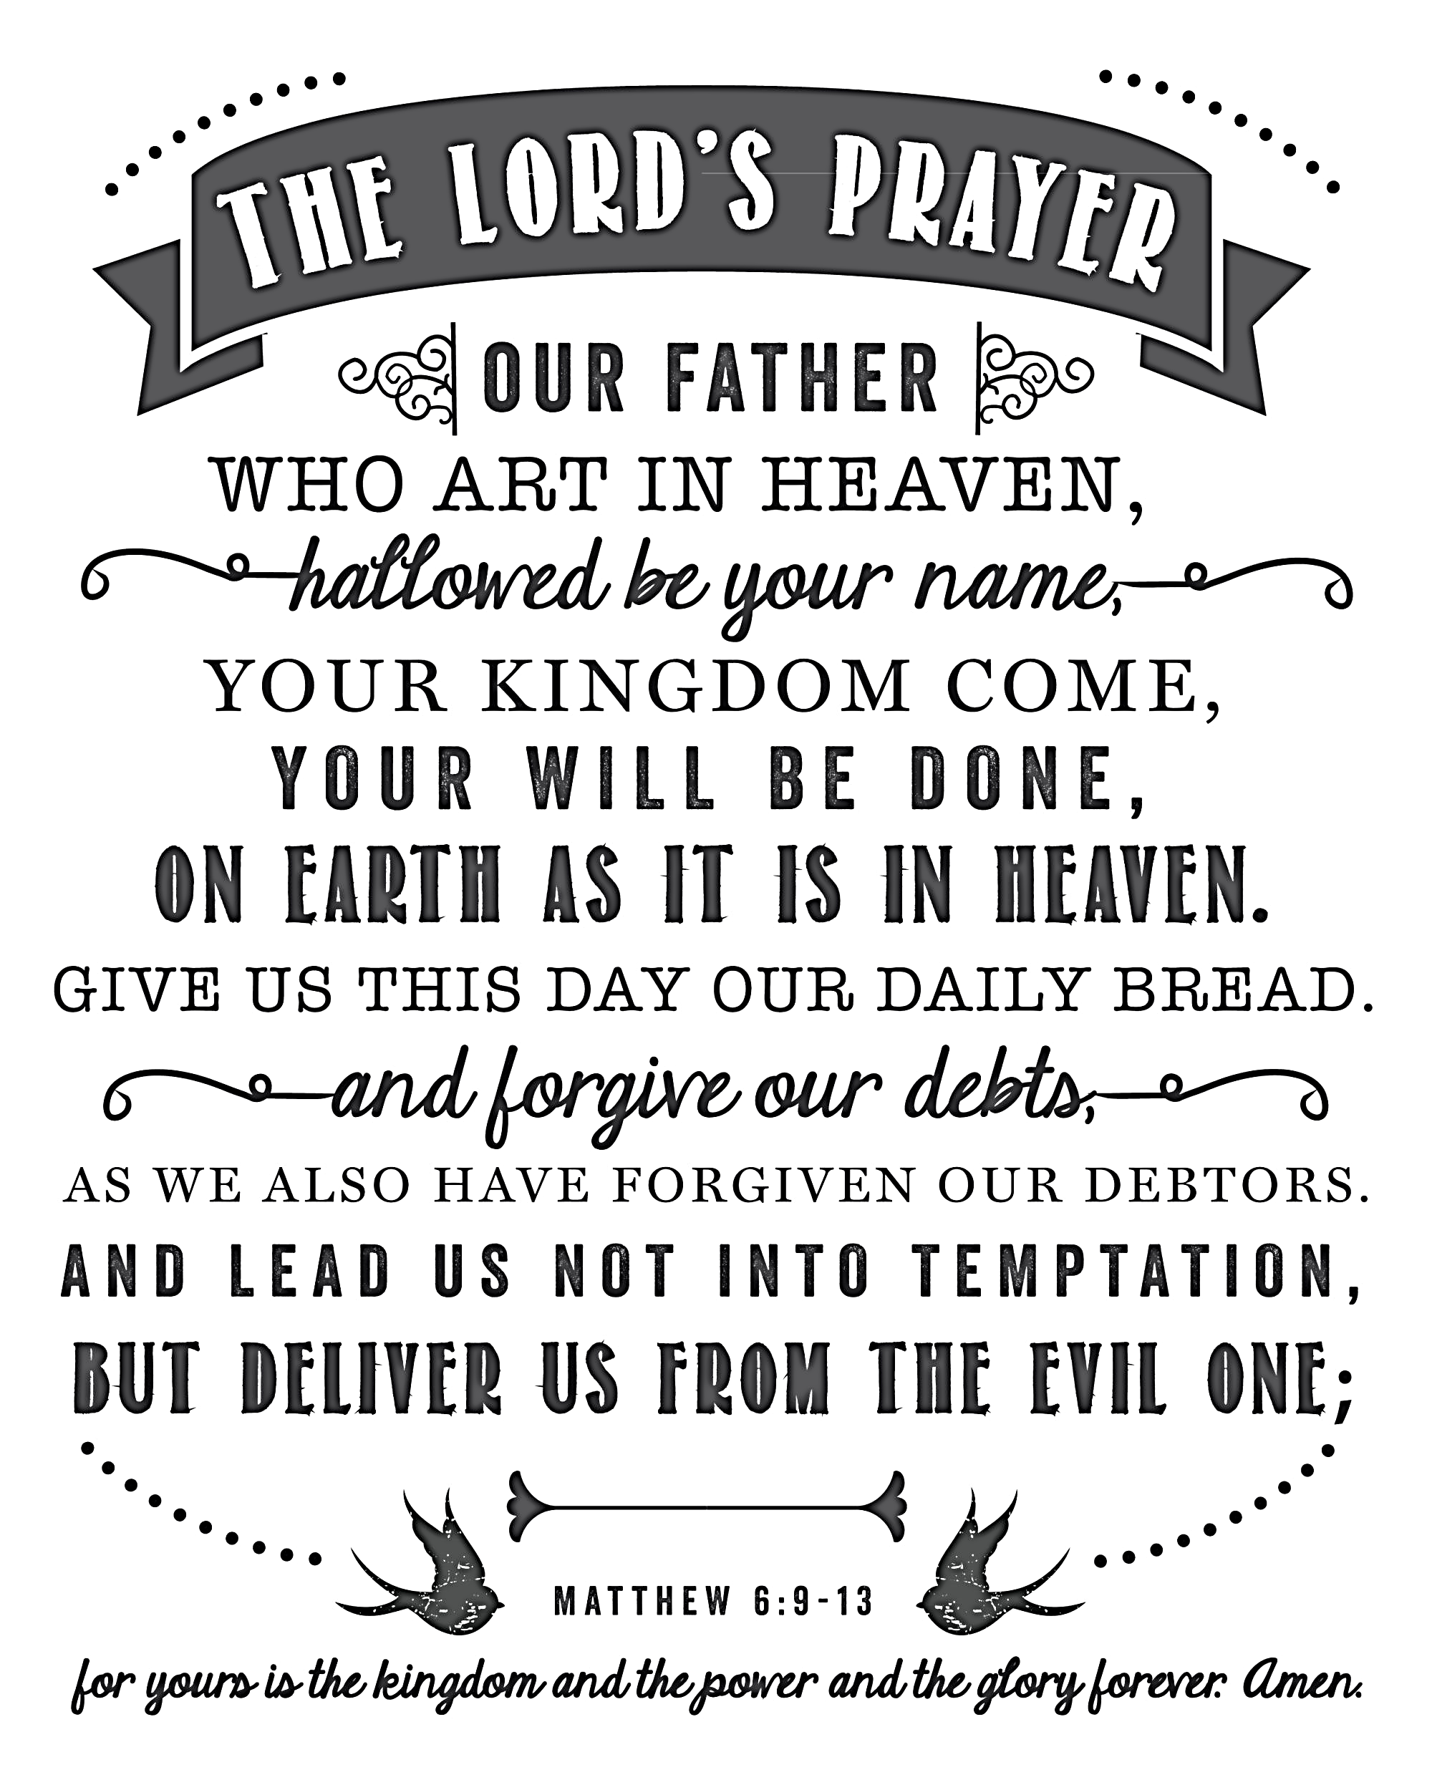](https://www.google.co.uk/url?sa=i&rct=j&q=&esrc=s&source=images&cd=&cad=rja&uact=8&ved=0ahUKEwiV0dPKt7LYAhVlDsAKHYR5BEwQjRwIBw&url=https://www.sincerelysarad.com/the-lords-prayer-free-printable/&psig=AOvVaw2DR5sxNL7dfFShAL9hqbwQ&ust=1514747296836430)

*6*

The Lord’s Prayer

Using a key, highlight the different types of prayer included in this prayer that Jesus taught.

[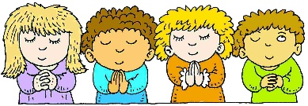](https://www.google.co.uk/url?sa=i&rct=j&q=&esrc=s&source=images&cd=&cad=rja&uact=8&ved=0ahUKEwi__rOu4bLYAhUnLcAKHU4LDB4QjRwIBw&url=http://weclipart.com/kid%2Bpraying%2Bclipart&psig=AOvVaw1iURatQ13U13dirgi07ret&ust=1514758470378533)

The importance of the Lord’s Prayer.

The Lord’s Prayer gives Christians a ________________ for how to

pray as it combines ________________ ________ and ____________

________________________________________________________.

It also reminds Christians that _______________________________

________________________________________________________.

It is believed that prayer ____________________________________

________________________________________________________.

The Lord’s prayer is often used in _____________________________

_______________________ and _____________________________

________________________________________________________.

The prayer can bring a sense of ____________________ and

____________________________ ________________________.

[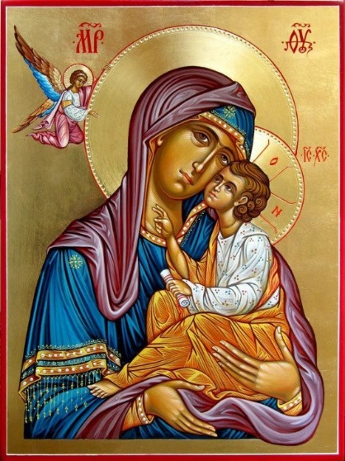](https://www.google.co.uk/url?sa=i&rct=j&q=&esrc=s&source=images&cd=&cad=rja&uact=8&ved=0ahUKEwiOr4nyrrTYAhXoJ8AKHWtIAm4QjRwIBw&url=http://www.orthodoxmom.com/2012/09/06/icons-and-christian-worship/&psig=AOvVaw1_Hm0eH40GomH8WowgDCgz&ust=1514813686435006)

*7*

Research (I.L.):

1. How do Orthodox Christians use icons to worship?

______________________________________________________

______________________________________________________

______________________________________________________

___________ __________________________________________

_ __________________________________________

__________________________________________

__________________________________________

__________________________________________

__________________________________________

Add a picture of a Christian icon here.

Christians believe God will answer their prayers but ____________

______________________________________________________

______________________________________________________.

In the passage above what is Jesus is asking God to do? (The prayer was said on the night of his arrest). _________________________

______________________________________________________

______________________________________________________

______________________________________________________.

What is the meaning of the last sentence? ____________________

______________________________________________________

______________________________________________________

______________________________________________________

______________________________________________________.

Despite this request Jesus is still crucified. Why does it seem that God doesn’t answer Jesus’ prayer? (Consider what you have learnt about the meaning of Jesus’ death). _________________________

______________________________________________________

______________________________________________________

______________________________________________________

______________________________________________________

_____________________________________________________.

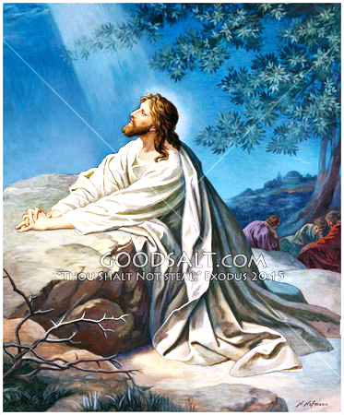[*Mark 14:32-36*](http://www.biblica.com/en-us/bible/online-bible/niv/mark/14/) *32They went to Gethsemane, and Jesus said to his disciples, "Sit here while I pray." 35 … he fell to the ground and prayed. 36"Abba, Father," he said, "everything is possible for you. Take this cup from me. Yet not what I will, but what you will."*

*9*

[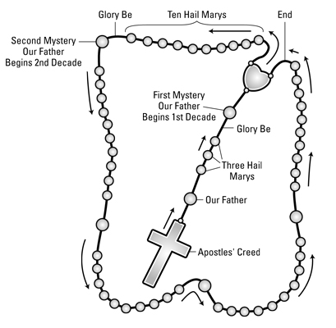](https://www.google.co.uk/url?sa=i&rct=j&q=&esrc=s&source=images&cd=&cad=rja&uact=8&ved=0ahUKEwjg56__trTYAhUkC8AKHXenBo8QjRwIBw&url=http://kcascension.org/how-to-pray-the-rosary/&psig=AOvVaw3RBPjRYrKUwdetgbRWrDd0&ust=1514815754111444)

Research (I.L.):

1. How do Catholic Christians use rosary beads to worship? In your answer explain what the Rosary actually is.

______________________________________________________

______________________________________________________

______________________________________________________

______________________________________________________

______________________________________________________

______________________________________________________

______________________________________________________

______________________________________________________

_____________________________________________________.

*8*