**..\WINDOWS\Application Data\Microsoft\Media Catalog\Downloaded Clips\cl68\j0260331.wmf..\WINDOWS\Application Data\Microsoft\Media Catalog\Downloaded Clips\cl68\j0260331.wmf**

**Buddhist Beliefs – Buddha’s Enlightenment**

The Three Watches of the Night. Buddha’s Enlightenment.

During his enlightenment Siddhartha was visited by a demon

called Mara, who liked to see people suffering. He saw

Siddhartha meditating. He tried to frighten Siddhartha with his

army of devils, with floods and thunderbolts, and to tempt him

with feasts and beautiful women. Siddhartha ignored it all and

continued meditating.

1. He remembered his past lives on earth (now the Jataka Tales).

2. He understood the repetitive cycle of birth, death and rebirth.

He understood how beings are reborn according to their karma (actions).

He understood that everything changes – nothing stays the same (anicca).

3. He understood that beings suffer (dukkha) because of desire,

hatred, ignorance, attachment and change.

He understood that suffering can end by following the

Eightfold Path.

[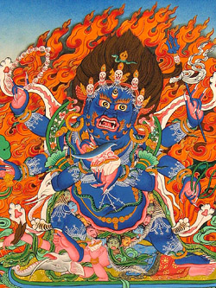](https://www.google.co.uk/url?sa=i&rct=j&q=&esrc=s&source=images&cd=&cad=rja&uact=8&ved=2ahUKEwi13qfMmdDZAhVGL8AKHcZ8BCMQjRx6BAgAEAY&url=https://www.pinterest.com/pin/344595808968346378/&psig=AOvVaw20ujgfGvLfGBvEleuvev8W&ust=1520168037965705)

D:\mhp\Common\MSShared\Clipart\std4prem\std4dir6\j0110748.wmf

[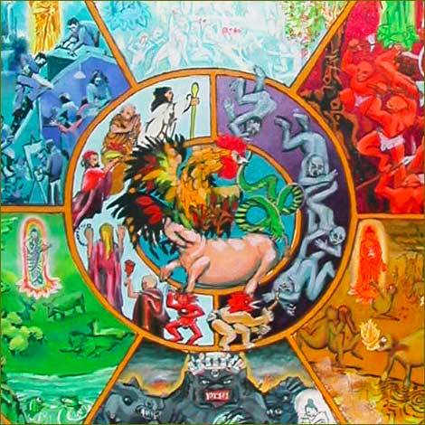](https://www.google.co.uk/url?sa=i&rct=j&q=&esrc=s&source=images&cd=&cad=rja&uact=8&ved=2ahUKEwjpsur-pNDZAhUBesAKHWCFAgYQjRx6BAgAEAY&url=https://bezen.wordpress.com/2008/12/12/buddhist-tool-box-three-poisons/&psig=AOvVaw30ES2LopKDbdJ0r8xKUB44&ust=1520171099694190)

After the enlightenment...

After Siddhartha’s realisation of the truth – enlightenment, he became known as the Buddha – the enlightened one. He achieved nibbana – freedom from suffering (dukkha). He went back to the five holy men who had also been looking for spiritual truths about life. He taught them what he had discovered and they became his first disciples.

The Middle Way (Eightfold Path)...

Buddha explained to them that they should take a ‘middle way’. His rich lifestyle had not led him to understand the nature of life, neither had giving everything up and living as an ascetic. The only way was to reject either extreme and to follow the Path to overcome suffering.

The Dharma...

Buddha went on to teach the dharma – the truth he realised when he became enlightened and the Path or teachings that need to be followed to reduce dukkha, be happy and gain enlightenment – freedom from dukkha.

Parinibbana…

When Buddha died, he achieved what is known as parinibbana. This meant that he did not have to be reborn and suffer all over again.

Things to do.

1. What do the cockerel the snake and the pig symbolise in Buddhism? You may draw and label pictures of each if you wish.
2. Give examples of actions that may result from being (a) greedy (b) full of hate, and (c) ignorant. You may do this in cartoon strip form if you wish.

Things to do.

1. What do the cockerel the snake and the pig symbolise in Buddhism? You may draw and label pictures of each if you wish.
2. Give examples of actions that may result from being (a) greedy (b) full of hate, and (c) ignorant. You may do this in cartoon strip form if you wish.

D:\mhp\Common\MSShared\Clipart\std4prem\std4dir6\j0110748.wmf

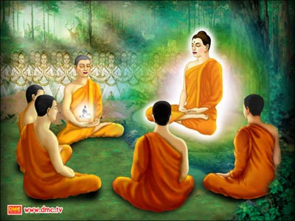

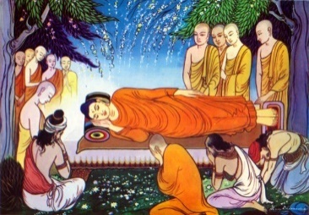

The Three Watches of the Night - Buddha’s Enlightenment.

During his enlightenment Siddhartha was visited by _________________

who______________________________________________________________.

___________________________________________________________________

He tried to distract Siddhartha by___________________________________

__________________________________________________________________.

But Siddhartha ___________________________________________________.

The Three Watches of the Night

1. He remembered his __________ ___________ (now the Jataka Tales).

2. He understood the _____________________________________________

________________________________________________________(Samsara).

He understood how _______________________________________________

__________________________________________________________(actions).

He understood that _______________________________________________

__________________________________________________________(anicca).

3. He understood that _____________ _____________ (dukkha) because

of ________________________________________________________________

___________________________________________________________________

He understood that _______________________________________________

__________________________________________________________________.

After the enlightenment...

One thing Buddha did was __________________________________________________

____________________________________________________________________________

One thing Buddha taught was ______________________________________________

____________________________________________________________________________

