Dependent Arising (Paticcasamuppada) Summary
(Textbook pages 18-19)
Vocabulary
dependent arising – the idea that all things/people depend on other things or conditions in order to exist
kamma - 1. a person’s actions; 2. the law that good deeds result in happiness and bad deeds result in unhappiness (In Sanskrit language this word is karma which is used in Hinduism as well.)
nibbana - a state of complete enlightenment, happiness and peace (In Sanskrit this word is Nirvana and is Hindu as well.)
nidanas - twelve factors that affect the process of birth, death & rebirth
paticcasamuppada – dependent arising
samsara - the cycle of birth, life, death & rebirth

Paticcasamuppada or dependent arising is the idea that everything that exists depends on something else.
- Everything is constantly changing.
- Nothing is permanent.
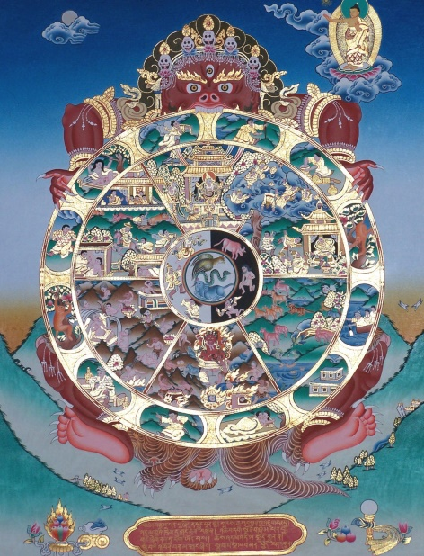
- Life is an interdependent web of conditions.
Examples
A tree needs soil, light and water in order to live. If you take any of these away the tree will die and cease to exist.
Bees need flowers to get nectar and flowers need bees to pollinate and reproduce. If all the flowers die the bees will die. If all of the bees die (as is in danger of happening in Britain due to pesticides) all of the flowers will die.
The Tibetan Wheel of Life
- This is a diagram shows samsara.
- On the outside edge are the twelve nidanas which are stages or links in this process.
- The twelfth nidana is the link between death and rebirth.
- The consciousness of a dead person goes into a new-born body.
- The new birth depends on their kamma from the previous life; if it was a good life it will be a good rebirth and a bad life leads to a bad rebirth.
- Buddhists are all aiming to achieve enlightenment and nibbana to be free from suffering.
Possible exam questions:
- Explain two examples of the Buddhist concept of dependent arising. (4 marks)
- Explain two ways in which kamma can affect a person’s future. (4 marks)
- ‘It is possible to live independently of others.’ Do you agree? (12 marks)
- ‘There is no justice in the world.’ Do you agree? (12 marks)
- ‘The Tibetan Wheel of Life has nothing to teach us about the real world.’ Do you agree? (12 marks)
- ‘Everything changes.’ Do you agree? (12 marks)

