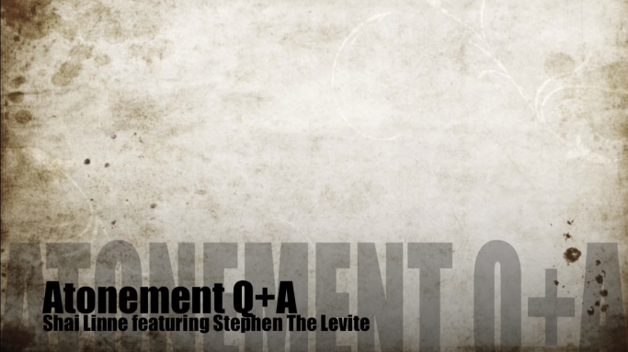
Atonement Q + A
By Shai Linne & Stephen the Levite
Terms
grace - undeserved kindness/unmerited favour
the Lamb - a title of Jesus
righteous - morally good
Soli Deo gloria – Only to God be the glory (Latin)
wrath - anger
- The result [of sin] is by nature we’re God’s _______________s and must pay the p__________.

- Redemption: we’ve been freed from _________________ to s______.

- Justification: God declares us _________________________.

- Repentance is ____________________ from your sin and trusting ___________ .
https://www.youtube.com/watch?v=7RUciHVpCbw
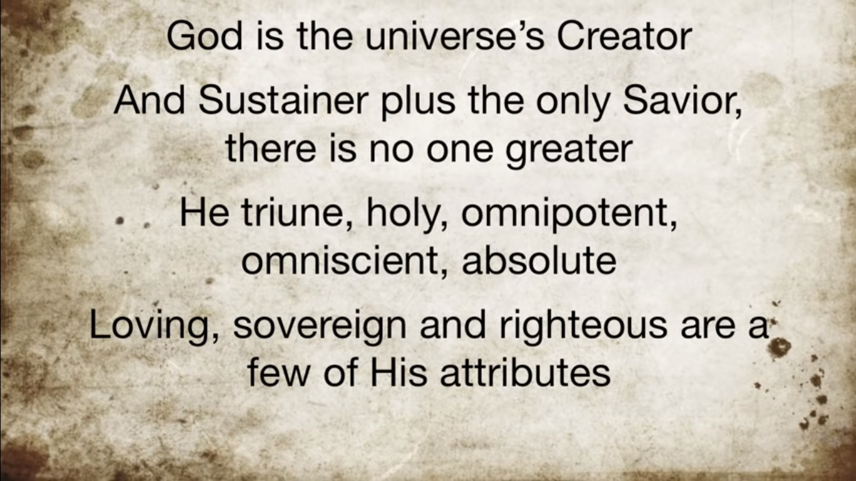
Explain two Christian beliefs about the atonement. (4 marks)
‘The atonement has no relevance for people today.’ (12 marks)

