Atonement & The Role of Christ in Salvation
(Pages 30-31 in the Christianity textbook)
According to the AQA specification you need to know the following things:
‘Beliefs and teachings about:
• the role of Christ in salvation including the idea of atonement.’

Atonement literally means ‘at-one-ment’. This word was coined by William Tyndale in his 1525 New Testament to express the idea that God and humans could be made one with each other by a sacrifice taking away the sins of the humans.
In the Old Testament, death came into the world through the sin of Adam. Human sin caused offence to God and broke the relationship between God and humanity. Justice meant sin needed to be punished and resulted in death & hell but God loved people and did not want this to happen. Animals were sacrificed to ‘cover’ the sins of the people. God commanded the Jews to sacrifice animals to cover over their sins; an innocent creature lost its life in place of the guilty. This is seen in the story of Moses when the 10th Plague of Egypt was the death of the firstborn son of every family in that country. Those who sacrificed a lamb and put its blood over the door would avoid all punishment for sin and the firstborn son would live. However, Old Testament animal sacrifice is seen as a temporary fix by Christians, who believe that God required a permanent solution.
‘For God so loved the world that he gave his only Son that whoever believes in him shall not perish but have everlasting life.’
John 3:16

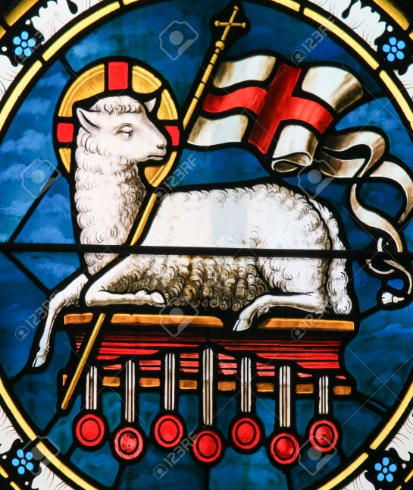
This solution was that Jesus voluntarily died on the cross as a once-and-for-all sacrifice to take away sins forever. In the New Testament Jesus is called the Lamb of God because he was innocent and was killed at Passover to take away the sins of people. God the Son sacrificed himself in order to take the punishment that would send all humans to hell for eternity. This means that anyone who believes in him can have forgiveness of their sins (if they are sorry) and avoid hell.
This is called the Atonement; the idea that the death of Jesus can take away guilt and sin and buy forgiveness. Humans can be reconciled with God.
Paul compares Jesus to Adam: ‘For since death came through a man, the resurrection of the dead also comes through a man. For as in Adam all die, so in Christ all will be made alive.’ (1 Corinthians 15:21)
Salvation means being saved from sin & hell.
The role of Christ in salvation:
- As a volunteer;
- As a sacrifice;
- As an innocent he can trade places with the guilty;
- As God he alone could take away sin;
- As a human he represented the human race on the cross;
- His blood is metaphorically sprinkled on believers for cleansing.
The effects of the Atonement:
- All sin is punished on Jesus instead of on sinners;
- Sins are forgiven;
- Guilt changes to innocence;
- Bad people are made good;
- Relationship with God is mended;
- Instead of hell, believers go to heaven;
- Instead of eternal death he gives them eternal life.
Possible Exam Questions
Explain two Christian beliefs about the role of Jesus in salvation. In your answer you must refer to scripture. (5 marks)
Explain two Christian beliefs about the meaning of atonement. In your answer you must refer to scripture. (5 marks)
‘Salvation is God’s greatest gift to humans.’ (12 marks) ← From the textbook.
‘It was wrong for God to punish Jesus for the sins of other people.’ (12 marks)
‘There is no need for someone to die as a punishment for sin.’ (12 marks)
‘If Jesus had not died for us we would all go to hell.’ (12 marks)

