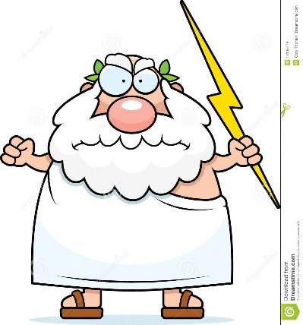
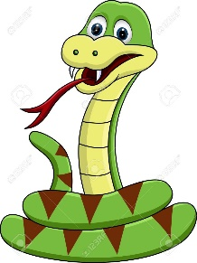

Adam and Eve were tempted by a snake who was the devil in disguise to eat from the tree of knowledge of good and evil, thereby disobeying God. This makes God angry and ‘man’ fell from God’s grace (love).

Adam and ________ were tempted by a _____________ who was the __________ in disguise to ______ from the _________ of knowledge of _________ and evil, thereby ________________ God. This made God ___________ and ‘man’ ________ from God’s grace (________).

Adam and ________ were tempted by a _____________ who was the __________ in disguise to ______ from the _________ of knowledge of _________ and evil, thereby ________________ God. This made God ___________ and ‘man’ ________ from God’s grace (________).

Adam and ________ were tempted by a _____________ who was the __________ in disguise to ______ from the _________ of knowledge of _________ and evil, thereby ________________ God. This made God ___________ and ‘man’ ________ from God’s grace (________).

Adam and ________ were tempted by a _____________ who was the __________ in disguise to ______ from the _________ of knowledge of _________ and evil, thereby ________________ God. This made God ___________ and ‘man’ ________ from God’s grace (________).

Adam and ________ were tempted by a _____________ who was the __________ in disguise to ______ from the _________ of knowledge of _________ and evil, thereby ________________ God. This made God ___________ and ‘man’ ________ from God’s grace (________).

