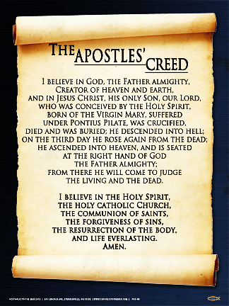

The Apostle’s Creed is…

Highlight key parts of the Apostle’s Creed;

**Key:**

* Death;
* Afterlife;
* Judgement.

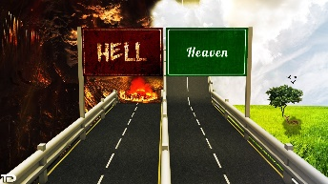

Complete the following…

An afterlife is dependent on belief in God because

The Apostle’s Creed is…

Highlight key parts of the Apostle’s Creed;

**Key:**

* Death;
* Afterlife;
* Judgement.



Complete the following…

An afterlife is dependent on belief in God because