Fill in the gaps to explain the meaning of these quotations.
We are born, therefore eventually we _______. However, if we are ______________ from the dead, we will have ________________ life.

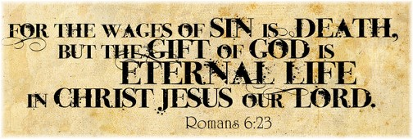
If we behave ___________ we will _________. But if a person believes in _____________, ________________ life is possible.

Jesus was _______________ from the dead. If a person believes in ____________ they too can have ________________ life.

Fill in the gaps to explain the meaning of these quotations.
We are born, therefore eventually we _______. However, if we are ______________ from the dead, we will have ________________ life.

If we behave ___________ we will _________. But if a person believes in _____________, ________________ life is possible.

Jesus was _______________ from the dead. If a person believes in ____________ they too can have ________________ life.

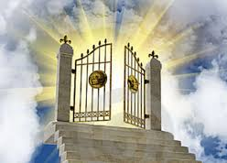
Complete the following (page 22)…
Christians believe that resurrection is a reality. However, there are different beliefs within Christianity about the form that resurrection will take.

Explain, in detail, the differences between the resurrection of the soul and a bodily resurrection.
Other Christians believe that some time in the future … _____________
______________________________________________________________________________________________________________________ The Catholic Church is clear that… _______________________________ ________________________________________________________________________________________________________________________________________________________________________________________________________________________________________________________________________________________________________

Some Christians believe a person’s soul … _________________________
____________________________________________________________________________________________________________________________________________________________________________________________________________________________________________

A belief in resurrection might affect the life of a Christian by…

_____________________________________________________________________________________________________________________________________________________________________________________________________________________________________________

