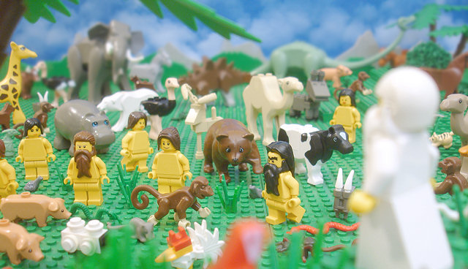
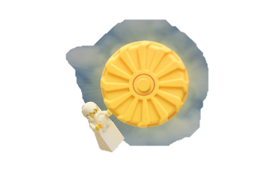
Genesis 1:1-30

Genesis 2:4-24

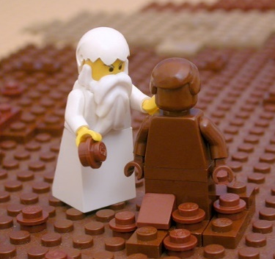
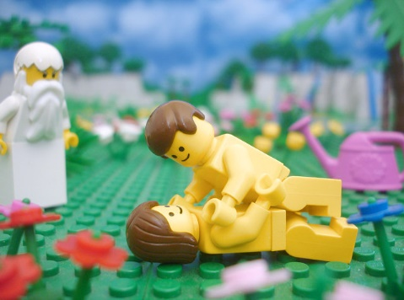
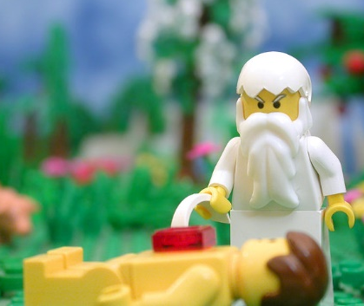
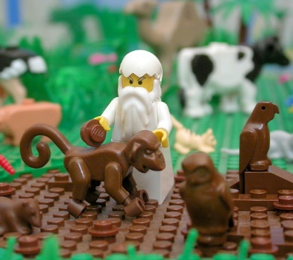
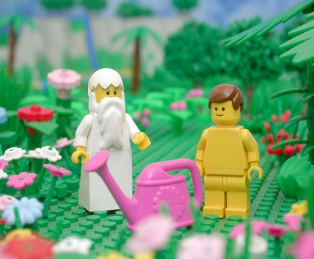
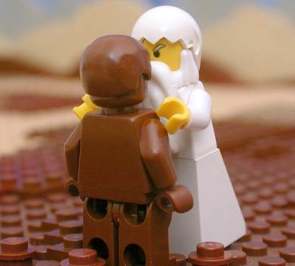

Genesis 1:1-30

Genesis 2:4-24

Genesis 1: The Beginning

1 ‘In the beginning God created the heavens and the earth. 2 Now the earth was formless and empty, darkness was over the surface of the deep, and the Spirit of God was hovering over the waters.’

Questions;

- Write an overview of Christian beliefs about Creation.

Christians believe God created the earth and everything in it. In the first creation story (Genesis 1) it says God created the earth in 6 days with animals and humans on the 5th day. God told man and woman to populate the earth. God thought all he had created was ‘very good’, he then rested on the 7th. Most Christians now, believe ‘6 days’ was 6 very long periods of time. As God is believed to be transcendent he is beyond space and time therefore ‘time’ is not the same to God as it is to us.

The second creation story (Genesis 2) explains how God created man out of clay and put him in the Garden of Eden to look after it. He then created the animals out of clay as companions to man, but none were suitable so when Adam was asleep, God took a rib and created woman.

Although many Christians recognise the Creation stories do not agree with the laws of science, they do believe the accounts contain a religious truth that God created the universe.

- What does the reference to ‘the Spirit of God’ suggest about the Holy Spirit’s existence?

John 1:1-3 The Word Became Flesh

In the beginning was the Word, and the Word was with God, and the Word was God. 2 He was with God in the beginning. 3 Through him all things were made; without him nothing was made that has been made.

Questions;

- Who does ‘the Word’ refer to?
- What does the reference to ‘the Word’ suggest about creation and the Trinity?
- Why do Christians suggest humans can never fully understand God?

Truth or Myth?

Some Christians take the Bible literally meaning what it says in the Bible is true word for word. If scientific discoveries disagree with what the Bible says, then science is wrong.
Most Christians believe that God created the universe is a religious truth, but they accept the creation stories in the Bible are myths. The stories are a way of explaining something unknown to humans.

Questions

Explain how and why Christians understand the creation stories in different ways.
What do these different beliefs suggest about the compatibility of religious and scientific views about creation?

Review – Exam Questions.

1. Explain two ways in which Christians understand the creation stories in the Bible. (4 marks).
2. Explain two Christian beliefs about God the creator. Refer to scripture in your answer. (5 Marks)

