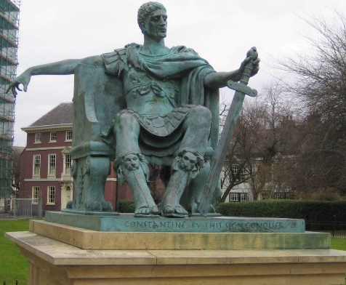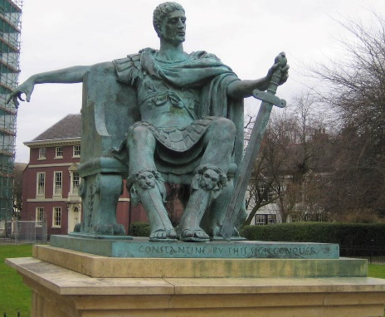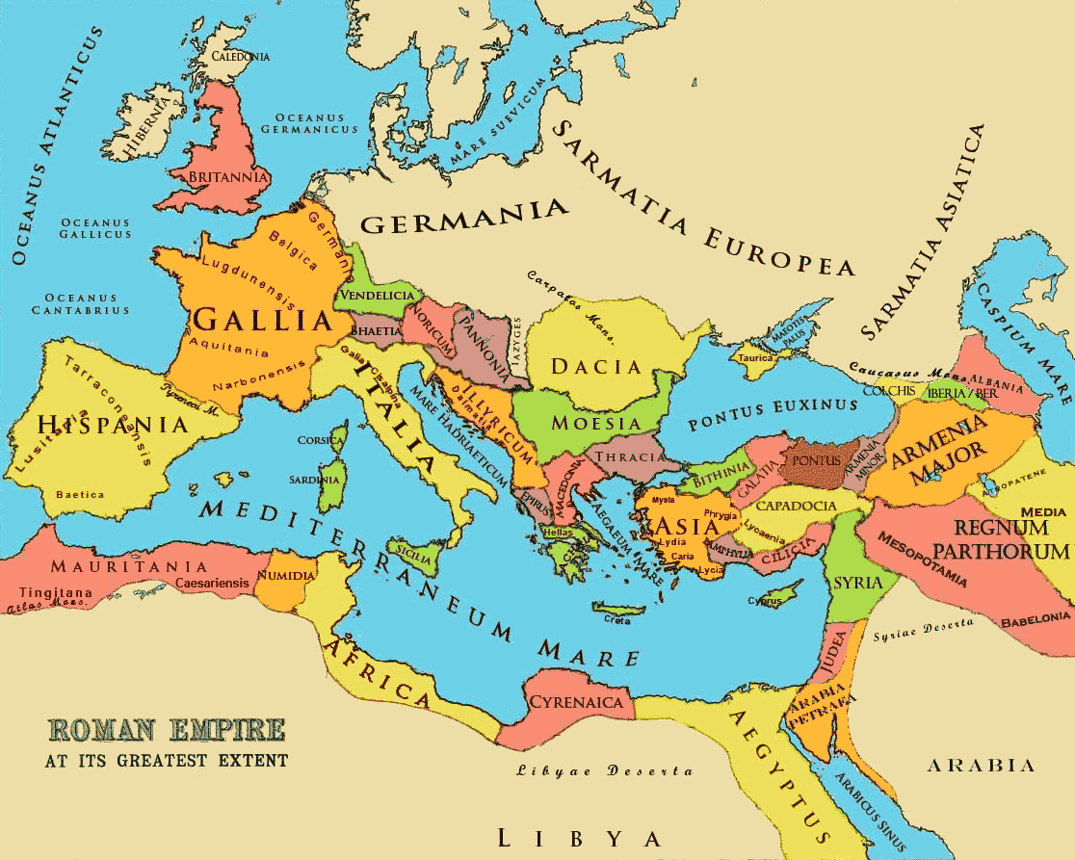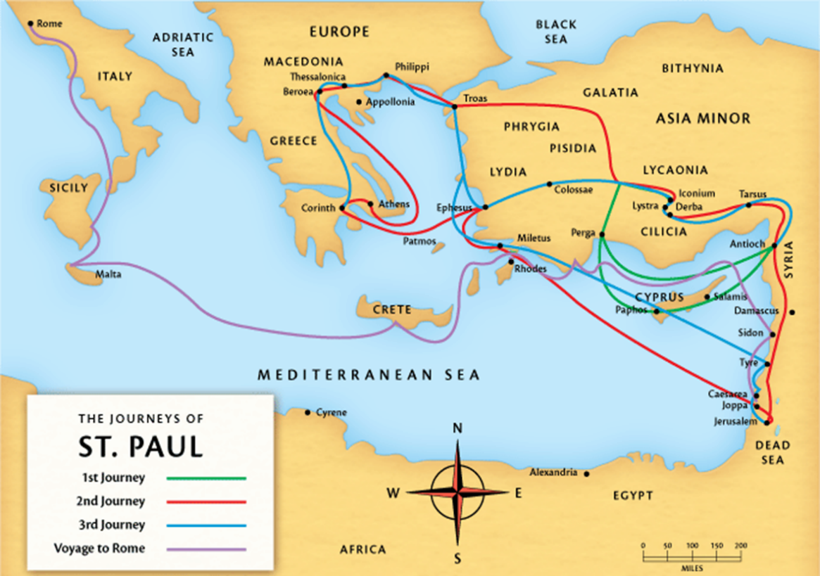

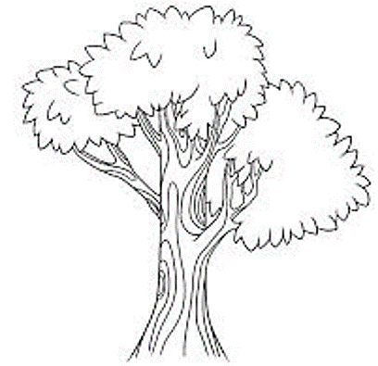

* In the spaces above briefly explain how the Christian Church was founded and then divided into the three main different denominations.
* In the ‘branches’ note down some of the main denominations for each ‘off-shoot’.

**The Reformation**

**16th Century**

**The Christian Church**

**Protestantism**

**The Great Schism - 11th Century**

**Jesus**

**1st Century**

|  |  |  |  |  |  |  |
| --- | --- | --- | --- | --- | --- | --- |
|  |  |  |  |  |  |  |



              
              
              



              
              
              

