Round Earth Theory
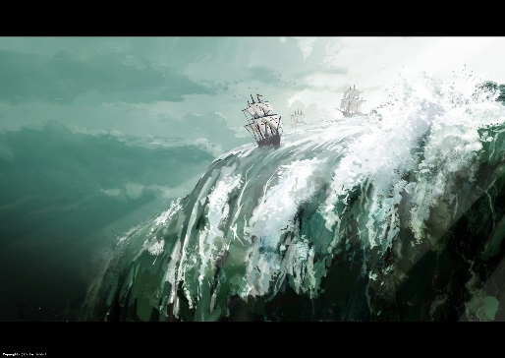
Most people in the Middle Ages were poorly educated and thought that the world was flat. It was believed by some that if you sailed to the edge of the world there was a giant waterfall at the edge of the oceans at which you would fall off. In fact, since ancient times there was a small number of people who were aware of the roundness of the earth (an ancient Greek mathematician called Eratosthenes had worked it out in about 240BC) but very few people knew about this.
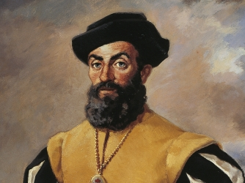
In the 1400s education in Europe began to improve and in 1492 Columbus knew that if he kept sailing west from Spain he should reach India; he thought this might be quicker than the usual slow route eastwards. (This is why when he discovered America he called the natives ‘Indians’ because he did not realise the ‘New World’ he had discovered was in fact not India!) In 1522 the first journey round the world was completed by a group of Portuguese ships originally led by Ferdinand Magellan.
Ferdinand Magellan
The Catholic Church had believed for centuries that the world was flat so when it was more widely realised that we were in fact living on a sphere it totally transformed people’s understanding of earth and was one of several factors causing people to question what the Church had taught. Other factors included:
- the discovery that the earth goes round the sun by Copernicus and Galileo (called the Cosmological Revolution);
- and the Protestant Reformation from 1517 onwards which attacked traditional Catholic beliefs like the existence of purgatory and the power of the Pope to be the leader of global Christianity.

Design versus Evolution
See also the 2014 textbook page 128 and notes on challenges to the Design (Teleological) Argument for the existence of God.
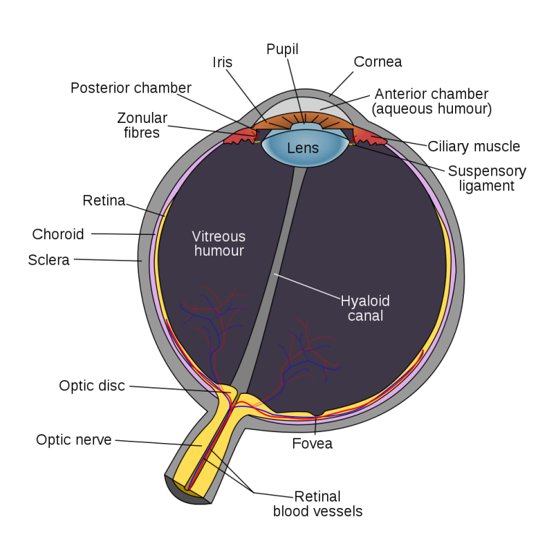
William Paley and others had taught the idea that living things must be designed by God because they are so complicated. It was thought that such delicate natural mechanisms were evidence that a super-intelligent being must have designed them because many parts of the body had to work together perfectly in order to have a functioning life form.
Although he originally believed these ideas, Charles Darwin came to reject design because he could see a way in which complicated creatures could come about through evolution and survival of the fittest. Organs in animals could gradually become more complicated and advanced over a very long period of time, due to natural variations giving some an advantage for survival and therefore reproduction. The idea of intelligent design of nature could be rejected because natural forces could have caused complicated life forms without a need for an overall god creating it.
Religious believers have challenged this rejection of design in two ways:
- Theistic evolution – the idea that God designed evolution as the process for creating life. Theistic evolution rejects a traditional interpretation of Genesis chapters 1 and 2 and sees these stories as not literally true. They are seen as simplified stories for non-scientific peoples of ancient times. God created evolution and he used it to form animals then humans over millions of years, as described by modern scientific theories. However, life on earth is extremely complicated and the idea that it all simply assembled itself by random chance with no help is seen as ridiculous and far-fetched.
- Creation science – this Christian idea believes in most aspects of modern science but clings to the traditional interpretation of Genesis as literally true. Creation science argues that evolution could not properly explain how certain life forms came about. An eye that is only partially evolved would not work; without the many parts being all in place at the same time, a creature would be blind and so there would be no advantage for survival, (e.g. no pupil or no optic nerve connecting the eye to the brain). Eyes need to have a very specific complicated chemical (C₂₀H₂₈0 in humans) that reacts with different frequencies of light to make the retina work. This specific chemical has to be produced naturally by the body of the human or animal otherwise it would be completely blind. Even allowing for million years of development, the existence of working eyes is so extraordinarily unlikely that it cannot adequately be accounted for by random-chance natural selection. It is argued that everything had to be right first time in order for the eye to work. In other words it had to be created by God perfectly at the start as described in Genesis.

A second example used is the bombardier beetle. This insect shoots liquid fire out of its back end as a defence against other animals. (See diagram.) It has two different chemicals contained separately inside its body. When the chemicals are mixed together they react violently with force and heat. The body of the beetle has chambers capable of withstanding these corrosive chemicals and their reaction. Creation scientists say that this defence mechanism could not evolve gradually. If it were only partly evolved it would either blow itself up, poison itself or simply have no advantage for survival and just die out. Therefore, creationists reject evolution.
Most scientists reject creation science. It is seen as being backward and unrealistic for believing that all life on earth could be created in just six days and for not believing in evolution.
