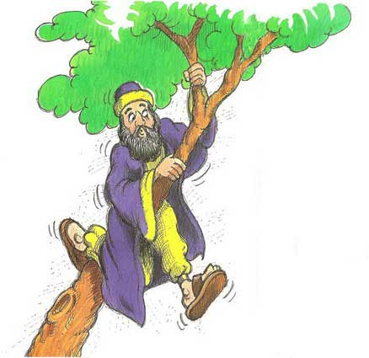
Human Rights & Social Justice Revision Quiz 2 Wealth and Poverty
- What does the term, ‘Fat Cat’ mean?

- How did Bill Gates become rich?

- Give 3 other ways in which people can become rich.

- What is a tithe?

- What is the name of the tax collector that Jesus wanted to have tea with?

- How much of his wealth did the tax collector give away?

- How much did he give back to people he had cheated money out of?

- What is the second Buddhist precept?

- What is compassion?

- What is karma?

- Give the name of 2 Christian Charities.

- What is exploitation?

- What is Human Trafficking?

- What is short term aid?

- Give an example of long term aid.

Fill in the missing words;

- ‘It is easier for a ___________ to go through the eye of a ___________ than for a __________ ________ to enter the kingdom of ________’. (Jesus)

- ‘Love thy ________________________’. (Jesus)

- ‘My religion is __________________’. (Dalai Lama)

- Do not exploit the ___________ because they are ___________’. (Bible)

- All Human Beings are born ____________ and ___________ in dignity and ____________. (UDHR)

- Women should be ____________ in the ______________. (Bible)

- There is neither _________ nor Gentile, ____________ nor free, Male nor _____________. Your are all one in _____________ ____________.

- Everyone has the right to freedom of ______________, conscience and _________________. (UDHR)

- ‘The one who is unwilling to _________ shall not ________’.

- . ‘Avoid harming any ___________ _______ __________. (Buddhism)

