Emergency Quotations Sheet
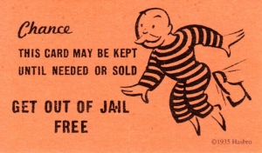
Use these quotes in exams when you are stuck for something to write for the religious bit of a tricky question. Make sure you relate the quote to the question.
Buddhism
‘My religion is kindness.’ Dalai Lama
‘Do not harm a sentient being.’ Buddha
‘To understand all is to forgive all.’ Buddha (?)
‘Do not take what is not offered.’ Five Precepts of Buddha
‘Better than a thousand hollow words is one word that brings peace.’ Buddha
Christianity
‘In the beginning God created the heavens and the earth.’ (Genesis 1:1)
‘You shall not kill.’ God (Ten Commandments)
‘Blessed are the peacemakers.’ Jesus (Matthew 5)
‘Love your neighbour as yourself.’ God. (Leviticus 19:18)
‘God is love.’ Apostle John (1 John 4:16)

Emergency Quotations Sheet
Use these quotes in exams when you are stuck for something to write for the religious bit of a tricky question. Make sure you relate the quote to the question.
Buddhism
‘My religion is kindness.’ Dalai Lama
‘Do not harm a sentient being.’ Buddha
‘To understand all is to forgive all.’ Buddha (?)
‘Do not take what is not offered.’ Five Precepts of Buddha
‘Better than a thousand hollow words is one word that brings peace.’ Buddha
Christianity
‘In the beginning God created the heavens and the earth.’ (Genesis 1:1)
‘You shall not kill.’ God (Ten Commandments)
‘Blessed are the peacemakers.’ Jesus (Matthew 5)
‘Love your neighbour as yourself.’ God. (Leviticus 19:18)
‘God is love.’ Apostle John (1 John 4:16)

