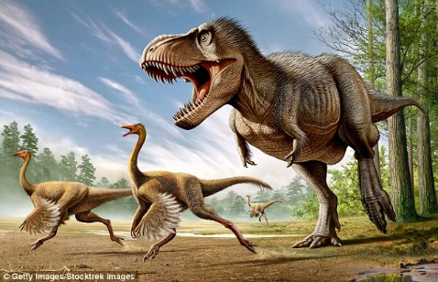
Photos taken by Mr Haughton earlier
Instructions for Outdoor iPad Lesson

We are going outdoors, down to the woods to explore the flora & fauna.
- You will be allocated into groups of four.
- Each group will have one iPad which is for taking photos.
- The main objective of your group is to photograph and identify as many different types plants & animals (mainly insects) as possible in the time allocated.
- Even if you can’t identify them, photograph as many different creatures as you can.
- Water and iPads don’t get along very well so please keep them separate.
- Each group needs four roles:
  - Photographer;
  - Book researcher to identify the plants & animals found (people can use their iPhones for this if they want);
  - Explorer to seek out the best subject matter;
  - Scribe to record all findings in an exercise book.
- Please stay within the woods at all times and do not wander beyond there where it might interfere with PE and other lessons.
- We will be going to the pond afterwards as well.
- After 30 minutes we will come back and share findings with each other via the big screen.
- The relevance of all of this will be revealed when we get back.

