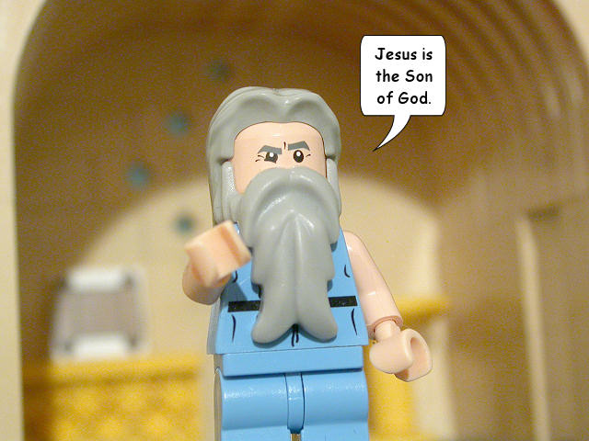
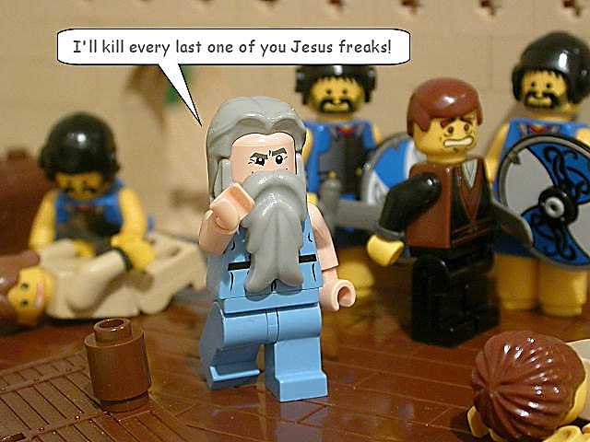

Saul
Paul
The Conversion of Saul

What happened to Saul that led to his conversion? Acts 9:1-19. Read the story and, in the box above, briefly summarise what happened. Explain how Paul’s vision can ‘prove’ the existence of God.

Saul
Paul
The Conversion of Saul

What happened to Saul that led to his conversion? Acts 9:1-19. Read the story and, in the box above, briefly summarise what happened. Explain how Paul’s vision can ‘prove’ the existence of God.

Acts 9:1-19
The Conversion of Saul

9 Saul was still breathing out murderous threats against the Lord’s disciples. He went to the high priest ² and asked him for letters to the synagogues in Damascus, so that if he found any there who were Christian, whether men or women, he might take them as prisoners to Jerusalem. ³ As he neared Damascus on his journey, suddenly a light from heaven flashed around him. ⁴ He fell to the ground and heard a voice say to him, “Saul, Saul, why do you persecute me?”
⁵ “Who are you, Lord?” Saul asked. “I am Jesus, whom you are persecuting,” he replied. ⁶ “Get up and go into the city, and you will be told what you must do.”
⁷ The men travelling with Saul stood there speechless; they heard the sound but did not see anyone. ⁸ Saul got up from the ground, but when he opened his eyes he could see nothing. So they led him by the hand into Damascus. ⁹ For three days he was blind, and did not eat or drink anything.
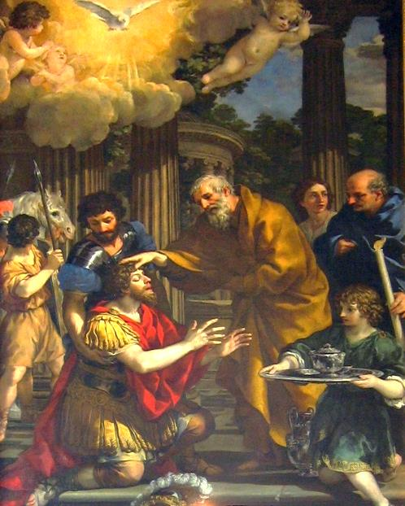
¹⁰ In Damascus there was a disciple named Ananias. The Lord called to him in a vision, “Ananias!” “Yes, Lord,” he answered. ¹¹ The Lord told him, “Go and ask for a man from Tarsus named Saul, for he is praying. ¹² In a vision he has seen a man named Ananias come and place his hands on him to restore his sight.”
¹³ “Lord,” Ananias answered, “I have heard many reports about this man and all the harm he has done to your people in Jerusalem. ¹⁴ And he has come here with authority from the chief priests to arrest all the Christians.”
¹⁵ But Jesus said to Ananias, “Go! This man is my chosen instrument to proclaim my name to the Gentiles and their kings and to the people of Israel.
¹⁷ Then Ananias went to the house and entered it. Placing his hands on Saul, he said, “Brother Saul, the Lord—Jesus, who appeared to you on the road as you were coming here—has sent me so that you may see again and be filled with the Holy Spirit.”¹⁸ Immediately, something like scales fell from Saul’s eyes, and he could see again. He got up and was baptized, ¹⁹ and after taking some food, he regained his strength.

