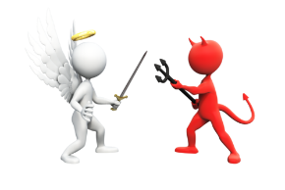

**Nature of Evil – Evil People**

|  |  |  |  |
| --- | --- | --- | --- |
| Person | What did they do? | Was it evil? Why? | Nature/origins of the Evil |
|  |  |  |  |
|  |  |  |  |
|  |  |  |  |

