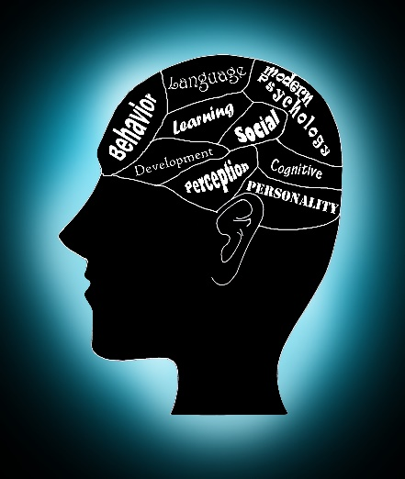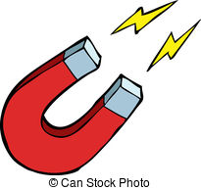

Personal Being.

Evil could be said to be caused by the devil because…

Psychological Phenomenon.

Evil could be said to be a psychological phenomenon because…

Impersonal Force.

Evil could be said to be like a magnet because…

**Nature of Evil – Explanations**