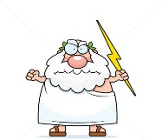
The Argument from Miracles

What is a miracle?

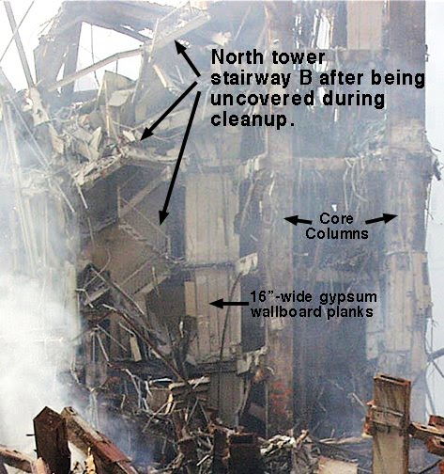
Stairwell B, September 2001.

Sixteen people survived the collapse of the North Tower of the World Trade Centre during the terrorist attack on September 11th 2001. The fact that these people survived when nearly 3000 people died makes some people regard this as a miracle. Others argue that they survived because they were protected by the stairwell and ended up near the top of the debris.

Key Terms

Miracle – a seemingly impossible event, usually good, that cannot be explained by science, that often breaks the laws of nature and is sometimes thought to be the work of God.

Types of Miracle.

Some people use the word ‘miracle’ to describe wonderful things that happen, for example the birth of a new baby. Other people would disagree and point out that babies are born every day and science can explain the process. A religious person might suggest
that a woman who has been unable to have children and then prays to God
and then conceives, would be a miracle because the only explanation is that
God has answered her prayers.

What a miracle is, is therefore, debatable. However, miracles are generally thought of in two ways;

- Events that break the laws of nature and cannot be explained by science. For example, Jesus is said to have turned water into wine at a wedding.

- Happy coincidences in which no natural laws are broken, but something happens just at the right moment to cause a good outcome. For example, a train stops just in time to avoid hitting a toddler who has just wandered onto the tracks.
Discuss and answer…

Was the survival of the 16 people on stairwell ‘B’, a miracle?
Give at least two reasons for both sides of the argument.
Complete the following …

- One type of miracles is…
- An example of this type of miracle would be…
- Another type of miracle is…
- An example of this type of miracle would be…

Then…
Write the definition for ‘miracle’, on your key terms sheet.

Objections to the Argument from Miracles

Atheists might argue that miracles cannot prove God’s existence because;

- Miracles are no more than lucky coincidences

- They may have scientific explanations not yet discovered

- Miracles healings may the result of mind over matter on the part of the sufferer or a misdiagnosis by the doctor.

- Some miracles are fakes, made up by people wanting fame or money.

Even some religious people do not accept miracles because they believe it suggests God is unfair as some people get miracles and others don’t.
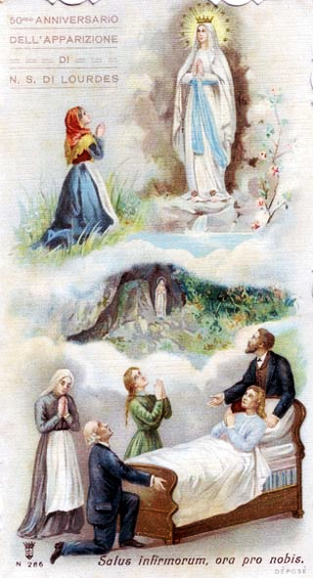
A Miracle in Lourdes.

Marie Bailly was from Lyons in France. When she was 22 she was diagnosed with tubercular peritonitis, a condition that made her abdomen swell and she could not eat. She was taken to Lourdes where she believed she would be cured. On arrival in Lourdes she was taken to hospital in a critical condition, after no improvement, doctors said she was dying. She asked to be taken to bathe in the waters that are believed by some to have miraculous healing properties. She prayed to Mary, the mother of Jesus, and declared, ‘I’m cured’. Her colour returned, her abdomen reduced in size and she returned to health. Her cure took place in 1902.

Christianity and Miracles.

Christians believes God works through miracles. Jesus performed miracles to show the power and love of God. Miracles claimed at Lourdes (a pilgrimages site due to visions of the Virgin Mary) are investigated by the Catholic Church. Out of over 3,000 claimed miracles the Church have officially recognised 69 as genuine.

Some atheists and agnostics have converted to faith in God because they have experienced miracles. Christians believe that these experiences show the miracles are genuine, therefore God exists.
Complete the following …

- Three reasons why miracles cannot prove the existence of God are…

- Some religious believers do not accept miracles because…

- An example of a miracle at Lourdes was…

- Miracles ‘prove’ the existence of God because…

Exam question…
Explain two contrasting beliefs about the argument from miracles for the existence of God. Refer to Christianity and non-religious beliefs in your answer. (4 marks)

