

**The Teleological (Design) Argument**

The Design Argument basically states that the universe is so complex that it had to have a designer and could not have come about by chance, the only being powerful enough to create the universe is God, therefore God exists. Several philosophers have used the idea of design to ‘prove’ God’s existence.

St. Thomas Aquinas (1225-1274);

Aquinas said that the universe (the sun, moon, stars, earth etc) could only be kept in order by an intelligent being.

William Paley (1743-1805);

The Argument was developed by William Paley. Paley argued that a

watch was a very complex piece of machinery, which had obviously

been put together carefully. A watch does not exist by chance, but is

obviously designed. The universe is far more complicated than a watch,

therefore the universe must be designed. The only possible designer for something as complex as the universe must be God, therefore God must exist.

Sir Isaac Newton (1643-1747);

Newton said that because humans and apes have opposable thumbs, unlike any other creatures, it is an example of God’s design. He also claimed that our thumb prints are evidence that God created us all separately and uniquely, as no two thumb prints are the same.

F.R.Tennant (1866-1957);

Tennant developed a modern version of the Design Argument called the Anthropic Principle. He said that God designed the world so that human life would develop. The gravitational pull at the moment the universe began was just right for the universe to develop. The universe expanded at just the correct rate to allow the development of planets such as earth. Once earth formed it had just the right conditions for life to develop. These perfect conditions could have only been created by the actions of God, not by chance.



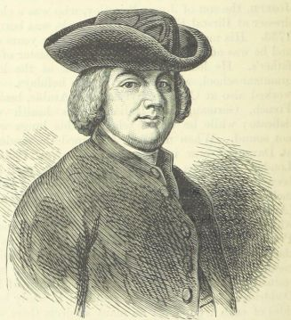



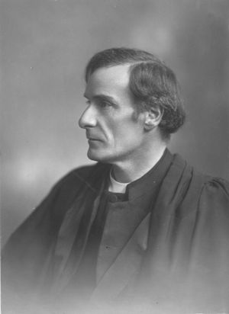

Things to do.

1. Use the template outlines to briefly explain each of the Design Argument theories.
2. ‘The Teleological argument proves that God exists’. Explain how a theist would respond to this statement.

Criticisms of the Teleological (design) Argument.

* The thumb, the eye, birds wings etc are the result of evolution, not God’s design.
* If God designed the planet why is there so much suffering? There is beauty but also cruelty in nature, for example the lion chasing the zebra.
* There are faults in the design of the earth – volcanoes, earthquakes, floods etc. If God was such a clever designer he should have created a planet without these faults that cause human and animal suffering.

Counter Arguments.

* Theists might suggest that if we don’t experience suffering we will not appreciate the good times in our lives.
* Suffering from things like disease and natural disasters teaches us compassion for others, evident in many religious charities such as Christian Aid.

Things to do.

1. Stick pictures of the earth’s ‘design faults’ in your exercise book, label them and explain why ‘design faults’ could bring into question the existence of God.
2. ‘The Teleological argument proves that God exists’. Explain how an atheist would respond to this statement.



Practice Exam questions.

1. Which of the following best expresses the idea that God is all-knowing?
2. Omniscient B) Omnipotent C) Transcendent D) Immanent
3. Give two philosophical arguments for the existence of God. *(2 marks)*
4. Explain two contrasting beliefs in contemporary British society about the existence of God. In your answer you should refer to the main religious tradition of Great Britain and non-religious beliefs. *(4 marks)*

